Language of the Half Term: **Romanian**

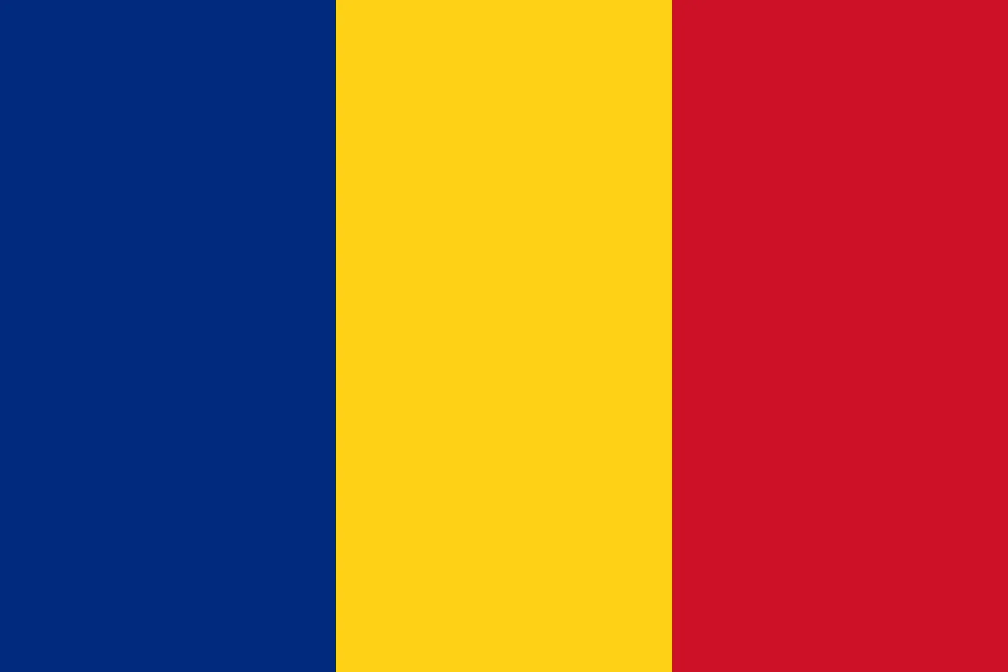Romania is a country in Eastern Europe known for its beautiful landscapes, rich history, and unique traditions. The country is home to the Carpathian Mountains, has a capital called Bucharest, and is famous for its castles, including Bran Castle, often associated with the legend of Dracula.

|  |  |
| --- | --- |
|  | **Learn Romanian:**   * *Welcome:*   Bun venit * *Hello:* Buna ziua * *Goodbye:* La revedere * *Please:* Vă rog * *Thank you:* multumesc * *Well done:* bine făcut |

**Romanian festivals:**

**Christmas:** 25th December

**Unification Day:** 24th January - to commemorate the [unification of the Romanian Principalities](https://en.wikipedia.org/wiki/Unification_of_Moldavia_and_Wallachia) ([Moldavia](https://en.wikipedia.org/wiki/Moldavia) and [Wallachia](https://en.wikipedia.org/wiki/Wallachia))

**Children’s day:** 1st June

**The Dormition of the Mother of God:** 15th August -The Dormition of the Mother of God is a Great Feast of the Eastern Orthodox, Oriental Orthodox, and Eastern Catholic Churches. It celebrates the "falling asleep" of Mary the Theotokos, and her being taken up into heaven.

**Romanian Food:**

Romanian cuisine is a vibrant mix of Balkan and Mediterranean influences, known for its hearty dishes and rich flavors, with a focus on meat, especially pork, and traditional ingredients like polenta (mămăligă). Some popular dishes include sarmale (stuffed cabbage rolls), tochitură (pork stew), and various soups and stews.