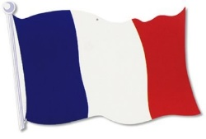
This half term we will have a special focus on France:
France is the largest country in Western Europe. It borders Germany and Belgium in the north; the Atlantic Ocean in the west and the Pyrenees Mountains and Spain in the south. France is one of the oldest nations and the most ethnically diverse country in Europe. These deep and broad influences have made France a world leader throughout history in nearly all aspects of culture, including cuisine, wine-making, politics, philosophy, music, art, film, fashion, literature, and sports. The capital of France is Paris, where you can see the Eiffel tower and the famous painting ‘The Mona Lisa’.
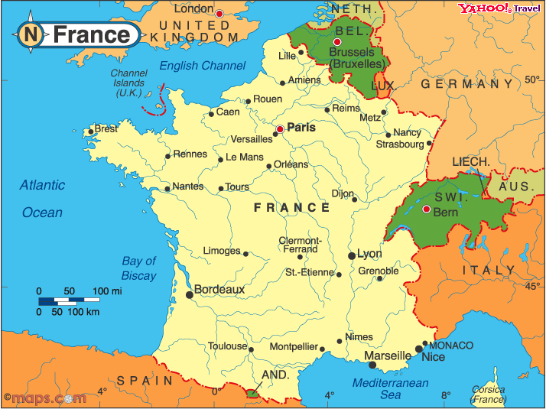
Learn French:
  - Hello: Bonjour
  - Goodbye: Au revoir
  - Thank you: Merci
French numbers
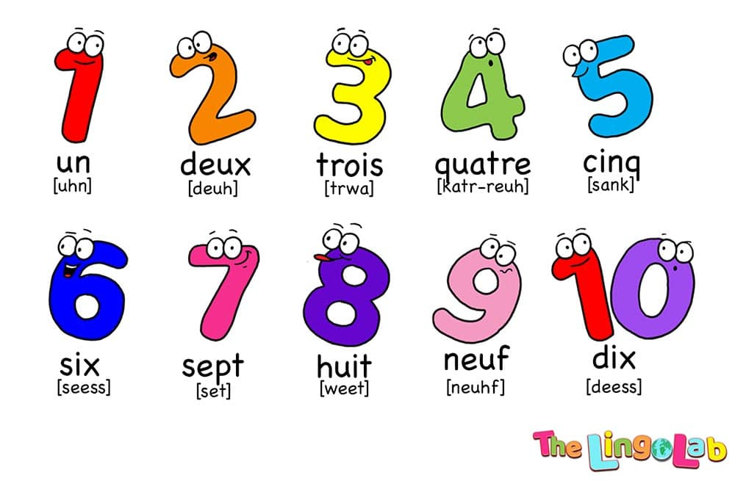

Bastille Day is celebrated on the 14th of July
Known in France as “le 14 juillet”, this is a holiday celebrating the storming of the Bastille—a military fortress and prison—on July 14, 1789, in an uprising that helped usher in the French Revolution. The celebrations in Paris start with a Military parade and end with a firework display.

Food

French food is famous worldwide and many great Chefs have trained in France. Cheese and wine are a major part of the cuisine, and vary according to different regions. Champagne comes from France and famous dishes such as Coq au Vin, Soufflé and Tarte tatin. France is also famous for its baked goods, such as Croissants and Baguettes. Another well-loved French food are crepes….

French pancakes are very thin. Sometimes they are enjoyed with savoury fillings. Crepes are very tasty, even when only sprinkled with sugar and folded.
