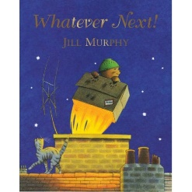
Whatever Next! By Jill Murphy

Dear Parents / Carers,
This half term our core story is Whatever Next! by Jill Murphy – a book about imagination and role play and reaching for the moon.
Baby Bear looks out of his window and asks “can I go to the moon?” and when his mum tells him he will need a rocket he finds some space boots , and a helmet and dresses up ready to fly off in his rocket (a cardboard box!). He packs a teddy 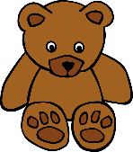 and some food 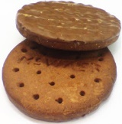 and sets off on his journey 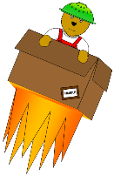. An owl flies past him on the way and they picnic 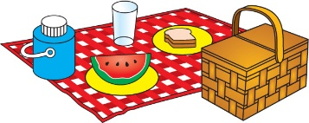together on the moon before Baby Bear flies back down the chimney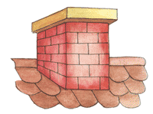 . Back at home Baby Bear is in need of a bath and ready to go to bed 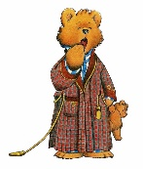.
Children often like to chat about the picture showing the bear covered in soot:
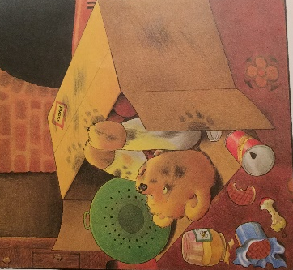
– did he really come down the chimney?! Your children no doubt have their own imaginative ideas about what to do with a cardboard box as well and probably enjoy packing up their own picnics too. Now it is dark in the evenings maybe you will spot the moon together …

The Whatever Next! “Story Sacks” are now in the library for you to borrow & enjoy at home. If you would like to do so then please sign a sack out in the green “Library Loans Record” folder in the library. There are also copies in the classroom which you are welcome to borrow.
Thank you for sharing this story with us.

