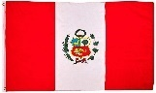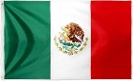This half term we will have a special focus on Spanish: 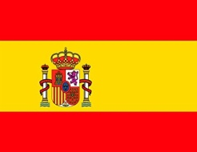 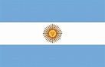
Spanish is the official language in the following countries: Argentina, Bolivia, Chile, Colombia, Costa Rica, Cuba, Dominican Republic, Ecuador, El Salvador, Equatorial Guinea, Guatemala, Honduras, Mexico, Nicaragua, Panama, Paraguay, Peru, Spain, Uruguay, and Venezuela. There are 425,000,000 Spanish speakers in the world. It is the fourth most widely spoken language.

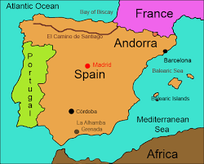 | Some key words:  - Welcome: Bienvenido  - Hello: Hola  - Goodbye: Adios  - Please: Por favor  - Thank you: Gracias

Here is a link to one of our favourite nursery rhymes, in English and in Spanish, ’Twinkle Twinkle, Little Star’, ‘Estrellita en el cielo’.

Estrellita Dónde Estás - Plim Plim - Bing video

English version: | Spanish: | Literal translation:
Twinkle Twinkle little star,  How I wonder what you are.  Up above the world so high,  Like a diamond in the sky.  Twinkle Twinkle little star,  How I wonder what you are. | Estrellita, ¿dónde estás?  Me pregunto qué serás.  En el cielo brillarás,  Un diamante de verdad,  Estrellita, ¿dónde estás?  Me pregunto qué serás. | Little star where are you?  I wonder what you are.  In the sky you will shine,  A real diamond.  Little star where are you?  I wonder what you are.

Counting:

Spanish Cuisine:
From tasty tapas to superb seafood and traditional roasts, Spanish food is all about making the most of the best local produce.
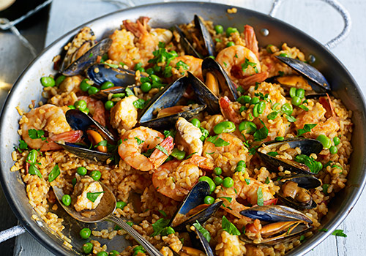 | 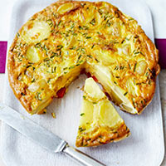 | 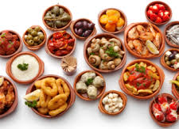
Paella  Paella is a Spanish dish of rice, saffron, chicken, seafood, etc., cooked and served in a large shallow pan. | Tortilla Española  A Spanish omelette is made from eggs, potatoes and onions and other foods can be added to suit your taste, for example, chorizo or spinach. | Spanish Tapas  Tapas are a variety of small savoury Spanish dishes, often served as a snack with drinks, or with other tapas as a meal.

Here is a recipe for a Columbian dish, Arepas de Queso (Cheese Arepas) that you might like to try at home.

Arepas de Queso (Cheese Arepas)

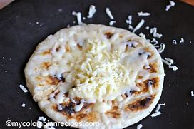 | INGREDIENTS  - 1 cup pre-cooked white or yellow arepa flour or cornmeal  - 1 cup warm water  - ⅓ cup white or mozzarella cheese grated  - 2 tbsp butter  - Pinch salt

INSTRUCTIONS
  - Combine the cornmeal, warm water, cheese, 1 tbsp butter and salt, mixing thoroughly. Let mixture stand for five minutes.
  - Knead with your hands for about 3 minutes moistening your hands with water as you work.
  - Form 4 small balls with the dough. Place each ball between 2 plastic bags and with a flat pot cover flatten to ½ inch.
  - Add the butter to a nonstick pan over medium heat. Place the arepas in the pan, and cook about 3 minutes on each side, until a crust forms or they are golden brown.

