This Photo by Unknown Author is licensed under CC BY-NC-ND
This half term we will have a special focus on Turkish:
Turkish is the most widely spoken of the Turkic languages, with around 80 to 90 million speakers. It is the national language of Türkiye and Northern Cyprus. Smaller groups of Turkish speakers also live in Germany, Austria, Bulgaria, North Macedonia, Greece, Cyprus, other parts of Europe, the Caucasus, and some parts of Central Asia, Iraq, and Syria. Turkish is the 13th most spoken language in the world. Türkiye is a diverse and dynamic country, with a rich history, culture, and cuisine.
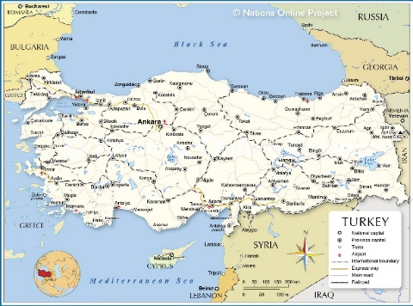

Türkiye
Learn Turkish:
Hello: Merhaba
Goodbye: Hoşçakal / Güle Güle
Please: Lütfen
Thank you: Teşekkürler

Counting:
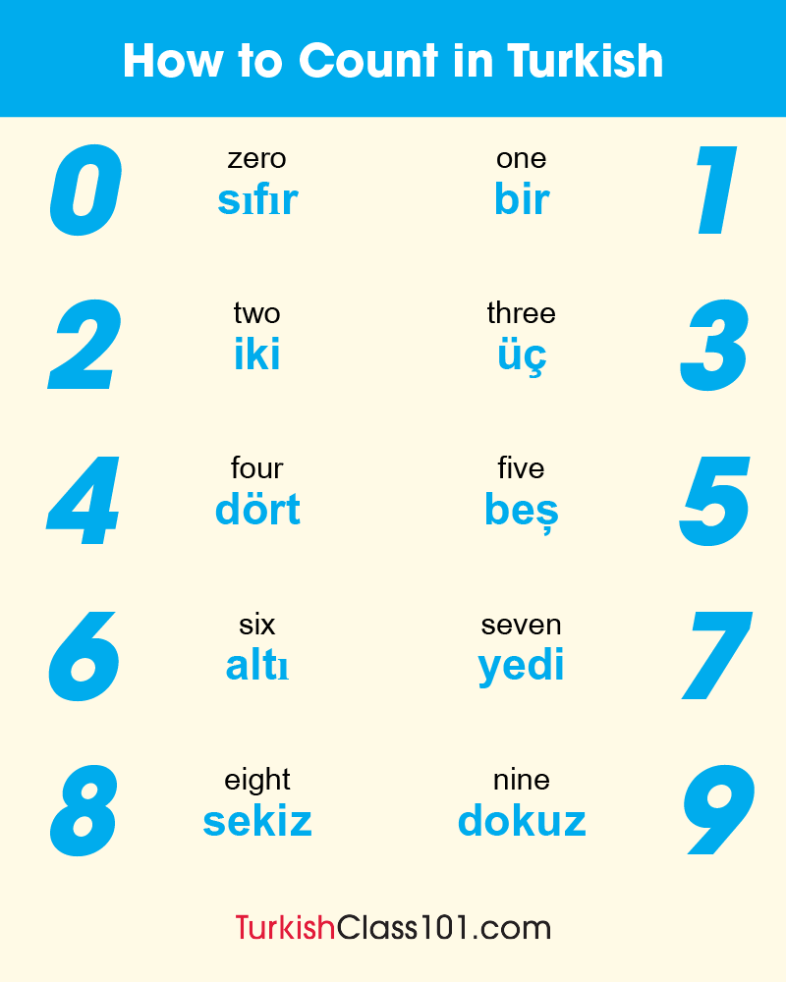

Turkish Cuisine:
Soups have held an important place in traditional Turkish cuisine for centuries. The Turkish word for soup, çorba, is derived from the Persian šurbâ, a combination of the two words’ salty’ and ‘love’.
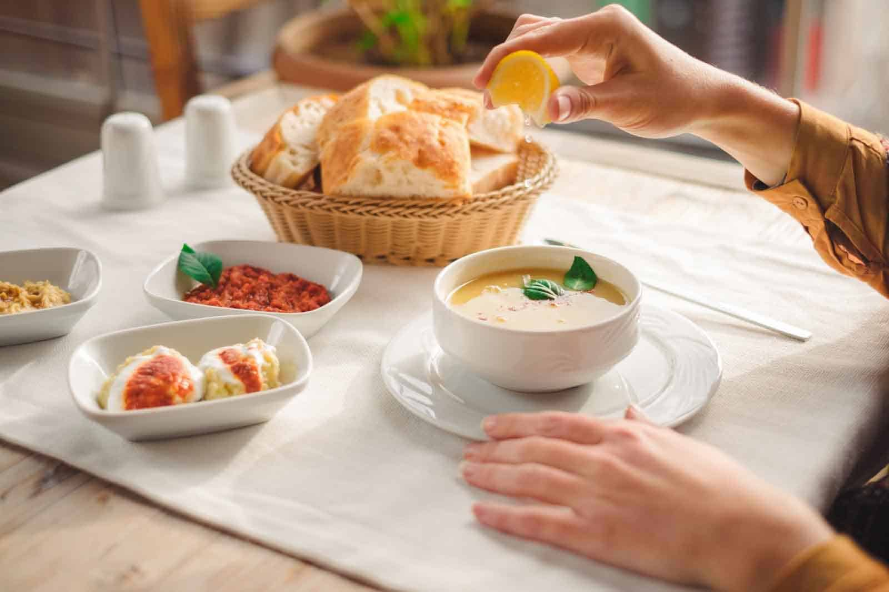
Turkish meals usually start with a bowl of soup. Turks developed many different rich varieties of soups, primarily prepared from a base of water or broth. These broths are laden with staple but nutritious ingredients to ensure a wholesome start to the meal.
In addition to being comforting and satisfying the nutritional value of most Turkish soups is quite high since many are prepared and seasoned with broths. It is said that consuming soup before the main meal ‘softens’ the stomach and gets it ready for more substantial foods. Because it is liquid, it is essential to a healthy digestive system. Therefore, it is also commonly consumed at breakfast, especially in the winter.
The richness and variety of soups found in traditional Turkish cuisine are broad. According to the main base ingredient, we can divide them into soups prepared with grains and flour, with dried legumes, with meat and offal, with chicken and other poultry meat, with yoghurt and milk, and vegetable soups.
Certain Turkish soups are prepared especially for events or holidays and served to guests. Wedding soup (düğün çorbası), Toyga soup (Toğga çorbası) and highland soup (yayla çorbası) are examples. It is also a common tradition to bring soup to a patient’s home during visits with a poorly family member or friend.

Among the most popular Turkish soups are:

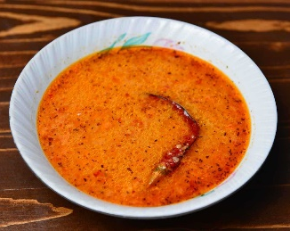
Tarhana Soup (Tarhana Çorbası)
Tarhana is made by adding vegetables, herbs and spices to yogurt before letting the mixture dry out and crushing to a powder.

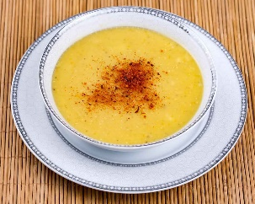
Red Lentil Soup (Mercimek Çorbası)
Mercimek çorbası, red lentil soup, is one of those flavours you will find on almost every restaurant menu in Turkey. Besides the fact that it is easy to prepare, with few ingredients and low cost, it has a wonderfully comforting flavour and is both satisfying and nutritious.

High Plateau Soup (Yayla Çorbası)
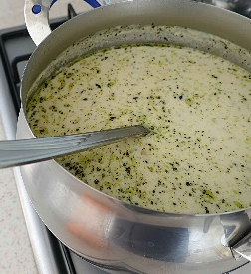
Yayla çorbası (Highland Soup) is a quintessential taste of traditional Turkish cuisine. It is easy to make, by adding some rice into a soup mixture made from yoghurt. Finally, dried mint is combined with hot oil and mixed through, bringing out the full feast of the soup’s flavours!

Recipes:
Many thanks to Jihan, mum of Alexander and Alessia who are currently in the nursery, who has very kindly provided a recipe for red lentil soup for us to try:

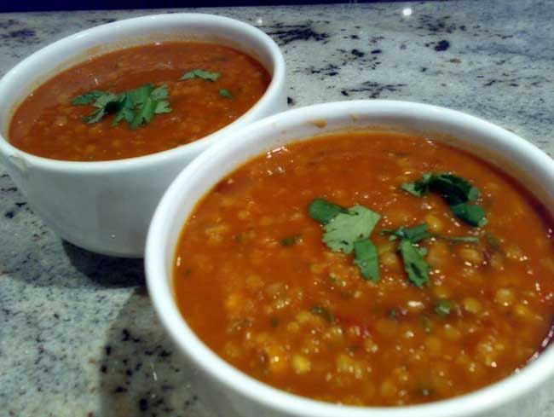
Lentil Soup
Ingredients:
- 2 litre vegetable stock
- 150g red lentils
- 3 carrots, finely chopped
- 2 medium leeks, sliced
- Small handful of chopped parsley to serve

Method:
- Heat the stock in a large pan and add lentils.
- Bring to the boil and allow the lentils to soften for a few minutes.
- Add the carrot and leeks, and season.
- Bring to the boil, then reduce the heat, cover and simmer for 45 minutes- 1 hour until the lentils have broken down.
Scatter over the parsley and serve with buttered bread if you like.

