Online Safety Policy – replaces previous E-safety policy

School Name | Homerton Early Years Centre
ICO Registration Number | Z8371500
Version Date | May 2022
Status | Approved
Date Approved | November 2022
Review Date | November 2024

Agreed and Signed by Chair of Governors
Name | Professor Ken Ong

School supported by: | GDPR DPO Service provided by The ICT Service  dpo@theictservice.org.uk | 0300 300 3000  www.theictservice.org.uk/gdpr-dpo-service  Training available upon request

Online Policy Guidance

Read and then delete this page when finalising your Policy:
This policy template contains sample text and suggested content written by The ICT Service to guide schools in developing their own online safety policy.
Where there are specific references (which may or may not apply to your school) these have been marked in blue font, with a note in red advising you to edit and complete each section as appropriate to your school.

It is essential that this policy shows your school’s ability to:
- protect and educate pupils and staff in their use of technology
- have the appropriate mechanisms to intervene and support any incident where appropriate.
(Inspecting online safety in Schools, Ofsted 2012)

This policy takes into account guidance from:
- Teaching Online Safety in Schools guidance – DfE, June 2019
- Education for a Connected World – UKCIS, June 2020
- National Curriculum in England - Computing - DFE, Sept 2014
- Relationships and Health Education – DfE, July 2020

In preparation for completing / updating your online safety policy, you may wish to make use of an auditing tool such as those found at www.theictservice.org.uk/e-safety or contact The ICT Service (info@theictservice.org.uk) for more guidance.
Contents
E-Safety Policy Guidance 1
Background to this policy 2
Rationale 3
The Online Safety Curriculum 5
Continued Professional Development 5
Mobile phones and use of 3G and 4G data in school 6
Monitoring, and averting online safety incidents 6
Responding to online safety incidents 7

Background to this policy

The purpose of this policy is to describe the safeguarding measures in place for adults and children in school in relation to online safety, including:
- The policies and practice embedded in our school and followed by the whole school community
- The infrastructure and how it is set up to keep pupils safe online, including filtering, monitoring, and preventing and responding to online safety incidents
- A progressive, relevant age-appropriate online safety curriculum for all pupils which (as a minimum) meets the requirements of the National Curriculum for Computing and the statutory Relationships and Health Education
Online safety in schools is primarily a safeguarding concern and not a technology one. Therefore, this policy should be viewed alongside other Safeguarding policies and approaches including, but not limited to:
- Safeguarding and Child Protection
- Personal Social and Emotional Development
- Safer Working Practices
- Data Protection Policy
- Anti-Bullying Policy
- School Complaints Procedure
- Cambridgeshire Progression in Computing Capability Materials
- Whistle Blowing Policy
This policy must be read alongside the staff and pupil Acceptable Use Policies attached as appendices. These AUPs outline the expectations and sanctions which apply to staff and pupil use of technology.

The development of our online safety policy involved:
- The Headteacher
- The Designated Safeguarding Lead

- Cambridgeshire Local Authority Advisor (Cambridgeshire Education ICT Service)
- The governor responsible for Safeguarding
It was presented to the governing body on and ratified on 22 November 2022 and will be formally reviewed in November 2023.
- This policy may also be partly reviewed and / or adapted in response to specific online safety incidents or developments in the school’s use of technology. It has been shared with all staff in the staff policy folder and on the website.
- All staff must be familiar with this policy and all staff and pupils must sign the relevant Acceptable Use Policy before being allowed to access school’s systems (see appendices). As Online safety is an important part of our school’s approach to safeguarding, all staff have a shared responsibility to ensure that the policy and practices are embedded. This will be monitored by the Headteacher, the Designated Safeguarding Lead and governors as appropriate.

Rationale

At Homerton Early Years Centre we believe that the use of technology in schools brings great benefits. To live, learn and work successfully in an increasingly complex and information-rich society, our children must be able to use technology effectively.
The use of these exciting and innovative technology tools in school and at home has been shown to support learning and promote pupil achievement. Yet at the same time, we recognise that the misuse of technology can put young people at risk within and outside the school.
The risks they may face can broadly be categorised into the ‘3 C’s’ Contact, Content and Conduct (Livingston and Haddon) and may include:
- Access to harmful, illegal or otherwise unsuitable content including gaming, gambling sites, sexually explicit material and websites with extremist ideologies and images
- Unauthorised access to / loss of / sharing of personal information
- The risk of being subject to grooming by those with whom they make contact on the internet, including the sharing of Self-Generated Indecent Images
- The sharing / distribution of personal images without an individual’s consent or knowledge
- Inappropriate communication / contact with others
- Cyber-bullying
- An inability to evaluate the quality, accuracy and relevance of information on the internet
- Plagiarism and copyright infringement
- Illegal downloading or streaming of music or video files
- The potential for excessive use which may impact on the social and emotional development and learning of the young person.
While children and young people need support to keep them safe online, the risks associated with the use of technology are not restricted to just them. Online safety issues can also affect adults who work or are associated with the school and this will be referenced in more detail later in this policy.
Technologies regularly used by pupils and staff include: (Edit and complete the following as appropriate)

Staff:
- Staff laptops / iPads / Chromebooks / desktops - staff devices can also be used at home in accordance with the staff AUP, particularly with regard to GDPR.
- Staff / some staff have access to school systems beyond the school building (e.g. MIS systems, cloud platforms e.g. Microsoft 365 or Google Workspace).
- Class cameras and other peripherals such as visualisers and Interactive Whiteboards
- Staff level internet access
- Anything else? Social media platforms?

Pupils:
- Curriculum laptops / iPads / Chromebooks / desktops including filtered access to the Internet and pupil level access to areas of the school network
- Cameras and peripherals including programming resources
- Cloud platforms / online tools providing pupils with access within and beyond the school gates
- Anything else?
Where the school changes the use of existing technology or introduces new technologies which may pose risks to pupils’ safety, a risk assessment will be completed to show how the risk is being mitigated and reduced to an acceptable level.

The Online Safety Curriculum

When using online technologies, it is essential that children understand how to behave in a safe and responsible manner and how to react when faced with inappropriate content or situations which make them feel uncomfortable. The need for a progressive, age appropriate online safety curriculum is clearly documented in the National Curriculum for Computing (England) and the statutory Relationship and Health Education.
At Homerton Early Years Centre we believe that a comprehensive programme of online safety education is vital for developing our pupils’ ability to use technologies safely. We believe that just as children learn how to swim by going to a swimming pool so they will learn safe life-long online behaviours by accessing and using a range of online services including the World Wide Web.
Our online safety curriculum is based on the Cambridgeshire Progression in Computing Capability Materials, and the Cambridgeshire PSHE Service Primary Personal Development Programme, with reference to UKCIS’s Education for a Connected World
This is achieved using a combination of:
- Discrete and embedded activities drawn from a selection of appropriate materials and is linked to demonstrating safe practice in our online learning platform
- Key online safety messages are delivered and reinforced through cross curricular opportunities such as emailing, researching, blogging and communicating in appropriate online environments.
- Focus events to raise the profile of online safety for our pupils and school community
- A flexible curriculum which is able to respond to new challenges as they arise.

Continued Professional Development

Staff at Homerton Early Years Centre receive up-to-date information and training on online safety in the form of staff meetings and updates from the school’s online safety and Designated Safeguarding Leads, as well as training from external providers where appropriate.
Nominated members of staff receive more in-depth online safety training to support them in keeping up to date and reviewing the school’s approach, policies and practice.
New staff receive information on the school’s acceptable use policy as part of their induction, including advice on Protecting their Professional Reputation Online.
All staff have been made aware of individual responsibilities relating to the safeguarding of children within the context of online safety and know what to do in the event of misuse of technology by any member of the school community.

Mobile phones and use of 3G and 4G data in school

Keeping Children Safe in Education (September 2020) highlights the need for schools to have a clear policy statement on, and carefully consider ‘how access to 3G and 4G data is managed on their premises’, and also how they manage the increasing risk of ‘peer on peer abuse’.
The school’s approach to this should be made clear within staff and pupil Acceptable Use Policies, but schools may also wish to include a policy statement here. Guidance to help schools formulate a statement on their approach to this can be found by clicking here and more detailed guidance is available for schools who subscribe to Cambridgeshire’s Education Safeguarding Team service. Use this guidance to formulate your policy on the use of personal mobile devices and 3G / 4G data and publish it here.
At Homerton mobile phones are only to be used in areas where there are no children present – please refer to Acceptable use of ICT policy. In exceptional circumstances the Head may use mobile phone when taking photos for the weekly bulletin, if this is necessary then these will be downloaded to photo file on Head’s computer immediately and deleted from phone.

Monitoring, and averting online safety incidents

The school keeps children safe when using online technologies through a combination of online safety education, filtering and monitoring children’s online activity and reporting incidents, including following Safeguarding procedures where appropriate.
The school’s technology infrastructure is designed to minimise the risks associated with adult and pupil use of technology. This is provided and maintained The ICT Service on behalf of the local authority. Safeguards built into the school’s infrastructure include:
- Secure, private EastNet internet connection to each school with a direct link to the National Education Network.
- Managed firewalling running Unified threat management (UTM) that provides restrictions on download of software, apps and file types from known compromised sites.
- Foundation DDoS mitigation service, security analysts carefully monitor the patterns of traffic across the network.
- Enhanced web filtering provided to all EastNet sites as standard.
- Optional SSL decryption available on web traffic to allow for greater visibility of sites being accessed and requested.
- Antivirus package provided as part of EastNet Connection.

Staff also monitor pupils’ use of technology and, specifically, their activity online. This is achieved through a combination of:
- Appropriate levels of supervision when pupils are using online technologies
- Auto-generated alerts which flag up activity in specific safeguarding categories which may raise child protection concerns
- Use of additional reporting tools to monitor and investigate pupil use of the internet
Staff use of the schools’ internet can also be monitored and investigated where needed.

A system of staff and pupil passwords is in place to enable appropriate access to the school network. (Edit and complete the following as appropriate)
- All members of staff have individual, password protected logins to the school network / cloud service / MIS systems.
- Visitors to the school can access part of the school systems using a generic visitor login and password.
- The wireless network is encrypted to the standards advised by the Local Authority and the wireless key is kept securely by the school office.
- School staff and pupils are not permitted to connect personal devices to the school’s wireless network and a guest wireless key is issued to visitors on a case by case basis.
Whilst we recognise that it is impossible to totally eliminate the risks associated with the use of technology, these safeguards are in place to help minimise these risks to an acceptable level.

Responding to online safety incidents

It is important that all members of staff – teaching and non-teaching – are aware of how to respond if an online safety incident occurs or they suspect a child is at risk through their use of technology.
- Staff responses to online safety incidents must be consistent with responses to other incidents in school. This may mean that serious actions have to be taken in some circumstances.
- If an online safety incident occurs, Homerton Early Years Centre will follow its agreed procedures for responding including internal sanctions and involvement of parents (this may include the deactivation of accounts, restricted access to systems as per the school’s AUPs or reporting incidents to the police and other authorities– see appendix).
In addition, the Education and Inspections Act 2006 empowers headteachers to such extent as is reasonable, to regulate the behaviour of pupils when they are off the school site and empowers members of staff to impose disciplinary penalties for inappropriate behaviour. This is pertinent to incidents of cyber-bullying, or other online safety incidents which may take place outside of the school but has an impact within the school community.
- With this in mind, the headteacher may decide to apply the sanctions and / or procedures in the relevant AUP to incidents which occur outside of schools if s/he deems it appropriate.
The Education Act 2011 gives school staff the powers, in some circumstances, to search personal digital devices and decide whether or not to delete data or files if the person thinks there is good reason to do so.
However, there is a risk that this could conflict with guidance about dealing with incidents where a child may be at risk where it may be inadvisable to delete, save or share content. The school will always seek to resolve areas of concern in line with safeguarding procedures, and with parents where appropriate, before taking any further action. NB: In our school, the likelihood of these types of instances occurring are already reduced as we don’t allow pupils to use personal devices in school and we are a nursery school so some of the above is not applicable to the children we teach due to their age 2 – 4.
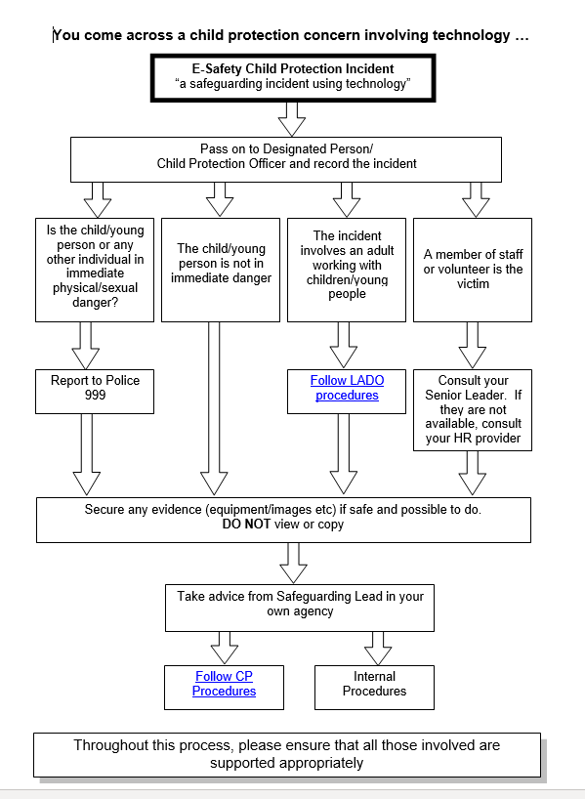
Where the school suspects that an incident may constitute a Safeguarding issue, the usual Safeguarding procedures will be followed. This process is illustrated in the diagram below.

