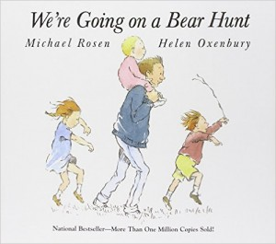
We’re going on a Bear Hunt by Michael Rosen
Dear Parents / Carers,
We welcome the summer term with an adventure story - full of delight in exploring the natural world, with a wonderful repetitive text and an ending which inspires children to offer their own interpretation of the characters’ feelings.
At the beginning of the story a family 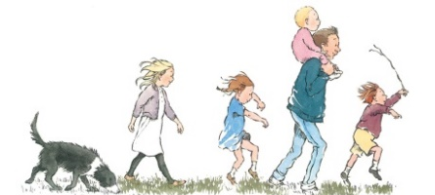set off confidently to hunt for a bear 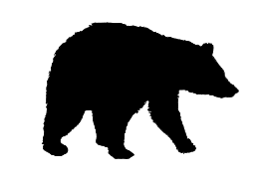 and on their way they have to push through a field of grass , wade though a river , squelch through mud 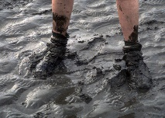, stumble through a forest 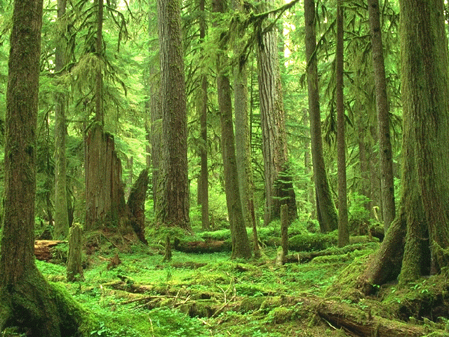 and find their way through a snowstorm 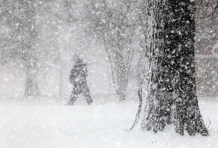 before they discover a cave with a bear 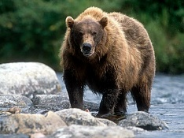 and rush home , not feeling quite so brave.
Your children are already quite familiar with this story so they might like to use these pictures to re-tell it with you. If you speak another language as well as English perhaps you can also chat at home about the story in that language too – this can help your child make sense of the story in school if English is not their first language. It would be fun for us to know the words for e.g. bear or grass or river etc. in other languages actually so please do come and share some vocabulary with us if you would like to.
You may know already that we have a “Going on a Bear Hunt” event in school is coming up soon so do look out for information about that event and we look forward to re-living this story with you then.
Thank you for sharing this story with us.

