This half term we will have a special focus on Greek: 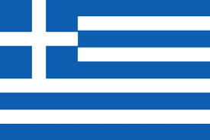
Greece has the longest coastline in Europe and is the southernmost country in Europe. The mainland has rugged mountains, forests, and lakes, but the country is well known for the thousands of islands dotting the blue Aegean Sea to the East, the Mediterranean Sea to the South, and the Ionian Sea to the West. Nearly two-thirds of the people live in large cities. Athens is the largest city, with over 3.7 million people.
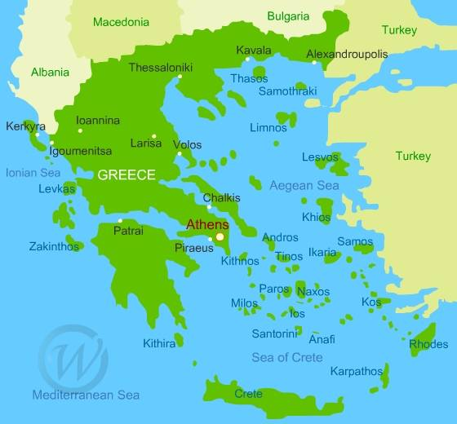

Learn Greek:
- Hello: Χαίρετε chaírete
- Goodbye: αντιο σας antio sas
- Thank you: ευχαριστώ efcharistó

We enjoy singing the days of the week song at Homerton. Have a listen to the days of the week in Greek:
https://www.youtube.com/watch?v=dLa3P76RvDg

Pascha: Easter
Did you know that Easter – or 'Pascha' in Greek – is the greatest celebration of the Eastern Orthodox Church, honoured by various customs and religious ceremonies.
A main focus of Easter Sunday is on traditional Greek Easter foods. The customary main attraction of the day is whole roasted lamb.

The dates for Greek Orthodox Easter in 2022 are:  - Good Friday - April 22.  - Holy Saturday - April 23.  - Easter Sunday or Easter Day - April 24.  - Easter Monday - April 25. | 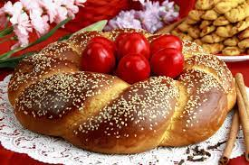

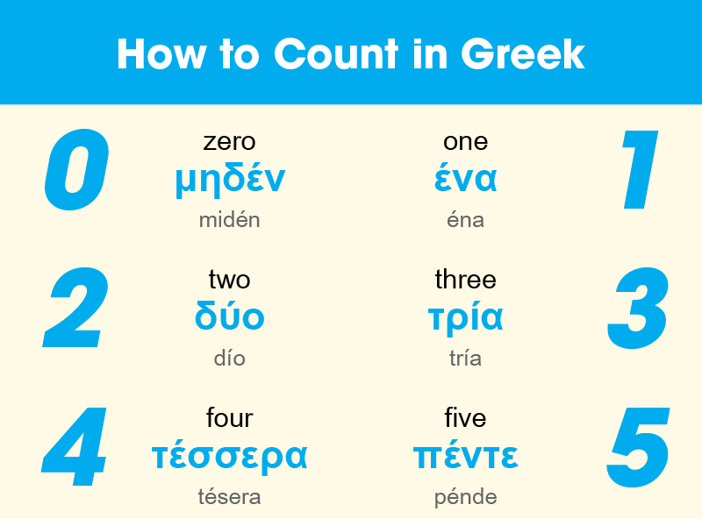

Cuisine:
Greek food uses mainly fresh local ingredients such as Mediterranean vegetables, olive oil, lemon juice, various types of fish and meat, as well as grains. Traditional Greek dishes are flavoursome and packed with a variety of fresh and dried herbs.
It would be lovely to share any Greek recipes you may have at home. If you have a Greek recipe that you would like to share please email it to the school office and we will put it on our twitter page.
Elena, mum of Orpheas who is currently at Homerton, has kindly shared the recipe for the traditional Greek dish, ‘Spanakopita’ (Spinach and Feta pie).

Spanakopita (Spinach and Feta pie)

· 1 kilo spinach  · 1 large handful cut parsley  · 1 handful cut mint  · 1 handful dill  · 3 leeks  · salt  · pepper  · 400g good quality feta cheese  · lemon zest, of 1 lemon  · 2 eggs, medium  · A splash or two of olive oil for cooking greens and about half cup for brushing on filo pastry. Better to use light olive oil as virgin olive oil can leave a bitter after taste. Alternatively, you can use melted butter.  · Filo pastry (if frozen leave in refrigerator overnight or leave outside freezer for around 1.5-2 hours). Usually 7 sheets per pack | 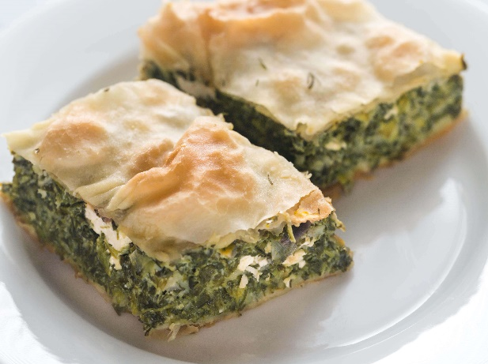

Cooking instructions
Cut the leeks and place in a pan with a little oil. Once wilted, place the parsley too. Then place the spinach. You may have to deposit spinach a little at a time, as it takes a lot of space initially, but it wilts quickly. Add a little salt (not much as the feta will also be salty) and pepper. At the very end for a minute or two stir in the mint, dill and lemon zest. Take it off the cooker and place in a colander to let the mixture cool down for a few minutes and when cool, squeeze to drain some of the excess juice.
Add the feta cheese by crumbling it and tossing it throughout the greens. Stir the eggs lightly in a cup and mix them with the greens and feta. You can use your hands to spread the eggs, feta and greens evenly.
Assembly
Place filo sheets on the bottom of a rectangular dish. In-between each sheet brush with some olive oil or butter and stack them up. The oil/butter helps it become crunchy and to get some flavour. The sheets may be too long and that is fine, let them fall out of the dish and you can turn them in at the end. Place the greens, cheese, egg mixture on top of the 3 sheets. Now take the remaining 4 sheets and brush them with olive oil or butter by stacking them on top of the greens. Any remaining sheets that extend beyond the dish can be brushed and rolled back on top and side of the pie.
Cook in the oven for 30-40 minutes at 180 degrees Celsius. Cover the dish with aluminium foil to avoid the filo catching on top. Remove foil in the last 5-10 minutes to ensure the filo gets a nice golden-brown colour. And enjoy

