This half term we will have a special focus on Chinese:
Mandarin is the official language of China, but China is not the only place in the world where people speak Mandarin. Some people in Thailand, Singapore, Malaysia and Indonesia also speak Mandarin. One of the reasons people in these countries speak Mandarin is because a lot of Chinese people live there.
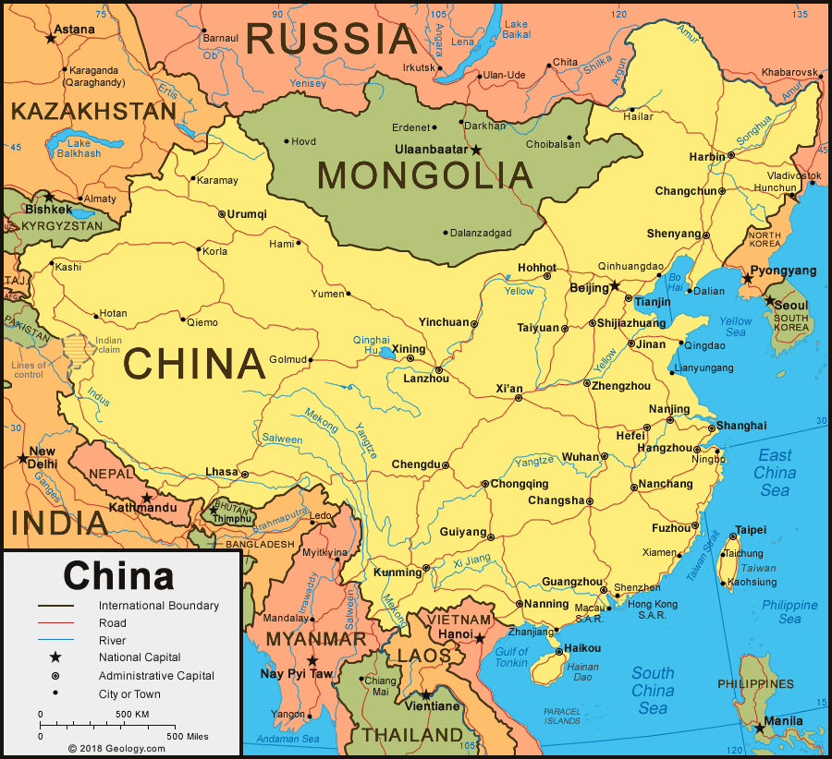 | Some key words and phrases:  - Welcome: Huanying  - Hello: Ni hao  - Goodbye: Zaijian  - Please: Qing  - Thank you: Xiexie  - Well done: Zuo de hao

 | Chinese Noodles
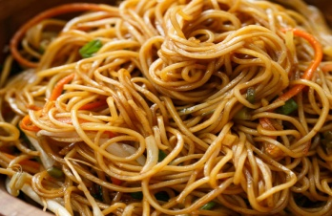 | Dong’s recipe:  Dong in West Room has often treated the staff at Homerton to her delicious noodles, and this is her recipe if you would like to try making them at home:
- Boil dry noodles following instructions on the packet and drain the water.
- Add some oil to a wok and stir fry vegetables of your choice for a couple of minutes to soften before adding the drained noodles.
- Add soy sauce to your liking and mix together.
- Lastly add a few drops of sesame oil to add flavour and stir for a few minutes before serving.
It would be lovely to share Chinese recipes you may make at home. If you have a Chinese recipe that you would like to share, please email it to the school office and we will put it on our twitter page.

The Guqin
 |  | Dong has been learning to play the guqin, a plucked seven-string Chinese musical instrument. We are very lucky because during this half term Dong will play the guquin to the children during classtime.

Lunar New Year
We will be celebrating Lunar New Year at Homerton. Lunar New Year is celebrated by many different communities across the world, especially in China, North and South Korea, Singapore, Japan and some other Asian countries. The first day of Lunar New Year begins on the new moon that appears between 21 January and 20 February. In 2022, the first day of the Lunar New Year will be on Tuesday 1st February, which is the Year of the Tiger. Our Lunar New Year celebrations will include learning about customs and traditions, mark making Chinese numerals, making and eating noodles, Chinese dragon dancing in Rainbow room, sharing the zodiac story of New Year and listening to and making music.
Here is a link to the Lunar New Year story:
https://www.youtube.com/watch?v=eVClAj8q_lY
Lunar New Year Zodiac Wheel
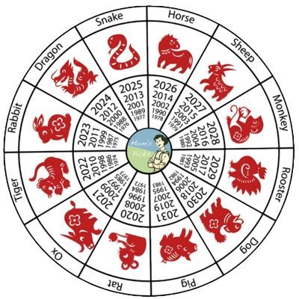

Chinese Numerals

