This half term we will have a special focus on Spanish: 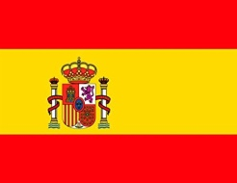
Spanish is the official language in the following countries: Argentina, Bolivia, Chile, Colombia, Costa Rica, Cuba, Dominican Republic, Ecuador, El Salvador, Equatorial Guinea, Guatemala, Honduras, Mexico, Nicaragua, Panama, Paraguay, Peru, Spain, Uruguay, and Venezuela. There are 425,000,000 Spanish speakers in the world. It is the fourth most widely spoken language.

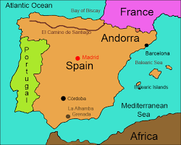 | Some key words:  - Welcome: Bienvenido  - Hello: Hola  - Goodbye: Adios  - Please: Por favor  - Thank you: Gracias

Here is a link to one of our favourite nursery rhymes, in English and in Spanish, ’Twinkle Twinkle, Little Star’, ‘Estrellita en el cielo’.  https://www.youtube.com/watch?v=W3cW6Jr4kfE | 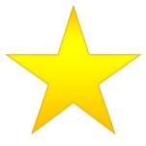

English version: | Spanish: | Literal translation:
Twinkle Twinkle little star,  How I wonder what you are.  Up above the world so high,  Like a diamond in the sky.  Twinkle Twinkle little star,  How I wonder what you are. | Estrellita, ¿dónde estás?  Me pregunto qué serás.  En el cielo brillarás,  Un diamante de verdad,  Estrellita, ¿dónde estás?  Me pregunto qué serás. | Little star where are you?  I wonder what you are.  In the sky you will shine,  A real diamond.  Little star where are you?  I wonder what you are.

Counting: | Recipes:  It would be lovely to share Spanish recipes you may make at home. If you have a Spanish recipe that you would like to share please email it to the school office and we will put it on our twitter page.  