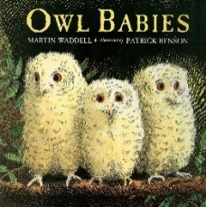
Owl Babies by Martin Waddell

Dear Parents / Carers,
In class we are enjoying reading and exploring our core story Owl Babies by Martin Waddell – a warm and reassuring book about separating from loved ones, finding ways to cope and being reunited again. A story about owls is also a nice way to start the year since the Homerton logo is an owl. In the story we encounter …
a Mummy owl 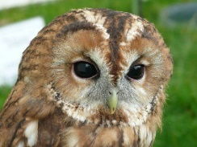 and some baby owls 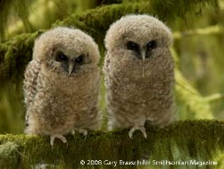 who live in a
nest 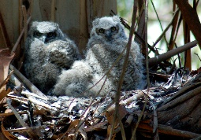 in a tree 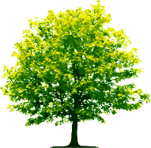. One day, the babies wake up to find their
owl mother is gone. After worrying a bit, 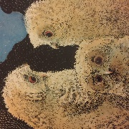 (“I want my Mummy” says Bill, the youngest owl), they guess she has gone to find some mice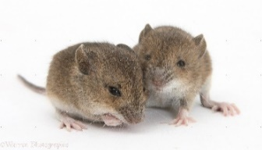to eat and she does soon comes back 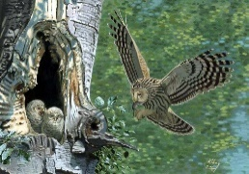 to feed them. The youngest owl is delighted to see her and ends the story saying “I love my Mummy!” 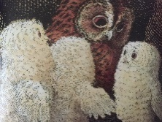 .
You and your children might like to chat about this story together – they might be able to share with you what they remember or like about the story or you could use these pictures as a prompt to talk about it.
You might also like to look at some pictures of owls in a wildlife book or online together. www.rspb.org.uk has some lovely pictures and information about owls in their Bird Guide.
Finally, there are some “Story Sacks” in the library which have a copy of the Owl Babies story which you can borrow & enjoy at home. If you would like to do so then please sign a sack out in the green “Library Loans Record” folder in the library.
Thank you for sharing this story with us.

