Holiday Club
Here is a selection of the themes, activities, events and experiences we offer this holiday club.
Monday 25th | Tuesday 26th |  | Wednesday 27th
Theme: Autumn Fun | Theme: Autumn Fun |  | Theme: Autumn Fun
Arts and Crafts:  Fruit Printing  Messy Play:  Autumn Foam  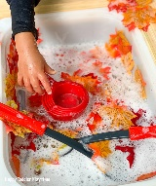  Outdoor Play:  Leaf Collecting in the  ‘Old Orchard’  Special Events:  Peppa Pig Halloween Movie  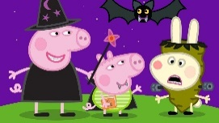 | Arts and Crafts:  Leaf Laminates  Messy Play:  Conker Rolling  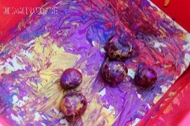  Outdoor Play:  Bike & Trike Racing  Special Events:  Park Play  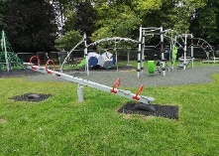 |  | Arts and Crafts:  Marbling  Messy Play:  Bug Hunt  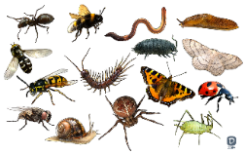  Outdoor Play:  Den Building  Special Events:  Parachute Play
Thursday 28th |  | Friday 29th
Theme: Autumn Fun |  | Theme: Autumn Fun
Arts and Crafts:  Spooky Skeletons  Messy Play:  Potion Making  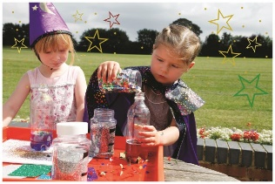  Outdoor Play:  Autumn Hunt  Special Events:  Pumpkin Carving  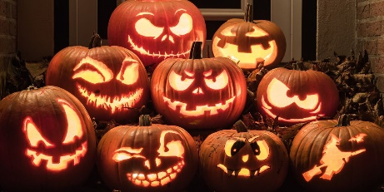 |  | Arts and Crafts:  Cat Masks  Messy Play:  Icky Sticky Slime!  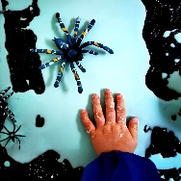  Outdoor Play:  Sandpit Treasure Hunt  Special Events:  Room on the Broom & Popcorn  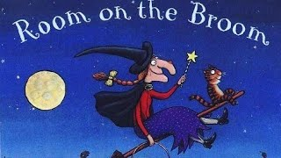
Children will be able to enjoy watching a short carefully selected children’s story which may be linked to the day’s activities at the end of the morning and afternoon sessions as a relaxation after all our fun activities.

