This half term we will have a special focus on German: 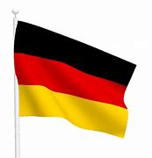
We hope you have all had an enjoyable Easter break. In Germany, many people will have enjoyed the German tradition of decorating trees and bushes with Easter eggs, known as the Ostereierbaum, or Easter egg tree. Hard boiled eggs or egg shells are decorated and then suspended with ribbons from trees, or if inside, twigs or branches set in a plant pot or bucket.
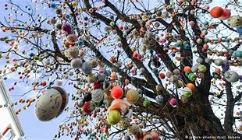

German is a native language to almost 100 million people worldwide and is spoken by a total of over 130 million people. It is the most widely spoken language in Germany, Austria, Switzerland, Liechtenstein, and the Italian province of South Tyrol. It is also spoken in other parts of the world.

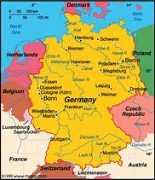 | Learn German:  - Welcome: Willkommen  - Hello: Hallo  - Goodbye: Auf Wiedersehen  - Please: Bitte  - Thank you: Vielen Dank  - Well done: Gut gemacht

Here is a link to one of our favourite songs at nursery, ‘The Wheels on the bus’, Die Räder vom Bus | The Wheels on the Bus in German | Kinderlieder Deutsch - Bing video. Maybe see if you can do the actions to go with the words as you watch.

English version: | German Version | Literal translation:
The wheels on the bus go round and round, round and round, round and round,  The wheels on the bus go round and round, all day long. | Die Räder vom Bus drehen sich rundherum, rundherum, rundherum  Die Räder vom Bus drehen sich rundherum  Den ganzen Tag. | The wheels of the bus turn all around, all around, all around,  The wheels of the bus turn all around,  The whole day.

Counting:
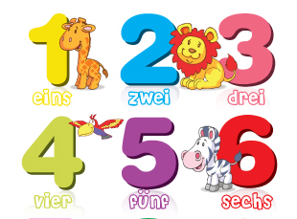

Recipes:
German Apple Cake:  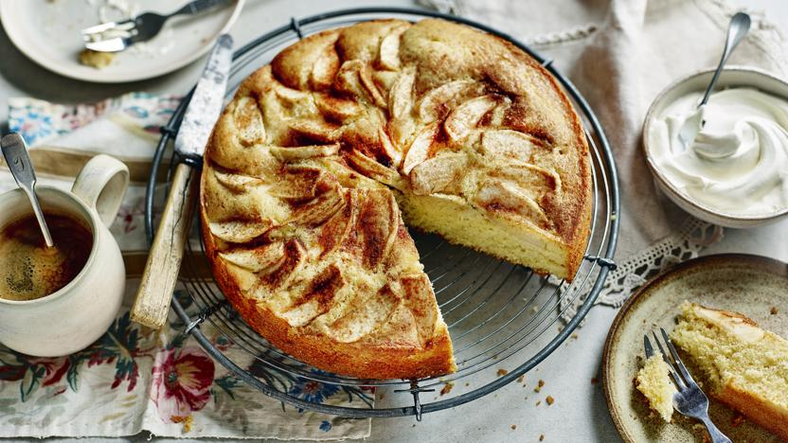 | Apple cake is revered in Germany, and tastes delicious! Maybe you might like to search for a recipe on the internet and try baking one at home!  It would be lovely to share any German recipes you may have at home. If you have a German recipe that you would like to share please email it to the school office and we will put it on our twitter page.

