German celebrations in the calendar year

The Three Kings / Epiphany (Dreikönigstag) - 6 January
This day marks the end of the Christmas period. Small groups of children dress up as the three wise men and go from door to door singing and blessing houses for the new year with a chalk inscription. They are known as the star singers (Sternsinger), as the leader carries a star.
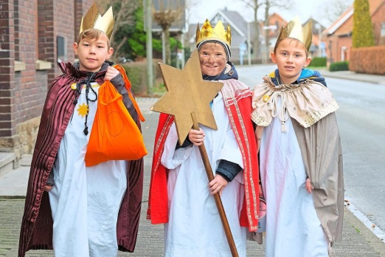

Carnival - usually in February
Known under different names (Karneval/ Fasching/ Fastelavend/ Fasenacht/...) and celebrated in different ways in different regions, especially in the Catholic areas of the Rhineland and in the South of Germany. Also known as the Fifth Season.
Preparations start in November (on 11/11 at 11:11h), but the main celebrations usually take place in February, in the week before Ash Wednesday (which falls exactly 46 days before Easter Sunday). Everyone dresses up and there are lots of parties, processions and other celebrations.
Carnival starts on Thursday with people dressing up for Weiberfastnacht (Women's carnival), and then there are normally big parades on Carnival Sunday and Rose Monday (Rosenmontag) during which lots of sweets are thrown from floats and caught by those watching. There is more partying (and drinking) on Shrove Tuesday and then everything finishes on Ash Wednesday, which marks the start of Lent. Krapfen (doughnuts, also known as Berliner in some places) are a traditional food of the carnival season.
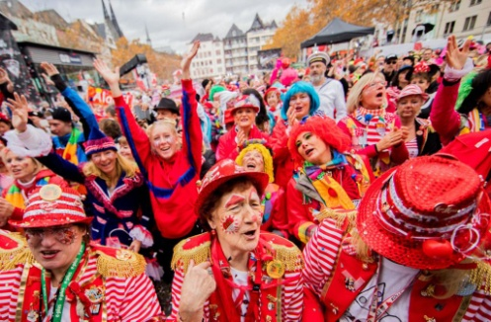

Easter - March/ April
Like here, an important day in the Christian calendar. Children hunt for Easter eggs in the garden (which have been hidden by the Easter bunny - the Osterhase) and a special Easter meal (often lamb) is prepared.
In the run up to Easter, children paint Easter eggs (the contents of which have been blown out through tiny pin prick holes) and many families put up an Osterstrauch (an Easter shrub - lots of spring branches in a vase) decorated with painted eggs.
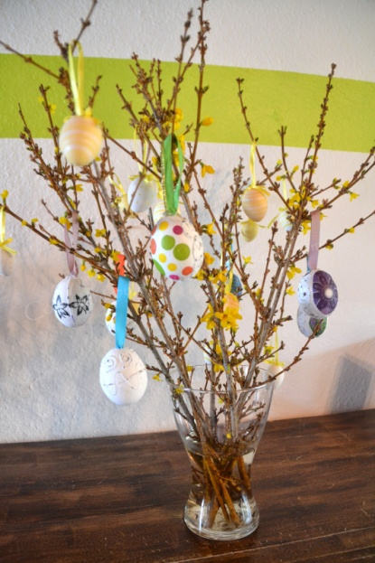
On Maundy Thursday (Gründonnerstag - green Thursday) many families will eat a special meal of 'green sauce' (a creamy white sauce made with eggs and herbs) with potatoes.

Maifeiertag - 1 May
May 1 is still an important public holiday in Germany, and there are a number of different customs practised in the different regions. Many towns and villages (especially in the South) erect a Maibaum (a May tree or maypole) decorated with colourful ribbons and streamers to welcome spring, while in some places communities will try to steal each others' trees for ransom (beer and food).
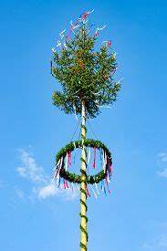
In other areas people put up May trees outside the house of the person they love.
In many regions May day celebrations start on the evening of 30 April, with the pagan Witches Night (Walpurgisnacht) and Dance into May celebrations.

Harvest festival - September
Many nurseries and schools will celebrate a harvest festival.

Saint Martin's day - 11 November
Children make their own paper lanterns and take part in candle lit lantern processions around their local area (normally with their schools or nurseries), singing Saint Martin's day songs (about lanterns and Saint Martin). The festival is in memory of Saint Martin, a Roman soldier who, legend has it, shared his cloak with a beggar during a snowstorm and became the patron saint of the poor. The procession is often led by a rider on a horse dressed as Saint Martin, and finishes with a bonfire and a special baked treat. In some areas, children then go from door to door and sing in return for candy (Martinssingen).
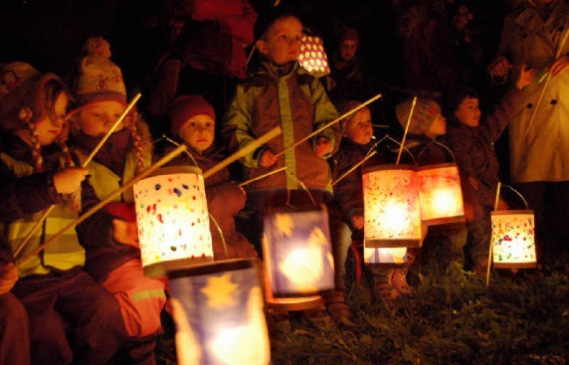

Advent - December
Advent marks the countdown to Christmas, and begins on the fourth Sunday before Christmas (i.e. in late November or early December). Children are given an Advent calendar and many families set up an Advent wreath (Adventskranz), which is made of fir branches and decorated with four candles, one for each week of advent. The first candle is lit on the first Sunday of advent, with an additional candle lit each Sunday thereafter until all four candles are lit on the last Sunday before Christmas. Traditionally, this was the main Christmas decoration until the Christmas tree was decorated on Christmas Eve.
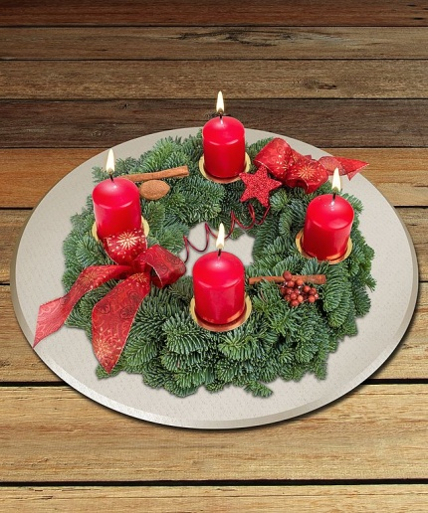

Saint Nicholas day (Nikolaustag) - 6 December
On 6 December, children receive a small gift, some fruit, nuts and chocolate from Saint Nicholas, the patron saint of children. There are quite a few different Saint Nicholas traditions, but generally they either involve children polishing their boots and putting them by the door on the night of 5 December for Saint Nicholas to fill them overnight, or a real life visit by someone dressed as Saint Nicholas at nursery, school or home. Sometimes Saint Nicholas is accompanied by a helper, Knecht Ruprecht (also known under many different names), who traditionally used to be quite a scary figure that frightened little children.

Christmas - Heiligabend - 24 December
The main Christmas celebration in Germany takes place on Christmas Eve (Heiligabend - holy night). The Christkind (the angel-like Christ child) leaves gifts under the Christmas tree (Tannenbaum) and after a special evening meal (often duck or goose) it is time for opening the presents ("Bescherung"- gifting). Many families use the Christmas days, 25 and 26 December, to meet up with other relatives.

New Year's Eve - Silvester - 31 December
After an evening of celebrations and perhaps melting a bit of lead over a candle and pouring it into cold water to predict your future (Bleigiessen), many people set off their own fireworks at midnight in the streets and wish each other "Guten Rutsch" (a good slide into the new year) or "Prost Neujahr".
Around New Year, some people give little good luck charms of ladybirds, pigs, four leaf clover, lucky mushrooms, chimney sweeps or horseshoes to their friends and family.
