This half term we will have a special focus on Italian:
Italian is spoken by 57.7 million people in Italy with a total worldwide 64 million speakers in 29 countries. Italian is the national, or de facto national, language of Italy, San Marino, Vatican City, Switzerland, and some areas of Slovenia and Croatia.
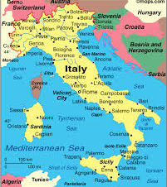 | Learn Italian:  - Welcome: Benvenuti  - Hello: Ciao  - Goodbye: Arrivederci  - Please: Per favore  - Thank you: Grazie  - Well done: Bravi

Here is a link to one of our favourite nursery rhymes, in English and in Italian, ’Twinkle Twinkle, Little Star’; ‘Brilla brilla una stellina’: Brilla Brilla la Stellina - Canzoni per bambini di Coccole Sonore - Bing video

English version: | Italian: | Literal translation:
Twinkle Twinkle little star,  How I wonder what you are.  Up above the world so high,  Like a diamond in the sky.  Twinkle Twinkle little star,  How I wonder what you are. | Brilla brilla una stellina  Su nel cielo piccolina.  Brilla brilla sopra noi,  Mi domando tu chi sei.  Brilla brilla la stellina,  Ora tu sei più vicina. | Twinkle, twinkle, little star  So small up in the sky  You shine, shine above us  How I wonder what you are  Twinkle, twinkle, little star  Now you are much closer.

Counting:

Recipes:
It would be lovely to share Italian recipes you may make at home. If you have an Italian recipe that you would like to share please email it to the school office and we will put it on our twitter page.
Antonella’s Tiramisu:
Antonella has often treated the staff at Homerton to her delicious tiramisu, and this is her recipe if you would like to try making it at home:

Ingredients:  - 4 eggs  - 5 tablespoons of sugar  - 2 x 250grams mascarpone cheese  - 2 x 200 grams savoiardi (ladyfingers)  - 1 tablespoon Rum  - Cocoa  - Pinch of salt  - Expresso Coffee | 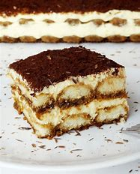
Make expresso coffee and let it cool.
Mix together the egg yolks and sugar until they are white and creamy. Then add the mascarpone cheese until smooth, creamy and combined. Add the rum and the whisked egg whites with a pinch of salt. Next dip savoiardi (lady fingers) in espresso and arrange in the bottom of a baking dish until fully covered. Then spread a part of the mascarpone mixture on top until evenly covered. Repeat the processbof dipping lady fingers, arranging them in the dish, and spreading mascarpone cheese on top one more time. Wrap the dish with plastic wrap and chill in the fridge for about 8-12 hours. Before serving, dust with cocoa. Buon Appetito!

Carnevale!
Carnevale is the last celebration before Lent begins on Ash Wednesday. Every town, even the smallest has its own ‘Carnevale’ parade. Every village celebrates, every family cooks up ‘frittelle’, ‘chiacchiere’, ‘castagnole’, to honour a century long tradition of dancing, masquerading and feasting. Children dress up in their favourite costumes and throw confetti at each other.

