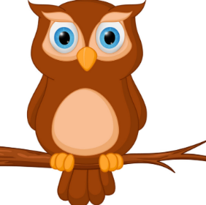
Homerton home-school planning ideas Week beginning 1st February 2021
We hope you are all safe and well. Here are some ideas to keep you entertained and busy. Do them however suits you best or interests your child.
Don’t forget to join us for Zoom circle time. Have a lovely week! 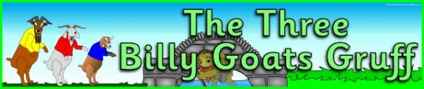 We are going to learn lots about Bridges and Number 3 and Goats!!!
Monday 1st Feb | Tuesday 2nd Feb | Wednesday 3rd Feb | Thursday4th Feb | Friday 5th Feb
Happy New Month!!  Learn a new nursery rhyme.  Or sing some of your favourites as you dance or do the actions. | Choose some new food to try, an exotic fruit or a new vegetable. or do some cooking with a grown up | Plant some grass seed in a shallow tray indoors or other seeds if you have them, (Cosmos or sweet peas are good) or plant an apple pip or tomatoes seeds and see what happens | Make a troll from an old sock puppet or recycled materials | Explore books or the internet to find out all about goats, what they eat and where they live and how any different colours and horns do they have. Soon you might be able to go out and see some!!!
Share the story of 3 Billy Goats Gruff, if you have the story book or on YouTube.  Get to know it well!! | See if you can build a great big bridge out of lego or duplo. Or make a bridge between objects in the house with a grown up helping. Or go outside and do some building with recycled materials or wood and bricks. | Go for a bike ride or scooter ride and see how many bridges you can find, over the river, over a road, over the railway. For walking or bikes or cars.  Cherry Hinton Hall, Railway station, Addenbookes, the River.  ’ Go on a Bridge Hunt’  Look up about Bridges in Cambridge | Make a bridge for your troll to hide under, or play hide and seek with your troll in your home. | Look at all the different clocks in your house and see if they have numbers on? Do they tell the same time?!!!!
Can you draw a map or bridge or another story picture | Play I spy.  Listen carefully for the initial sound of the object or give another clue. | Play a board game or a dice game.  Count the dots on the di carefully. | Find 3 sets of small, medium and large of the same object. E.g Saucepans, shoes, plates, or boxes.  How many other words can you think of for small, medium and large? | Play “What’s the time Mr Wolf”  Mr Wolf may call a clock time (e.g., "3 o'clock"). The other players will then take that many steps, counting them aloud as they go ("One, two, three"). Then they ask the question again. Mr Wolf may call "Dinner time!"/"Lunch Time", when Mr Wolf will turn around and chase the other players back to their starting point.

