We hope you are all safe and well. Here are some ideas to keep you entertained and busy. Please feel free to do these activities as well as following your child’s interests
Week beginning 8th February 2021
Follow Homerton on Twitter Homerton EYC and join Circle times on Zoom
Monday 8th February | Tuesday 9th  February | Wednesday 10th February | Thursday 11th  February | Friday 12th  February
Have fun playing musical bumps – when the music stops you need to sit down as quickly as possible! | Have fun with your family with a song some of you may know from Homerton: Stand up, sit down:  Sticky Kids - Stand Up, Sit Down - Bing video | Choose objects or toys from your home to make a story about e.g. Teddy finding a friend and going on an adventure. What will they get up to? | Can you have a go at getting dressed all by yourself today! What clothes will you choose? | Use chalks to make some pavement art.
Read the story of Chinese New Year if you have it at home or watch it via this link:  CBeebies | Chinese New Year (Lunar New Year) | Zodiac Story - YouTube | Make a Chinese Dragon using for example a cardboard box or an egg box and sticking on red or orange items or using paint.  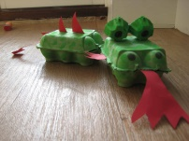 | Have a go at mark making and saying Chinese numerals from 1 to 5. | Learn a little bit about Chinese New Year and maybe do your own dragon dance!  CBeebies: Celebrating Chinese New Year - Let's Celebrate - Bing video | Maybe eat some Chinese food, such as noodles or Spring Rolls to celebrate Chinese New Year.
Can you make and design a place mat for you or a family member to use at dinner time today?  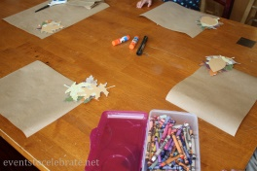 | Can you find objects round your home that rhyme e.g. clock and sock, mat and hat, ted and bed. How many can you find? | Try out cosmic yoga with the story of Cracker the dragon of Wonder:  Cracker The Dragon Of Wonder | A Cosmic Kids Yoga Adventure! - Bing video | Make some music using household objects, such as a wooden spoon and a saucepan, or make a shaker using rice or pasta and a container such as a yoghurt pot. | On February 14th it is Valentine’s Day. Maybe you could make a card for a family member you haven’t see for a while, or one you live with to show them how much you care about them.

