We hope you are all safe and well. Here are some ideas to keep you entertained and busy. Please feel free to do these activities as well as following your child’s interests.
Follow Homerton on Twitter HomertonEYC and join Wednesday Circle Times on Zoom Week beginning 25th January 2021.
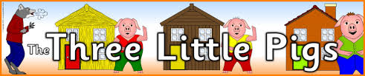
Monday 25th January | Tuesday 26th January | Wednesday 27th January | Thursday 28th January | Friday 29th January
Share the story of The Three Little Pigs if you have the story book or find the story on YouTube. | Make a model out of Lego, blocks or recycling materials.  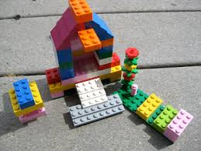 | Go on a shape hunt inside and outside. How many objects of each shape can you find? Eg a rectangle door, a circle clock… | Play snakes and ladders (printable game attached). Talk about the importance of taking turns and how this is fair. | Explore books or the internet to find out all about pigs, what they eat and where they live.
Can you draw or paint a picture of a house that the Three Little Pigs could live in. | Go for a walk and listen together. Talk about the sounds you have heard. | Build a house or den using materials you can find at home. Could the wolf huff and puff your house down? | Play hide and seek with a teddy. Practice counting together and use positional language clues to find teddy. Eg “teddy is next to/behind/in front of…” | Go for a walk and see how many different types of houses you can see.
Go on a colour hunt. How many objects of each colour can you find? | Tell a grown-up the story of Three Little Pigs. Remember to use different voices for the characters, you could even act out the story together. | Help prepare a healthy meal and set the table.  How many knives, forks, plates…do you need?  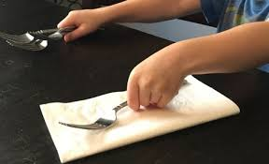 | Put some music on and make up a dance. | Can you find three things at home that begin with the same sound as your name?

