We hope you are all safe and well. Here are some ideas to keep you entertained and busy. Please feel free to do these activities as well as following your child’s interests
Week beginning 11 January 2021
Follow Homerton on Twitter Homerton EYC and join Circle times on Zoom (information coming soon!)
******REMEMBER Reception Class applications due in by January 15th 2021******
Monday 11th January | Tuesday 12th January | Wednesday 13th January | Thursday 14th January | Friday 15th January
Help to do some domestic jobs around the house, maybe the washing up, or dusting or laying the table or hoovering!! | Make some playdough  https://www.bbcgoodfood.com/howto/guide/playdough-recipe  use home cooking tools to mould and shape it. | Make a den, indoors under the table, behind the settee or in bed, using a sheet a few pegs and a broom handle.  If it’s cold and snowy play in the snow. ANY DAY!!!!! | Cook some soup or cheese straws for a meal and be a waiter to help serve it. | Write a letter or draw a picture to post to a relative to show you care and are thinking about them.  Learn about addresses and stamps and post-box.  (If you can’t go out give a picture to say Hello to a neighbour)
Sing some songs or  dance to your hearts content!! | Listen to a favourite story, using your own books or listen to one on YouTube, then act out the story yourself | Go for a walk and look out for all the numbers 1 to 10, on doors, cars, road signs, shops, noticeboards | Make a lego model and make up a story about your construction. | Make a stick picture or collect some other natural objects to make a collage.  If you’re staying in use some recycling to make model
Play a board game or dice game | If you have some chalk make a hopscotch  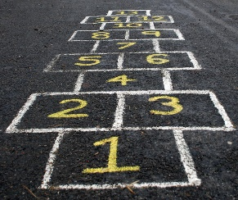 | Do an exercise video e.g. Joe Wicks.  Sit as still as you can for a minute and listen to the sounds or silence | Go for a walk and look out for every colour in the Rainbow.  Or look out your window and count different colours you can see and how they change at different times of the day, | Play a ball game outside, throwing, and catching, kicking, or rolling or knocking down skittles or target practice into a bucket.

