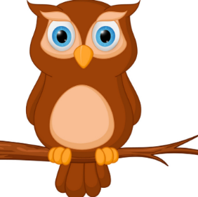
Homerton home-school planning ideas Week beginning 6th July 2020
We hope you are all safe and well. Here are some ideas to keep you entertained and busy.
Don’t forget to join us for Zoom circle time at 10am Thursday for Nursery and 10am Friday for Nest.
Have a lovely week!
Monday 6th July | Tuesday 7th July | Wednesday 8th July | Thursday 9th July | Friday 10th July
Paper plate weaving.  Cut a hole in the centre of a paper plate. Use a hole punch to make holes around the edge. Use some ribbon, wool or strips of fabric to weave in and out of the holes. | Feely game.  Put something inside a shopping bag and ask someone to put their hand in and guess what is inside using only touch. | Magic pictures.  Draw a picture using a white crayon or a plain white wax candle. Press very firmly. Then use some fairly watery paint and, using a soft brush, paint over what you have drawn. Your picture will then magically appear. | Make a mobile.  Find two sticks and tie them together with string to make a cross. Then decide on a theme and draw lots of pictures to cut out and hang from the sticks. You could make a mobile of your family. | 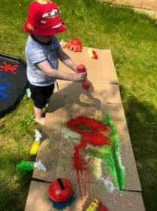  Why not have a go at painting or mark making on a larger scale.
Sorting activity.  If you have any buttons or beads at home, have a go at sorting them into groups by colour, size or shape.  Or if you don’t have either of these things, you could gather some socks together and sort them into matching pairs. | Make your own marble run.  Recycle clean food containers and tubes to make a magnificent marble run,  Set up different slopes for your marbles to travel down. Experiment with shapes and heights and see if you how you can make your marble travel faster. | Ask an adult to find you some glass jars. Fill them with different amounts of water (add food colouring if you have it). Listen to the different sounds they make as you gently tap them with a spoon. Why not see if you can make up a song? | 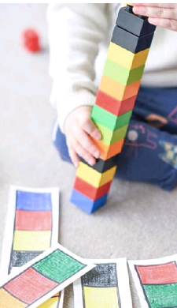  Ask an adult to draw a pattern of colours for you and see if you can copy it using Lego. | Have a game of I-spy with your family or friends.
Keep the balloon up game.  Throw a balloon up in the air and see how long you can keep it up there using your hands, head and feet. | Get some sponges and a bucket of water and use them to throw at a wall or fence and see what designs you can make. | Avoid the shark game. Tape dish cloths to the floor as your ‘safe islands’. See if you can jump from one to another so you don’t get eaten by the shark. | Good old fashioned egg and spoon race! Ask an adult to boil an egg for you and find a spoon to balance it on. See how far you can walk without the egg falling off the spoon. Race a friend/family member | Find some sticks or wooden spoons and ask an adult to tape a length of ribbon to them. Have fun doing a ribbon dance and making shapes in the air.

