Some ideas for Homerton home and school planning Week beginning 22nd June 2020
Monday 22nd June | Tuesday 23rd June | Wednesday 24th June | Thursday 25th June | Friday 26th June
Play a sorting game together. Sort some household objects into categories maybe by size or colour – count the objects when you have finished sorting. | Paint or draw a picture. | 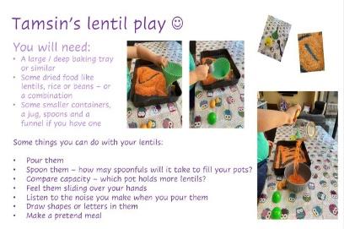  Larger version attached | Put some music on and make up a dance. | Make a den inside or outside using sheets, blankets, or anything else you can find! Why not read your favourite story in your den when it is finished.
Sing some of your favourite songs – don’t forget the actions too! | Virtual Museum – visit the Natural History Museum in London and take a look around! Find out about creatures that were around long, long ago  https://www.nhm.ac.uk/visit/virtual-museum.html | Help your grown up to do a job in the house eg sort the washing, make your bed or set the table for dinner. | Go for a local walk – how many things can you spot that begin with the same sound as your name? | Help to prepare a healthy picnic lunch – will you eat your picnic inside or outside?
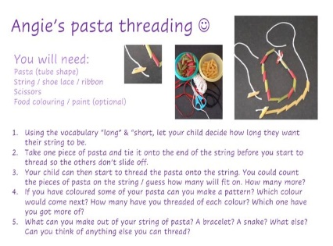  Larger version attached. | Make a model using Lego, Duplo or other building blocks. Or use recycling to create your model. | Play a turn taking game with your family. Talk about the importance of taking turns and how this is fair. | Design and make an obsiticle course at home or in the garden. How fast can you complete it? | 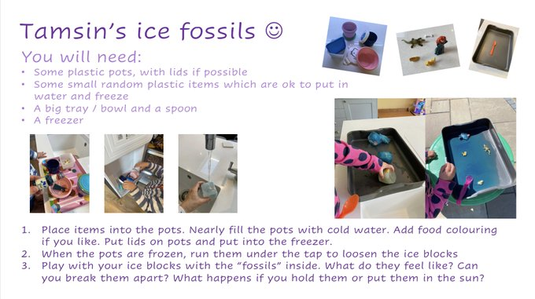  Larger version attached.
Some links to online activities:
For all links please check settings are child friendly and safe viewing first

- https://hungrylittleminds.campaign.gov.uk/
- Lots of great ideas to help engage with children at home and chat, play & read together. The activities are in age groups from 0-5 years and there is also a list of quality approved apps that support language and communication development.

- https://www.youtube.com/watch?v=-8o8wMgAT-Y
- Daily physical activities with Joe Wicks

- https://small-talk.org.uk/
- Small Talk is another website from the National Literacy Trust with lots of ideas to help develop language and communication skills at home for ages 0-5.

- https://www.playfulchildhoods.wales/ideas-for-play-things-to-do
- Playful childhoods that are fun and cheap to do using things you have around the house.

Follow Homerton on Twitter:

https://twitter.com/HomertonEYC

Join Homerton staff for Nursery or Nest circle times on Zoom at 10am:

Thursday – Nursery Friday – Nest

