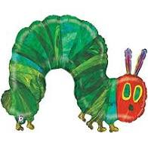 | Homerton home and school planning: Eric Carle:  ‘The Very Hungry Caterpillar’ & ‘The Very Busy Spider’  Remember: These are just ideas to hopefully give some inspiration.  For all links please check settings are child friendly and safe viewing first. | 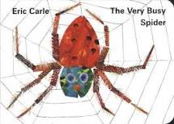

Monday 15 June | Tuesday 16 June |  | Wednesday 17 June | Thursday 18 June | Friday 19 June
The Very Hungry Caterpillar by Eric Carle: read by Antonella on our twitter link https://twitter.com/HomertonEYC (April 24)  And another version:  https://www.youtube.com/watch?v=75NQK-Sm1YY | This week you could go on a yoga adventure: The Very Hungry Caterpillar https://www.youtube.com/watch?v=xhWDiQRrC1Y |  | Use an old sock to make your own caterpillar. https://www.youtube.com/watch?v=xNfJVvH4MNE  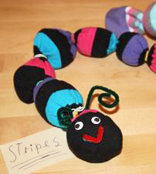 | The Very Busy Spider By Eric Carle: https://www.youtube.com/watch?v=TfL0g-XRxnA&t=24s  Can you remember all the animals that the very busy spider meets? Maybe draw a picture of one of them. | When you go on your daily walk you could do a mini beast hunt. This week we have had caterpillars, butterflies and spiders in our stories – I wonder if you’ll spot any of these? (There is a minibeast hunt sheet attached to the email.)
Mark make or draw pictures of some of the food that the Hungry Caterpillar ate. Talk to your family about what everyone’s favourite food is. Maybe try a food that you haven’t tried before.  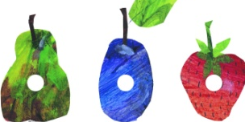 | Think about some of your favourite foods and mark make a shopping list. A family member could take it to the shops with them when they go. |  | Make a card or book mark for Daddy or another special man such as Grandad or Uncle to celebrate Father’s Day on Sunday.  Maybe draw a picture of something you love doing with them on the card. | You could follow these dances https://www.youtube.com/watch?v=tHOMIy0VCoY  or https://www.youtube.com/watch?v=30wD6Al8Yw0 or create your own dance to the Nursery Rhyme Incy Wincy.Spider. | Play a movement game – take it in turns to call out an animal or minibeast and your family have to move like that animal. You could also change the game so you move like an animal and everyone else has to guess which animal you are.
On a butterfly template, paint half of the butterfly – when you have finished – fold your painting over so that your butterfly is symmetrical. You could put this in your window for people to see on their daily walks.  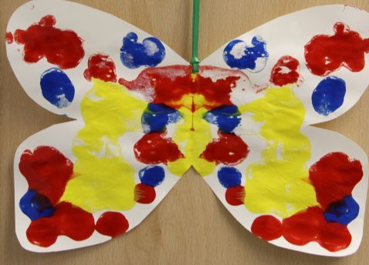 | Make a collage butterfly or caterpillar. Collage art is created by cutting different pieces of paper into different shapes and sticking them onto paper or card, sometimes with other resources like buttons or bottle tops to create a picture. (Carle paints acrylic paint on top of tissue paper, and then uses the dried tissue paper to create his collages.) |  | Explore printing circular shapes with junk modelling e.g. milk bottle top, yoghurt pot, cardboard tube, to make patterns:  https://www.carlemuseum.org/blogs/making-art/toddler-art-exploration-printing-circles-found-objects  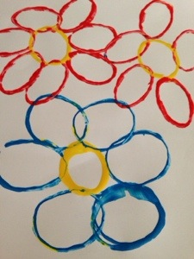 | Eric Carle uses bright colours and shapes in his illustrations, can you create some of your own animals in this style.  Or maybe you could create your own spider with a section of an egg box and 8 strips of paper or pipe cleaners for the legs.  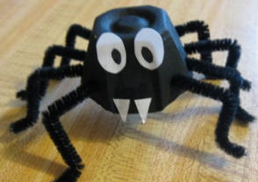 | Can you think of a job at home you can do to help your grown ups, such as tidying your toys away or helping to lay the table. How do you feel after you have done this job? How does it make your grown up feel?  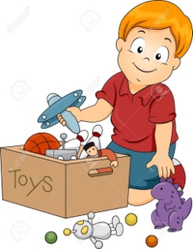
Life cycle of a butterfly: https://www.youtube.com/watch?v=3kZD6rlSLUw

ZOOM TIMES AND DAYS |  |  |  | Zoom Circle Time:  All Nursery Children at 10am | Zoom Circle Time:  All Nest Children at 10am

