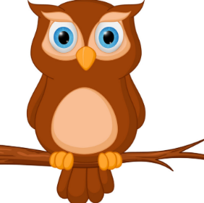
Homerton home-school planning ideas Week beginning 8th June 2020
Things are a little different this week as some of us will be back at Homerton, but wherever you are, you can still have fun having a go at these activities.
Don’t forget Zoom sessions are changing slightly too – Thursdays at 10am will be for Nursery and Fridays at 10am for The Nest. We look forward to seeing you there.
Stay safe and happy and have a lovely week!
Monday 8th June | Tuesday 9th June | Wednesday 10th June | Thursday 11th June | Friday 12th June
You could make some sock puppets and put on a puppet show for someone.  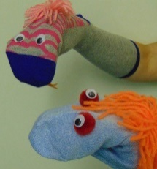 | Have a look around inside and outside. See if you can spot any interesting patterns and make rubbings of them using crayons and paper. | Make some jewellery using pasta and string. Can you count how many pieces you use to make a bracelet or a necklace?  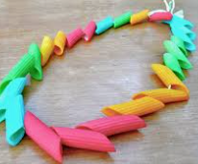  You could also  paint them. | Colour scavenger hunt.  Choose a colour and see if you can fill a bucket with things that are red, blue etc. Maybe have a competition with someone and see who can find the most. | Make a number collage. Write a number on a piece of paper and then stick that number of buttons, pasta pieces or whatever you can find onto the paper around the number. See if you can work from 1 all the way up to 10!
Change some words to a nursery rhyme that you know and sing it to someone.  ‘Hickory dickory dock, the mouse ran up the sock’ | Gather some toys together and use them to act out a story you know, for example ‘Goldilocks and the three bears’. | Find your favourite book which you know really well, get your pyjamas on, snuggle up under a blanket and read a teddy or doll a bedtime story. | Cut up some pieces of string. Can you then put them in order of length starting with the shortest? | Describe an animal to someone and see if they can guess what animal you are thinking of.
Ask someone to time you for 30 seconds and count how many jumps or hops you can do in that time. | Try some challenges – how far can you walk with a book on your head, how long can you balance on one leg for? Make up your own challenges. | Make a ramp for your toy vehicles, use books or anything flat that you can find. See which vehicle travels furthest. Why not see if you can measure it? | Make your own obstacle course and see how long it takes to get round it. Ask a friend or family member to try it too. | Pretend to be an animal – how does it move, what sound does it make?

