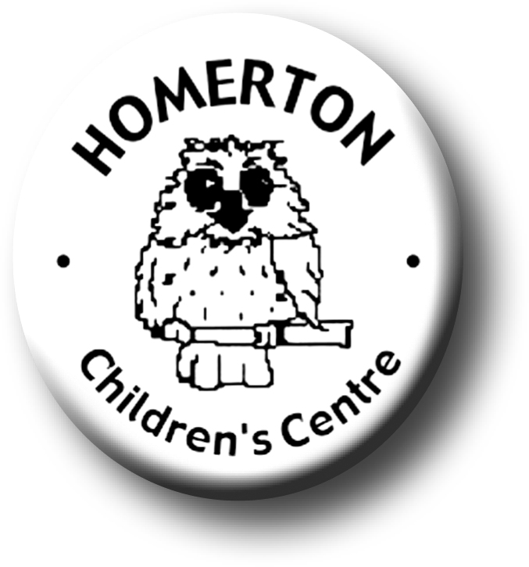
Medium Term Plans The Nest Summer 2

We follow the national Early Years Foundation Stage curriculum and The Characteristics of Effective Learning (see overarching Curriculum document).
www.foundationyears.org.uk
Positive relationships
A unique child

- Transition visits to Homerton Nursery.
- Celebrating key festivals e.g. Father’s Day.
- Parent events – New parent and child Drop-ins.
- Parent and carers volunteering.
- End of year summary and Special Books go home.
- Goodbye event

- Transitions – Exploring and extending boundaries safely, growing in confidence.
- Developing independence e.g. drinking, sunhats, rest and shade.
- Developing self-control, making choices and behaving appropriately.

Learning and development
Enabling environments

- Mini-beasts and Life cycles; caterpillars to butterflies, bug hunting.
- Growing and harvesting.
- Continuous provision – use opportunities to extend mark making opportunities outdoors, den making, planting and growing.
- Exploring with bare feet e.g. sandpit, water from hose pipe.
- Developing communication and social skills by sharing news with friends at Circle time and snack table.
- Learning though our core books eg Monkey Puzzle and Zog by Julia Donaldson.
- Remembering/retelling stories or parts of stories together.
- Music – Play instruments with favourite songs and rhymes.
- Continue to develop fine motor control e.g. mark making in a range of media, weaving, using small equipment.
- Developing balance and control and body awareness – Coordination through ball skills.
- Talking about past and future experiences.

ECAT

