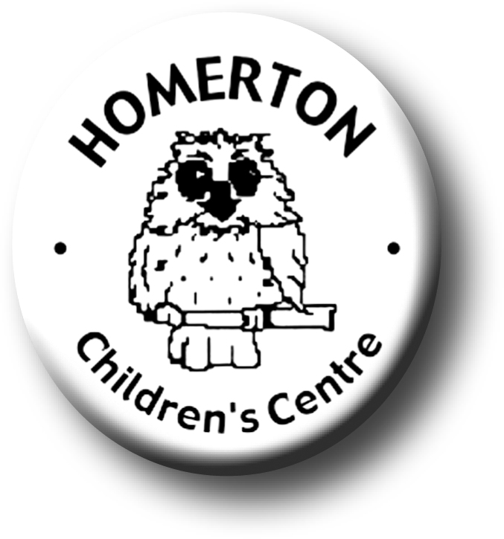
Medium Term Plans Summer 2

We follow the Early Years Foundation Stage curriculum and The Characteristics of Effective Learning (see overarching Curriculum document).
www.foundationyears.org.uk
Positive relationships
A unique child

- Transitions – Exploring and extending boundaries safely, growing in confidence.
- Developing independence e.g. drinking, sunhats, rest and shade.
- Developing self-control, making choices and behaving appropriately.
- Develop confidence to have a go and persevere.
- Using the language of thinking; think, know, remember, find out, forget, idea, makes sense, learn, figure out, trying to do.
- Supporting children’s interests over time, reminding them of previous approaches and encouraging them to make connections.
- Following the Staying Safe programme

- Transition visits to Morley and other schools and reception teachers to Homerton.
- “Maths on the Back” for home loans.
- Celebrating key festivals e.g. Father’s Day.
- Parent events – New parent and child Drop-ins.
- Parent and carers volunteering and visitors sharing experiences.
- End of year summary and Special Books go home.
- Reflecting on what has been learnt and enjoyed most at Homerton – places, people, activities and skills.
- Goodbye event at Homerton.

Learning and development
Enabling environments

- Mini-beasts and Life cycles; caterpillars to butterflies, bug hunting.
- Growing and harvesting.
- Road and cycle safety.
- Extend technical skills and problem solving e.g. use of cameras and iPads (extending uses), building, constructing, den making.
- Continuous provision – use opportunities to extend literacy skills and knowledge; mark making opportunities outdoors, den making, planting and growing.
- Exploring with bare feet e.g. sandpit, water from hose pipe.
- Sharing news with friends at Circle time and snack table and discussing favourite areas/activities at Homerton.
- Visits out e.g. allotment, park, library, Wandlebury.

- Learning though our core books eg “The Hungry Caterpillar” by Eric Carle.
- Understanding elements of story, sequencing and predicting outcomes.
- Music –Experience basic music concepts through mark making and beginning own compositions.
- Cooking – harvesting potatoes.
- Continue to develop fine motor control e.g. mark making in a range of media indoors and out, sewing, weaving, using small equipment.
- Developing balance and control and body awareness – Coordination through ball skills.
- Talking about past and future experiences.

ECAT

ECAT

