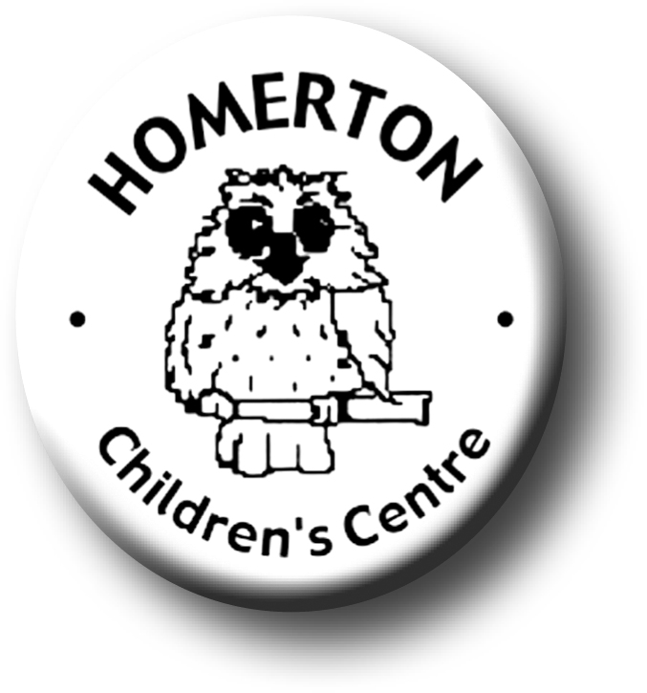
Medium Term Plans Summer 1
We follow the Early Years Foundation Stage curriculum and The Characteristics of Effective Learning (see overarching Curriculum document).
www.foundationyears.org.uk
Positive relationships
A unique child

- Developing sensitivity to the needs of others.
- Boundaries and behaviour; self-control and independence, working together and taking turns, sharing fairly.
- Celebrating key festivals e.g. St. George’s Day, May Day.
- Encouraging healthy lifestyles through “Walk to school week”.
- Parent events – “We’re Going on a Bear Hunt”, “Really wheelie Trail”.
- Parent and carers volunteering and visitors sharing experiences.
- Introduce “Maths on the Back” for home loans.
- School photographer taking individual, class and informal photos.

- Developing awareness of own needs, views and feelings.
- Develop child’s own voice e.g. reflecting on learning, discussing likes and dislikes, exploring ideas.
- Help children to develop their own goals, make plans, review their own progresses and successes.
- Encourage each child to learn together and from each other.
- Encourage open ended thinking by asking for example“Is there another way?”, “What else is possible?” etc.
- Model “Plan, do, review”.
- Following the Staying Safe programme ‘Out and About’.

Learning and development
Enabling environments

- Learning though our core books eg “We’re Going on a Bear Hunt” by Michael Rosen.
- Anticipating and joining in with repeated phrases and chanting repeated refrains.
- Telling and creating stories through use of puppets and props.
- Learning about growth e.g. plants, ourselves, animals & insects.
- Music – working with partners, identify well known songs through melody only, recognise short & long sounds through movement.
- Develop fine motor control e.g. mark making in a range of media indoors and out, sewing, weaving, using small equipment, cooking.
- Developing balance and control and body awareness – Moving in a variety of ways.
- Help children expand on what they say using more complex sentences.

ECAT

ECAT
- Planting – observing and experimenting.
- Continuous provision – use opportunities to extend mathematical skills and knowledge; den making, planting and growing.
- Maths toolkits – used in planning, constructing and creating, model uses.
- Extend knowledge of the world though pond and digging areas, additional stimulus and activities.
- Children sharing Special Books, reviewing past experiences.
- Visits out e.g. allotment, planting seeds, park.

