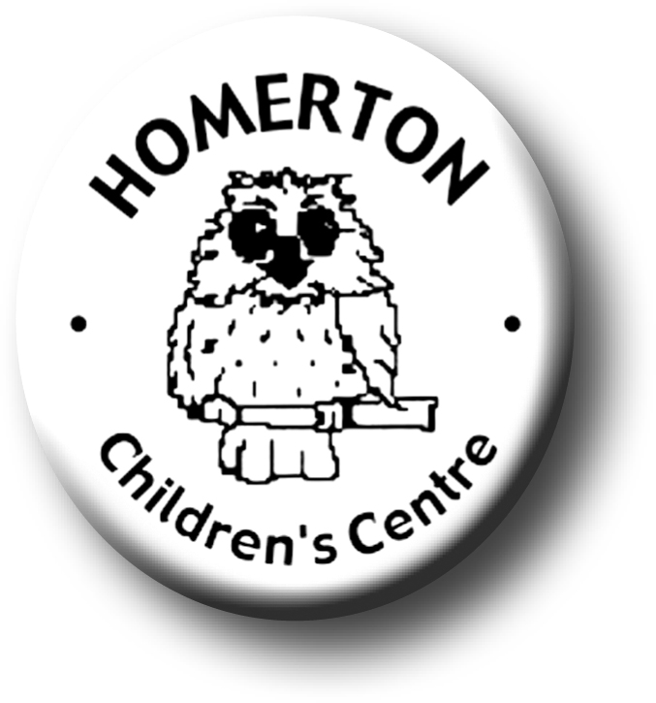
Medium Term Plans The Nest Spring 2

We follow the national Early Years Foundation Stage curriculum and The Characteristics of Effective Learning (see overarching Curriculum document).
www.foundationyears.org.uk
Positive relationships
A unique child

- Model and involve children in finding solutions to problems and conflicts.
- Celebrating key festivals e.g. Shrove Tuesday, Mothering Sunday, World Book Day, Easter.
- Parent event – Eggstravaganza.
- Parent and carers volunteering.

- Use photo boards or similar for children to be able to talk about their friends; who’s here today? etc.
- Developing play and learning through children’s interests.
- Planning for individual children’s next steps in development.
- Encouraging children to use all their senses.
- Building on independence skills e.g. completing a self chosen task.

Learning and development
Enabling environments

- Explore and observe changes to the weather, day light, new life, life cycles and growth (links to hatching chicks and caterpillars).
- Continuous provision – Ask open ended questions to encourage speaking and thinking skills.
- Tidying up – use opportunities to sort, match, categorise and count.
- Interactive display – stimulate common interests
- Develop vocabulary through interactive displays.
- Learning though our core books – Traditional tales.
- Explore change in materials e.g. water, paint, clay, cooking.
- Music – continue to learn some favourite songs and nursery rhymes by heart.
- Children contribute ideas to planning some experiences; what would they like in the sand, role-play area, to cook etc.

