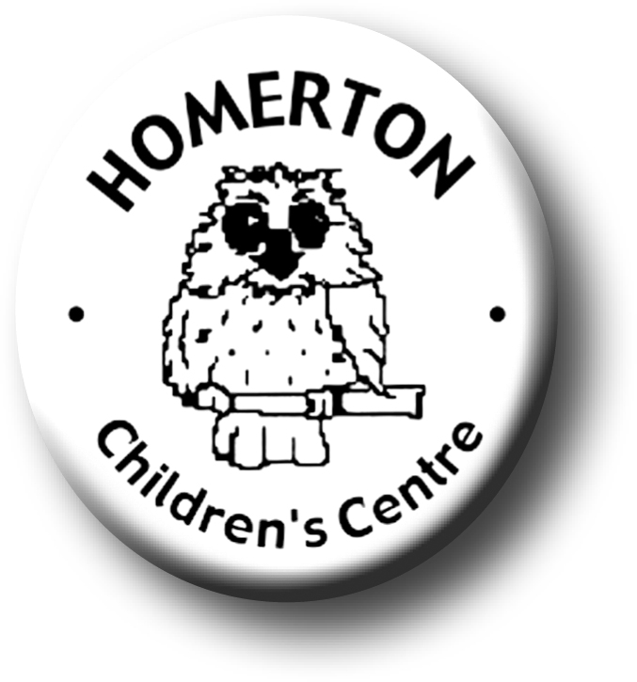
Medium Term Plans Spring 2

We follow the Early Years Foundation Stage curriculum and The Characteristics of Effective Learning (see overarching Curriculum document).
www.foundationyears.org.uk
Positive relationships
A unique child

- Use circle times for recalling stories about when they felt sad, lonely, excited etc.
- Model and involve children in finding solutions to problems and conflicts.
- Encourage children to think about the viewpoints of others.
- Celebrating key festivals e.g. St. David’s Day, St. Patricks Day, Shrove Tuesday, Holi, Science festival at University of Cambridge, Mothering Sunday, World Book Day, Easter.
- Parent event – Eggstravaganza.
- Parent and carers volunteering and visitors sharing experiences.

- Use photo boards or similar for children to be able to share feelings with others.
- Developing play and learning through children’s interests.
- Planning for individual children’s next steps in development.
- Encouraging children to use all their senses.
- Building on independence skills e.g. completing a self chosen task.
- Following the Staying Safe programme “Friends”.
- Supporting children in assessing their own risk.

Learning and development
Enabling environments

- Explore and observe changes to the weather, day light, new life, life cycles and growth (links to tadpoles, hatching chicks and caterpillars).
- Continuous provision – use opportunities to explore initial sounds relevant and interesting to children e.g. own name, days of the week, guessing games.
- Tidying up – use opportunities to sort, match, categorise and count.
- Interactive display – nature table, hatching chicks.
- Develop vocabulary through interactive displays.
- Visits out e.g. allotment, planting potatoes, park.

- Learning though our core books eg, Handa’s Hen by Eileen Browne
- Enjoy and recite repeated refrains in familiar stories.
- Explore change in materials e.g. water, paint, clay, cooking.
- Develop dance e.g. Irish dancing for St. Patrick’s day.
- Calculate and problem solve through practical daily routines e.g. register, snack, tidying up
- Music - Identify well-known songs through melody only, Clap rhythm of syllables of words e.g. names, fruits.
- Developing balance and control and body awareness – moving with a partner
- Children’s Individual ideas shared and used in planning.
- Book token and book start packs given to children.

ECAT

ECAT

