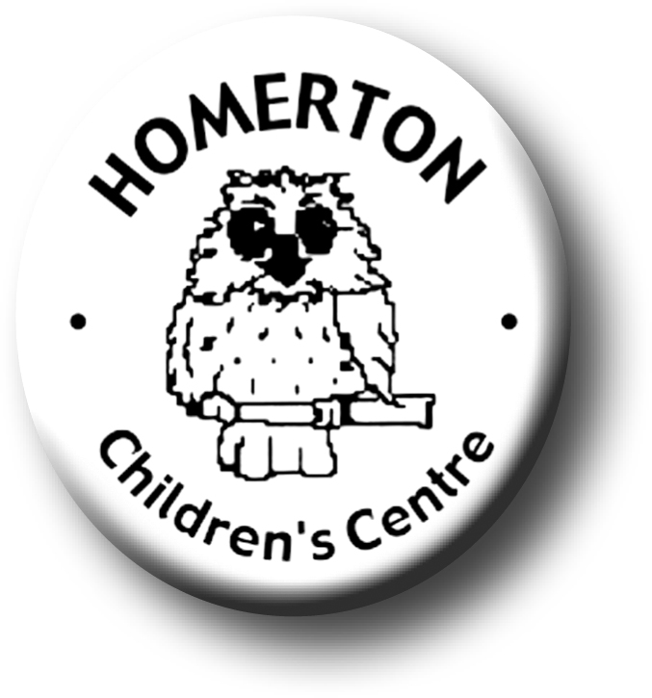
Medium Term Plans The Nest Spring 1

We follow the national Early Years Foundation Stage curriculum and The Characteristics of Effective Learning (see overarching Curriculum document).
www.foundationyears.org.uk
Positive relationships
A unique child

- Continue to develop learning to share.
- Name and talk about feelings helping children to recognise when they and others are sad or cross.
- Celebrating key festivals e.g. Chinese new year, Valentines day.
- Soft toy owl visit homes to encourage children to talk about their lives.
- Parents evening and parents survey.
- Extending how children learn e.g. finding out and exploring, being involved and concentrating and choosing ways to do things.
- Planning for individual children’s next steps in development.
- Developing independence through separating confidently, finding name card, accessing favourite resources, washing hands, toileting, etc.
- Children sharing Special books to celebrate what they know and can do.

Learning and development
Enabling environments

- Circle time, developing listening and attention
- Responding to the weather through exploring and questioning e.g. ice melting, freezing.
- Continuous provision – enhance through additional resources in response to children’s interests.
- Continuous provision – develop skills in using small and large equipment e.g. balancing and building with blocks, digging with spades, using glue for sticking etc.
- Conversation stimuli use talking table mats and photographs at snack table.

- Learning though our core books eg Dear Zoo by Rod Campbell.
- Introduce cooking activities including helping to prepare snacks.
- Learn some nursery rhymes or favourite phrases/songs by heart.
- Develop cooperative and pretend play in the role play area
- Develop of communication skills with use the role play area to talk about familiar events e.g. shopping, having tea etc.

