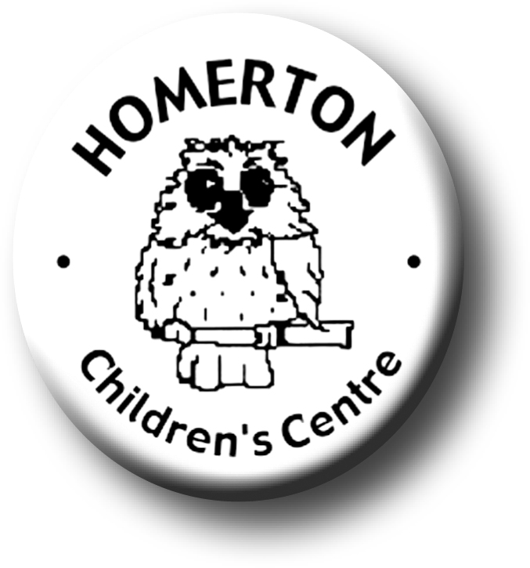
Medium Term Plans The Nest Autumn 2

We follow the national Early Years Foundation Stage curriculum and The Characteristics of Effective Learning (see overarching Curriculum document).
www.foundationyears.org.uk
Positive relationships
A unique child

- Building friendships.
- Learning to share.
- Celebrating key festivals e.g. Light festivals, Christmas.
- Parent event - Christmas Story Trail for families and Christmas raffle.
- Open evening for parents with a talk about learning and play.
- Library book loans for lunch times.
- Parent and carers volunteering.

- Developing confidence
- Continuing to get to know what children can do and enjoy through playing with children, observations and talking with parents.
- Planning for individual children’s next steps in development.
- Developing play and learning through children’s interests.
- Encouraging children to use all their senses.
- Supporting children in assessing their own risk.

Learning and development
Enabling environments

- Learning though our core books eg Stick Man by Julia Donaldson.
- Joining in with adult led sessions e.g. conker rolling, planting bulbs.
- Self –registering with name card including at snack time.
- Music – develop clapping a ‘beat’ using different parts of the body and resources.
- Developing communication and social skills - adults modelling ways to talk to our friends.

ECAT
- Learning daily and weekly routines.
- Continuous provision – expand to include range of equipment and materials accessible as skills are taught e.g. talking postcards, paint other creative media, parachute and ring games, action songs and rhymes.
- Planting bulbs and playing outdoors in all weathers.
- Building confidence in managing the environment.
- Developing vocabulary both inside and outdoors.

