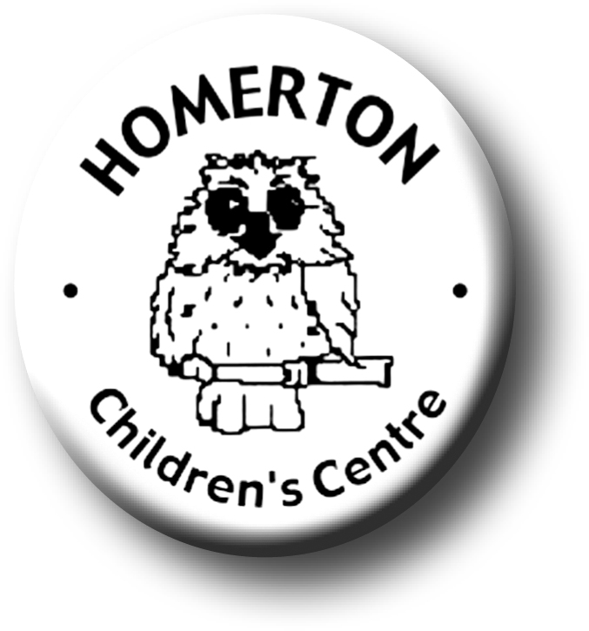
Medium Term Plans Autumn 2
We follow the Early Years Foundation Stage curriculum and The Characteristics of Effective Learning (see overarching Curriculum document).
www.foundationyears.org.uk
Positive relationships
A unique child

- Developing confidence
- Continuing to get to know what children can do and enjoy through playing with children, observations and talking with parents.
- Planning for individual children’s interests and next steps in development through ‘Planning in the Moment’.
- Self–registering with name card, one way into reading and writing.
- Developing play and learning through children’s interests.
- Encouraging children to use all their senses.
- Building on independence skills e.g. completing a self chosen task.
- Following the Staying Safe programme “All about me”.
- Supporting children in assessing their own risk.

- Continuing to build relationships with staff across Homerton.
- Building friendships.
- Learning to respect and take care of each other.
- Being polite to each other and developing shared values.
- Celebrating key festivals e.g. Light festivals, Christmas, Mill Road Winter Fair, Christmas play for children.
- Involving parents in ‘Planning in the Moment’ discussions about their child’s interests and ways they learn.
- Parent events - Messy play, Christmas Story Trail for families and Christmas raffle.
- Open evening for parents with a talk about learning and play.
- Library book loans begin.
- Parent and carers volunteering and visitors sharing experiences.

Enabling environments
Learning and development
- Learning daily and weekly routines.
- Continuous provision – expand to include range of equipment and materials accessible as skills are taught e.g. ICT, woodwork, paint other creative media, maths toolkit, parachute and ring games, action songs and rhymes.
- Beginning to manage winter clothing independently.
- Planting bulbs and playing outdoors in all weathers.
- Building confidence in managing the environment.
- Visits out e.g. allotment, park, old orchard – collecting apples etc
- Develop vocabulary through use of labels and images indoors and outside.

- Learning through our range of core books eg “Whatever Next” by Gill Murphy.
- Core story sack loans for home
- Joining in with adult led sessions e.g. conker rolling, planting bulbs, drawing myself.
- Cooking together, preparing snack, spreading skills.
- Music - Copy similar short rhythmic patterns, recognise short and long sounds, listen to a wide range of music
- Developing balance and control and body awareness – moving cooperatively in a group and developing awareness of space.
- Adults support language development by modelling ways to talk to our friends.
- Building listening skills using Letters and Sounds phase 1.

ECAT

ECAT

