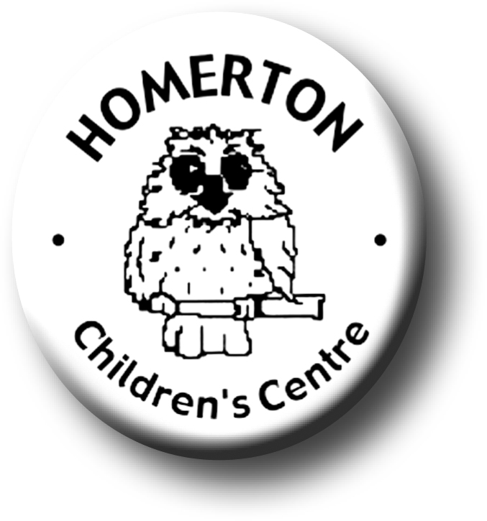
Medium Term Plans The Nest Autumn 1

We follow the national Early Years Foundation Stage curriculum and The Characteristics of Effective Learning (see overarching Curriculum document).
www.foundationyears.org.uk
Positive relationships
A unique child

- Getting to know each other through home visits and supporting children as they make the transition to Homerton Nursery.
- Sharing “All about me” books to get to know about our families.
- Getting to know staff in The Nest, particularly key people.
- Learning to behave in a range of situations.
- Celebrating key festivals e.g. Harvest festival, Diwali.

- Settling in and separating from carers.
- Getting to know what children can do and what they enjoy through playing with children, observations and talking with parents.
- Developing independence e.g. washing hands, accessing resources, snack and lunch routines, choosing where to play and who to play with.

Learning and development
Enabling environments

- Introducing Special Books.
- Learning routines and expectations for group times e.g. snack, singing together.
- Developing friendships.
- Learning to move safely indoors and out negotiating new spaces.
- Speaking and listening – Talking about ourselves by sharing our “All about me” books.

- Becoming familiar with the environment.
- Sand, water, construction, creating and making, books, music, role play, malleable materials, mark making, small world.
- Learning where things are indoors and out and where to put things.
- Learning daily routines.

