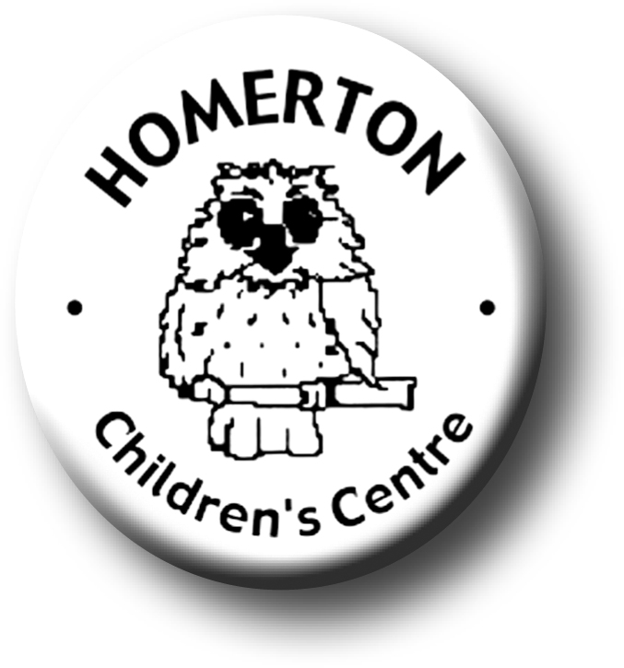
Medium Term Plans Autumn 1

We follow the Early Years Foundation Stage curriculum and The Characteristics of Effective Learning (see overarching Curriculum document).
www.foundationyears.org.uk
Positive relationships
A unique child

- Settling in and separating from parents/carers.
- Self-registration with name card.
- Getting to know what children can do and what they enjoy through playing with children, observations and talking with parents.
- Developing independence e.g. toileting, washing hands, accessing resources, lunch routines, choosing where to play and who to play with.
- Talking about ourselves by sharing our “All about me” books.
- Developing understanding and talking about feelings.
- Getting to know children and families through home visits, discussions with parents and carers, transition visits.
- Supporting children by working closely with parents and staff key people in initial settling period.
- Sharing “All about me” books with our classes to get to know about our families.
- Learning each other’s names
- Playing cooperatively.
- Learning to behave in a range of situations.
- Learning about the responsibilities of being “Homerton Owl”.
- Celebrating key festivals e.g. Harvest festival, Diwali.

Learning and development
Enabling environments

- Becoming familiar with the environment.
- Continuous provision – open ended resources easily accessible; sand, water, construction, creating and making, books, music, role play, malleable materials, mark making, small world.
- Learning where things are indoors and out.
- Caring for the environment e.g. looking after resources, tidying up.
- Learning daily routines.
- Understanding ‘Stop’ and ‘Go’ signs.
- Getting to know snack and meal routines.

- Introducing Special Books.
- Learning though our range of core books eg “Owl Babies” by Martin Waddell.
- Learning routines and expectations for Circle Time eg sharing books before Circle time starts.
- Focus on a range of songs and rhymes including number rhymes.
- Accessing the wider curriculum e.g. Rainbow room, music groups, meal times, Owlets.
- Music - reinforce pulse, move rhythmically, develop melodic sense, join in with dancing and ring games through call and response.
- Developing balance and control and body awareness – moving safely indoors and out negotiating new spaces.
- Every child a talker – Sharing “All about me” book.

