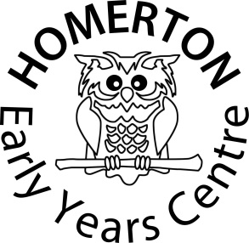

HOMERTON EARLY YEARS CENTRE

HOLBROOK ROAD
CAMBRIDGE
CB1 7ST
(01223) 508766

Email: office@homerton.cambs.sch.uk
Website: www.homerton.cambs.sch.uk

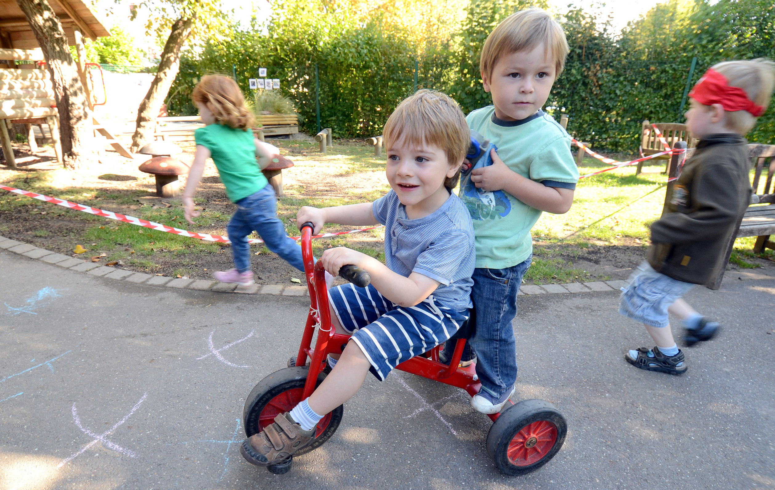

NURSERY AND NEST TERM DATES

2019/2020

From 4th September the Nursery is closed for Professional Days and Home Visits. Each child is given an individual starting date from early September.

Professional Day Wednesday 4th & Thursday 5th September

Half Term Monday 21st October –Friday 25th October

Autumn Term closes Thursday 19th December

Spring Term Opens Monday 6th January 2020

Half Term Monday 17th February – Friday 21st February
Professional Day Monday 24th February

Spring Term Closes Friday 3rd April

Summer Term Opens Monday 20th April

May Day Friday 8th May

Professional Day Friday 22nd May
Half Term Monday 25th May – Friday 29th May

Summer Term Closes Wednesday 22nd July

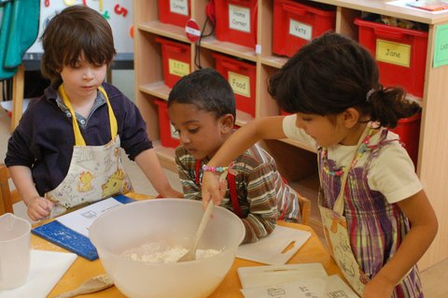

VISION

Homerton Early Years Centre joins with families in supporting, educating and caring for their children
For babies and young children this is a unique and important time in their development and we consider it to be a privilege to share in this part of their lives.

Homerton Early Years Centre provides a welcoming environment with exciting and enriching experiences where every individual is valued and nurtured.

We are a thriving Centre in the heart of the community that pays the highest regard to the needs of young children and their families. We are a Centre for learning, offering support and information. We work in partnership with families and their babies and children, Early Years settings and their practitioners, childminders and nannies, agencies supporting families, further education, schools and advisers.

Aims

Our Centre is a place where:

- families and individuals are supported to develop confidence, independence and self esteem.
- relationships are built in an environment of understanding and respect.
- we listen to everyone and explore ways to improve the lives of families in our community.
- we prioritise those in greatest need.
- we work in partnership with families to promote their children’s learning and development.
- quality experiences are offered which involve exploration, investigation and creativity.
- the environment is safe and caring so that children, families and staff can feel secure.
- we develop a shared understanding of spiritual, social and cultural diversity.
- we intervene to achieve better outcomes for all children and work to abolish prejudice.

Our values and principles are:

Providing and sustaining a warm and welcoming atmosphere
From our front desk and seamlessly throughout our Centre we create a warm, relaxed and motivating environment in which all are helped to feel welcome and belong.

Keeping safe
We have an ethos of emotional and physical safety that secures Homerton as a place where all can learn and develop. Everyone is valued and respected, with everyone’s concerns taken seriously.

Promoting and supporting the well-being of all
We all thrive and develop to our full potential with supportive relationships, at Homerton we all support each other!

A rich, pleasurable and exciting environment
Makes for an invigorating place to work and play. Homerton is full of light and resources that we use effectively to enrich children’s learning in imaginative ways. We work hard to ensure indoor and outdoor play are equally challenging and enjoyable environments in which to play and learn.

Early Years practice
We are proud of our Early Years knowledge and practice. We strongly believe in Homerton offering the best for young children’s development and their families through high quality staff and learning environments.

Everyone is treated equally
All children, families, carers, other professionals and staff are equally valued and important to us, irrespective of their gender, race, culture, religion, ability and age. We embrace diversity and take account of life differences to meet the needs of all.

Partnership with families
We are proud of hearing how welcomed families feel that they value and build trust with the staff. Families recognise that we listen, are open to change and aim to meet theirs and their children’s needs.

Learning community
At Homerton we all learn and continue to learn. Through a supportive and non-judgemental approach we are able to make mistakes safely and value learning through experience. Everyone has opportunities for professional development and to continue along their learning path.

Staff Teams
There are a number of teams within Homerton but none of these work in isolation. We are all part of the big Homerton team and proud of it! Staff often work across the different age groups and even sometimes in the office to share expertise. Through our daily lunches together and social events we make sure we have time to listen to each other and support each other’s lives beyond the Centre. We value good communication, friendliness, honesty, respect and humour and practise these by working hard at our relationships.
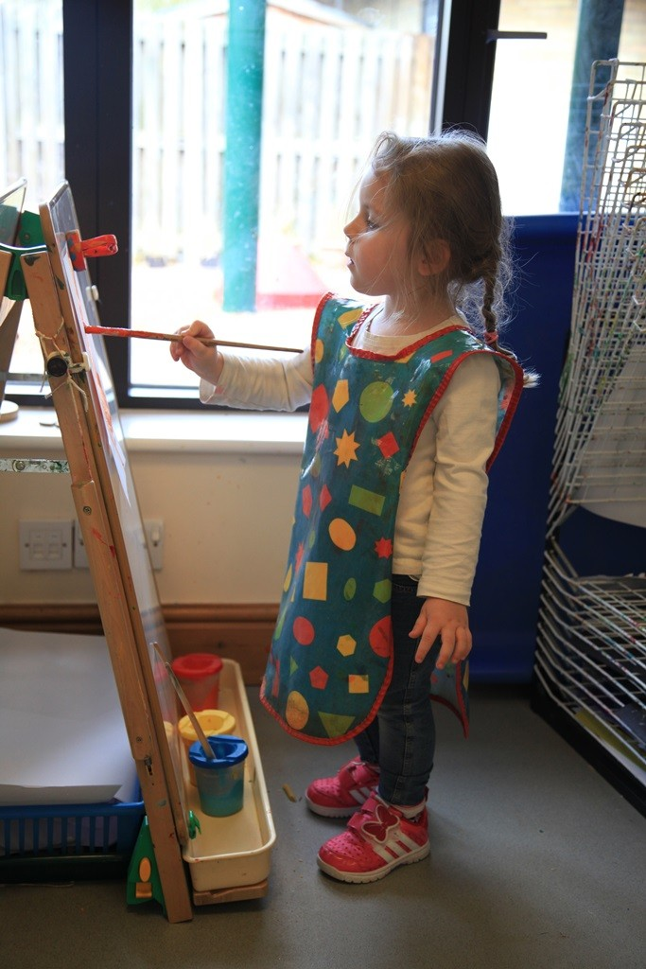

HOMERTON EARLY YEARS CENTRE: Some background information
Homerton was first established at the Faculty of Education, as a war time nursery school in 1940. The school moved in 1964 to its present site. In April 2003 Homerton Nursery School was designated by the government as an Early Years Excellence Centre. In March 2007 we opened our Early Years Centre.

Extended Sessions. We offer after school ‘Owlets’, and holiday clubs run by experienced and qualified staff.

Provision for 2 year olds, ‘The Nest’. We offer 8.30 - 5.45pm term time only. The Nest children are able to book into our Holiday Club.

Whole Centre. The whole Centre is closed for 2 weeks at Christmas, 1 week at Easter and approximately 2 weeks in the summer holidays. Outside of school term times we operate a Holiday Club.

Drop In Sessions

- Messy Play sessions for parents/carers with children aged 0-4

Training. We offer training and consultancy in all aspects of Early Years Education to visiting practitioners and our own Teacher Trainees. The children become very used to visitors walking around the school observing activities.

Visits. If you would like to visit the Centre, please email office@homerton.cambs.sch.uk or phone the office on 01223 508766, to arrange a date and time.

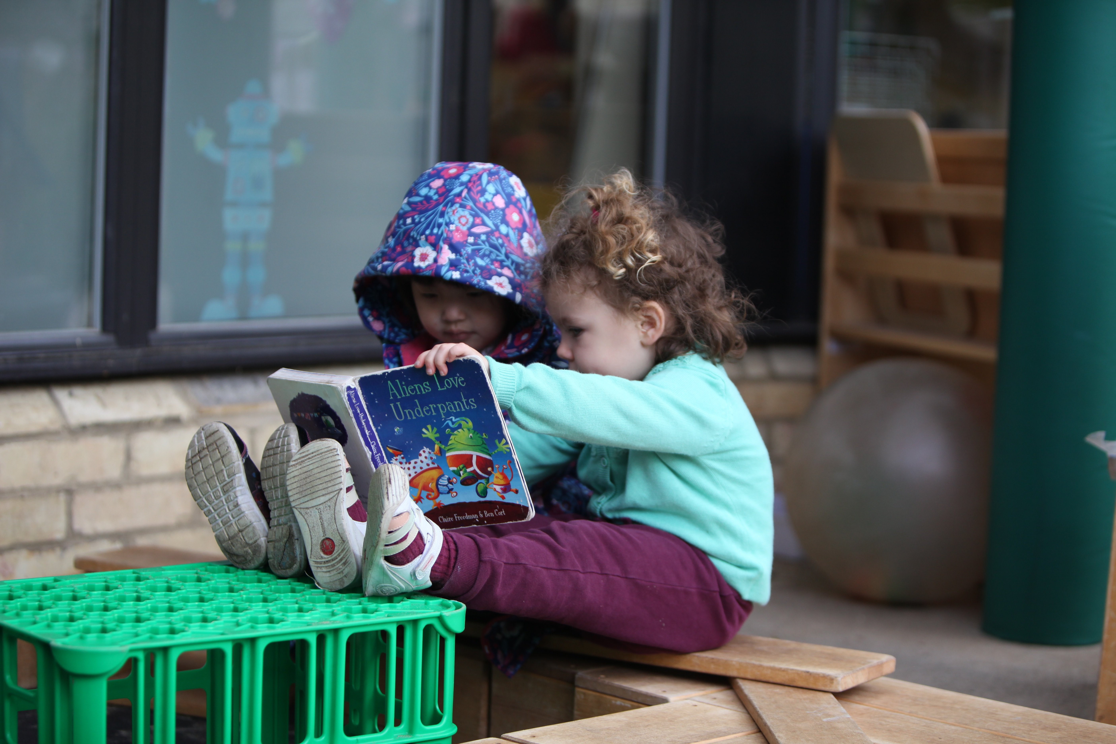

STAFF

Alex Pearson Head of Centre

South Room Liz Greenhalgh Teacher
Class Michelle Cooper Teaching Assistant
Heather Owen Teaching Assistant
West Room Bernie Cafferkey Teacher /Trainee SENCO
30 hour Class Melody Wright Owlets Manager
Dong Sun Teaching Assistant
Angie Ingle Teaching Assistant
Tamsin Fry Teaching Assistant
East Room Mitali Peckham Class Teacher East Room Felicity Higginson
(Red) Fran Crouch Teaching Assistant (Blue) Debbie Stebbings
Kate Mott Teaching Assistant Laura Price
Education
Support Staff | Bridget Cafferkey | Support Nursery Nurse
Owlets Melody Wright Owlets Manager
Staff Debra Bennett Owlets Playworker
The Nest
Antonella Mazzucco Teaching Assistant
Hyun Mi Lee Teaching Assistant
Bea Gyorgy Teaching Assistant
Natalie Kurklu Teaching Assistant
Jeannette Simpson Teaching Assistant
Maria Rolph Teaching Assistant
Julie Beattie Teaching Assistant
Siân Thorne Teaching Assistant
Office Staff Sue Smith Office Manager
Tracey Wheddon Clerical Assistant
Suzy Hughes Clerical Assistant
Heather Owen Clerical Assistant
Lunch Staff Rebecca Dalla-Libera Lunchtime Supervisor
Alison Knights Lunchtime Supervisor
Julia Creed Lunchtime Supervisor
Sarah Williams Lunchtime Supervisor
Emma Murdoch Lunchtime Supervisor
Celia Phipps Lunchtime Supervisor
Shohreh Sharifi Lunchtime Supervisor
Lesley Jenkins Lunchtime Supervisor
Angela Bushell Caterer
Helen Haughton Assistant Caterer
Cleaning Staff Angela Bushell Cleaner
Kelly Wolfe Cleaner
Roy Stamp Caretaker

GOVERNORS –

Ken Ong – Co-Opted, Chair of Governors
Tandy Harrison - LA
Alex Pearson – Head of Centre
Mitali Peckham – Co-Opted
Sue Smith - Staff
Rinchen Ato – Co-Opted
Mick Patel – Co-Opted
Marisol Basilio Seyler– Co-Opted
Kay Blayney – Co-Opted
Roger Lilley – Co-Opted
Sophie Bryce – Parent
Ross Sargeant – Parent
Kate Daenke – Parent
Sameer Garyali – Co-Opted
Gwyneth Barton – Clerk

Contact can be made with the Chair of Governors via the Office manager Sue Smith, Homerton Early Years Centre on (01223) 508766

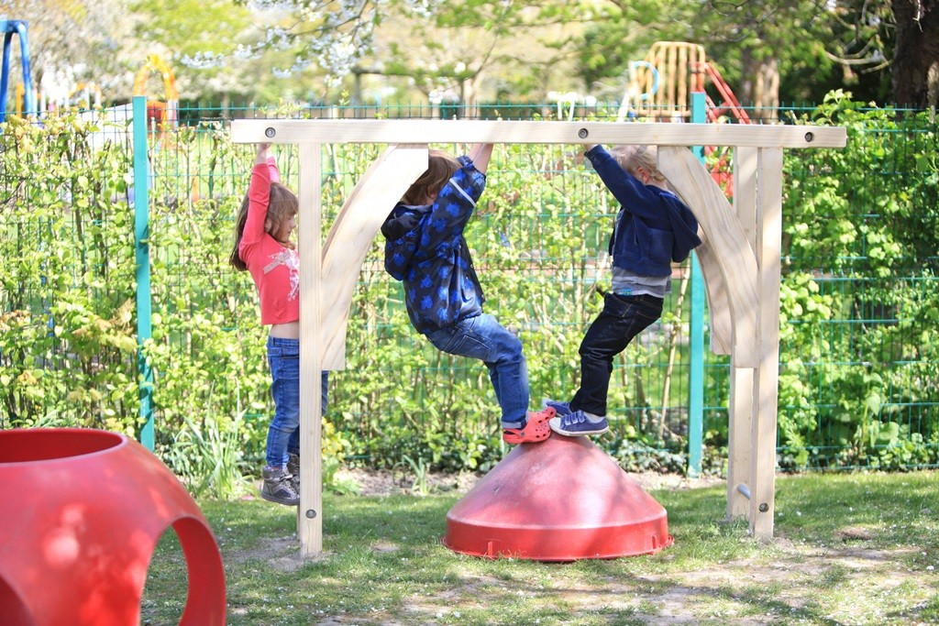

NURSERY SCHOOL PROVISION
Homerton Early Years Centre offers a combination of 30 hour places, (subject to eligibility) and 15 hour places which are Government funded nursery education. Each of our class rooms has up to 24 children with a teacher and a level 3 qualified member of staff. Additional qualified staff work in all of the classes to provide planning, preparation and assessment (PPA) time. There are also teaching assistants who work with children who have additional needs. All staff have excellent qualifications and experience in Early Years Education.

We also offer placements to students from our own teacher training school, local universities, colleges and schools, who are undertaking nursery training or work experience.

Parents may choose for their child to attend either 5 mornings (8.45 – 11.45am), or 30 hours for those working parents who are eligible 8.45-3.45 daily with a paid lunch. We also run two 2½ day classes at the beginning of the week Monday, Tuesday (8.45 – 3.45pm) and Wednesday morning (8.45 – 11.45) with the option to extend this on Wednesday afternoon with a paid lunch and care class until 3.45, or 2½ days at the end of the week Wednesday afternoon (12.45 – 3.45pm), Thursday and Friday (8.45 – 3.45pm).

BREAKFAST CLUB
We offer the option of paying to come to Breakfast Club which starts at 8.30am.

AFTER SCHOOL CLUB: Owlets
We offer an extended day to children through the after school club (3.45 pm – 5.45 pm). The club is run by our own members of staff, who offer a relaxed and fun session, following the ethos of the Centre. Please ask the office for current charges.

School Dinners
Children who attend the full day sessions in the Nursery and Nest have a dinner prepared for them by our in house cook Angela Bushell. Current costs for dinners per day are £2.50 with the additional charge for the care being £6.50 in the Nursery, and £7.50 in the Nest.
Please let us know if you are entitled to free school lunches.

DIETARY NEEDS
If your child has special dietary needs please alert the Centre to this before your child starts with us.

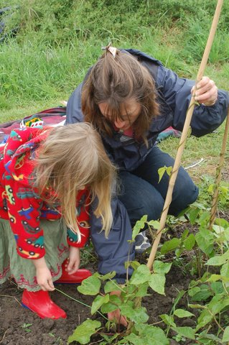

THE NEST - PROVISION FOR TWO YEAR OLDS
We offer all day or sessional places for two year olds, fees and admission criteria are available on request. The Nest Admissions policy is on our website. There are up to 24 places available in any one session. All staff have excellent qualifications and experience and work at a ratio of one adult to four children.

Sessions are:

Breakfast 8.30am – 9.00am
AM Session 9.00am – 12.00
Lunch 12.00 – 1.00pm
PM Session 1.00pm – 4.00pm
Late Session 4.00pm – 5.45pm

HOLIDAY CLUB
We run an all day (9am – 5pm) holiday club. Only children who are already at Homerton can book into the Holiday Club. Where space is available, we can offer places to children who have been at Homerton and are now at school, up to the age of eight years old. Older siblings up to the age of eight may attend by special arrangement, please put a request in writing to the Head of Centre. Children must be booked into the holiday club. Please book through the office as far ahead as possible. Holiday club quickly becomes full!

Introducing your Child to Homerton

We aim to ensure that your child has a gradual and happy start to their time in The Nest or at the nursery. We do this in the following ways:-

The Nursery School:
- Drop In and Play – An opportunity for children to come with their parent and have a play session in late June or early July
- Home Visit – During the first week of September we offer each new family a short informal home visit from your child’s teacher and teaching assistant. This gives an opportunity for your child to meet and play with their adults in the security of their own home.
- All About Me Booklet – we ask you to complete an All About Me book to bring into nursery on your first day.

The Nest:
- Home Visit – We aim to offer each family a home visit before their child settles in The Nest, according to staff capacity.
- All About Me – We ask that you complete our ‘All About Me’ book to bring with you on your first day.

After this, entry for children is phased throughout the next fortnight.

Settling In
The first visit session is for one hour and we ask parents stay with their children to help them settle in to this new environment and to fill in paperwork that we require. After the visit day your child’s time is increased according to need.

- Some settling advice - Some children starting with us will have been to playgroup or another setting before coming here and Homerton will be another new experience. We are possibly a larger setting than they have seen before – maybe our expectations differ. It will be an entirely new experience to adjust to and can be exciting and stimulating but also emotionally draining and your child may show signs of tiredness after a while. They may not want to tell you about all the lovely things they have done. This is entirely natural, so try not to question them too much.

Key Person
Every child at Homerton has a key person. Your child’s key person will help them to become familiar with the Nursery/Nest and to feel safe, confident and happy within it. They will take a particularly active role getting to know you and your child. They will be keen to hear about your child’s interests so that they can build on what happens at home and plan well for your child’s learning and care. The key person will encourage your child’s developing independence and be a secure adult to share in new experiences.

Key people build a relationship with children and their families to make sure that every child is being cared for appropriately and has the best opportunities for learning and development. Although they have a close relationship with their children, our key person ensures this never undermines a child’s bond with their parents. They also keep careful records of each child’s development and progress and share these with parents and children.

All children and families are encouraged to build a supportive and trusting relationship with all staff as well as their key person.

PLAYING AND LEARNING AT HOMERTON

At Homerton Early Years Centre we follow the Early Years Foundation Stage (EYFS) curriculum which covers ages 0 - 5 years. This sets out goals for learning for children to achieve by the end of their reception year. If you are interested in finding out more about the EYFS, please visit the Learning at School page of our website.

Children come to Homerton with a wide range of skills and experience. As we observe and record what children are doing, we use these observations to assess how children are developing. We can use this information to plan how to extend and develop your child’s interests, skills and experience, and where to give support if necessary. We record opportunities for children’s next steps in development in their Special Books. These are readily available in their classrooms and we encourage children and parents to share these together. (see Parent Partnership section for how you can contribute to these Special Books).

All of our activities are based on first hand experiences with the emphasis on play indoors and out. We want children to explore and be willing to ‘have a go’. We value children’s own ideas and their choice of how they will do things. We encourage them to be involved and keep trying so that they really enjoy achieving what they set out to do.

In the three prime areas of
- Personal, Social & Emotional Development,
- Communication & Language
- Physical Development

These support learning in the four specific areas of
- Literacy
- Mathematics
- Understanding of the World
- Expressive Arts & Design.

If you would like to know more about how we plan for your child’s learning please do talk to your child’s class teacher or make an appointment to see the Head of Centre, we hope that you feel fully informed about your child’s learning at Homerton.

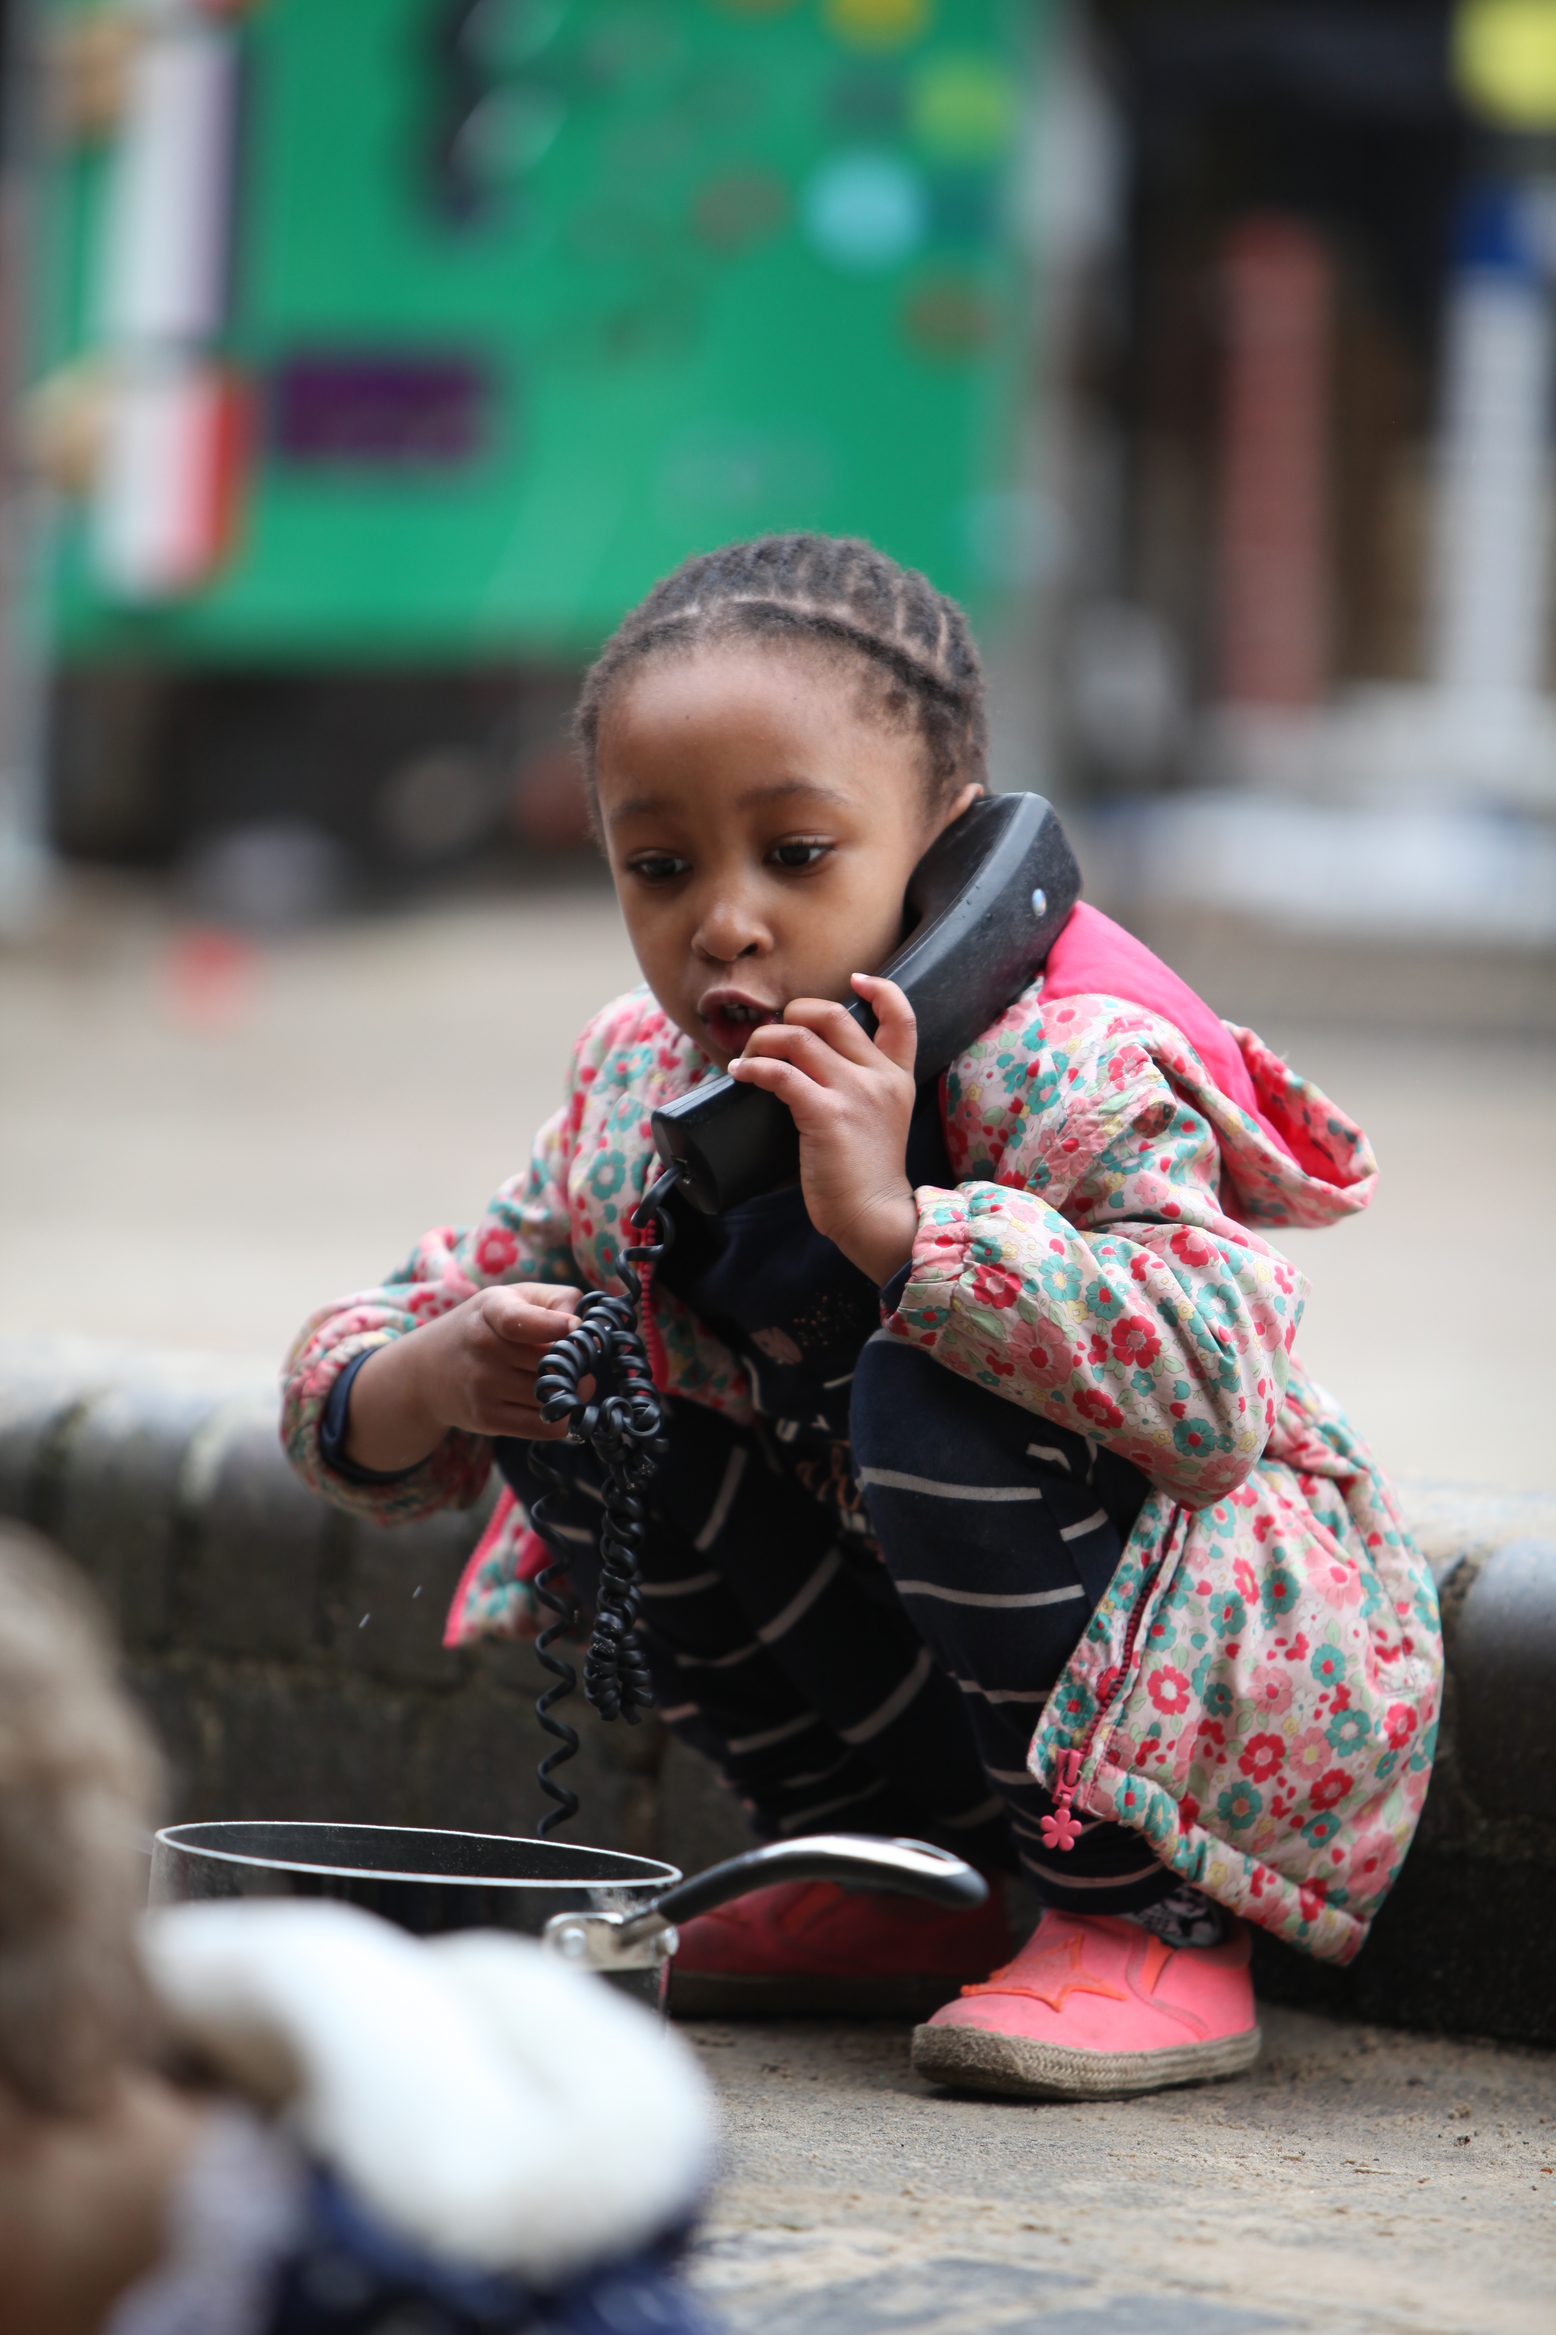

PARENT PARTNERSHIP

Children’s Progress and Parents’ Evenings

A large part of our work is to observe and record what children are doing so that we can assess children’s learning, to give support where needed and help us plan children’s activities.

In the Autumn term we hold open sessions when you can look around the Centre and find out more about what the children are engaged in.

In the Spring term we have our parent consultations when you can book a 10 minute appointment to talk about your child.

When your child leaves Homerton we share with you our profile of your child’s time with us in the form of a greatly treasured ‘Special Book’. Information is also sent to the next setting or school.

There may also be workshops or talks for parents.

Please don’t wait for the arranged evenings to talk to us if you have any concerns. We will always be happy to make time for you.

‘Special Books’ are kept to record children’s progress. These are always available in the classrooms; do look at them any time that you like. Please contribute to your child’s Special Book. Staff would really appreciate if you included photos, celebrations, anecdotes or achievements from home.

A Working Partnership

We hope that you are looking forward to starting with your child at Homerton.
We’ll do our best to make you feel welcome, happy and relaxed about the whole venture because the success of our work depends on that.

We see this as a partnership and we hope you’ll be able to get to know and trust us quickly and speak freely over any anxieties you have (worries can appear enormous to a child and it is best to sort them out quietly, usually out of earshot of your child). Use us as a source of experience – we have met and known many children over the years.

Parents are a child’s first teachers and the early years are the ones in which a child learns more and more quickly than at any other time in their life. Education begins at birth – if not before!

You as parents are the most important people to your child and it is only through you that we can get to know your child really well and learn how best to support him or her.

Children have different needs – different rates of development.
Parents have different expectations – different child rearing practices.
We as Early Years practitioners are aware of these differences and respect them.

Parents Helping
We welcome parent help in the classes. This help usually starts once all the children have settled. Unfortunately we cannot accommodate babies or toddlers in the nursery classes.

There are 4 different ways in which parents can be involved:

- You may stay and play with your child and other children in class from the start of the session until 11am in the morning.
- Share your expertise with your child’s class e.g. play an instrument, cook with a group or share an interest at ‘circle time’
- We also really value the time you can give to Homerton in helping us with the many and varied tasks we undertake e.g. mending toys, tidying the library, sewing, gardening (we have an allotment and Old Orchard garden), organising fundraising etc.
- Helping on school trips.

For all of the above please arrange mutually convenient times with your child’s class teacher.

Please don’t throw away good quality junk.
We collect buttons, small boxes, ribbon, corks, fabric, wool, old birthday cards etc for model making and collage.

Home Centre Links
We like to share our work at Homerton so that parents can use our ideas or resources at home. Here are some of them:-
- Book loans from the classes or main library
- Story Sack loans
- Maths on the Back packs
- Taking the owls home for the weekend

A Typical Day

We believe that security and routine are important for two to four year olds, as is the development of a child’s independence and motivation and enjoyment of learning. Therefore a typical day would look like this:-
- Arrival and self registration. Children arrive with their adult, who signs them in on the class register, and then hang up their coat on a peg with an individual symbol. A member of staff greets your child who then finds their name in a pocket and sticks it on a magnetised board. In one of the pockets is the Homerton Owl Badge for the Nursery School Children – this child will have special responsibilities for the day. A huge treat!
- Beginning to play. Children then can choose to play in any of the areas of the room, choosing their resources.
- The garden. After a short time the garden door is opened and the children may go into the garden or stay in their own room. The garden is a valuable resource and is planned as carefully as the indoor provision. Some children prefer to play and learn outdoors and we ensure our provision supports their all round development. There are opportunities for climbing, balancing, riding tricycles and trucks, ball skills, digging in the sand, observing the natural world, role-play and much more! We strongly believe in the principles of fresh air and exercise and actively promote this. Children are encouraged to play in the garden in all weathers so please provide coats or sun hats. Many of these ideals are achieved through our work as a Health Promoting School.
- Rainbow Room. Each nursery class or a group from the nursery classes visit Rainbow Room regularly. The children may have a movement session, practice small ball skills, engage in parachute play, drama, dance or music.
- Snack time. We encourage children to drink water whenever they are thirsty and there is a healthy snack table where children may eat fruit or vegetables when they are hungry. Fruit and vegetables are provided by the parents, as a voluntary contribution to the healthy food basket.
- Music Time
Every other week a qualified early year’s music teacher comes to Homerton, and works with all the children. This is a fun session involving singing, playing instruments and dancing.
- Circle time. At some time during the session the children tidy up the garden and classroom, then return to their own class base for circle time, which may involve stories, singing nursery rhymes and music. This time may also be used to share news, discuss activities, revisit events, or involve children in planning.
- What do the adults do? The adults who work with the children are engaged in activities with small groups of children where direct teaching may be involved, observing and recording play, modelling play, extending language, supporting behaviour and cooperative play and a million and one other tasks!

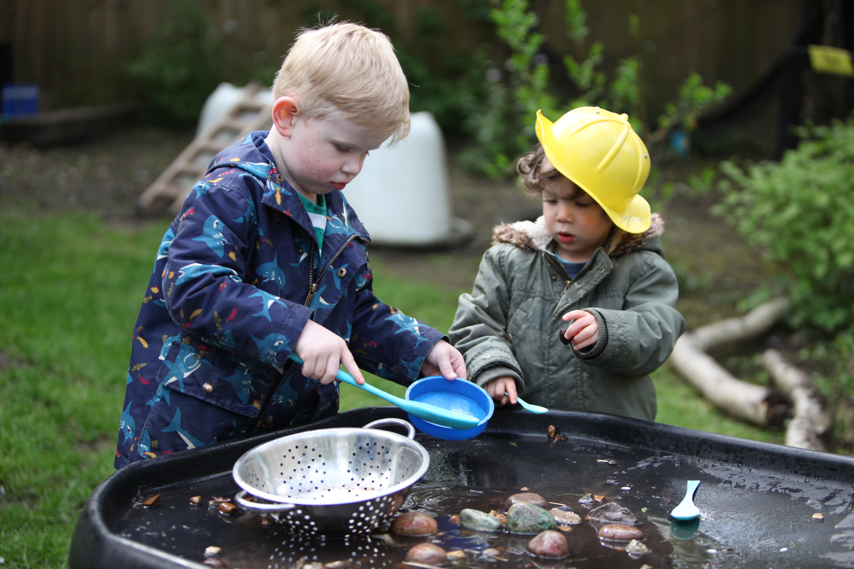

Ways you can help your child and us

Collecting your Child
Please let us know in advance if someone other than you is collecting your child, a note can be added to the ‘signing in’ register. Children will only be handed over to a named and known person who is over 16 years of age. If you are delayed for any reason, please try to telephone.
IF YOUR CONTACT NUMBER CHANGES PLEASE LET US KNOW AS SOON AS POSSIBLE.

Travelling to the Centre
We are committed to safe and environmentally friendly travel to school. Please walk or cycle to Homerton if at all possible. We have hooks for storage for cycle helmets. If you have to use a car, always use a child seat and strap your child in securely.

Parking
For your child's safety please - always approach the Centre by the little path - the car park is for staff use only. Please park courteously, avoiding our neighbours’ driveways. Help your child to cross safely. There is a parking area for child’s and adult’s bicycles. You may like to park in Glebe Road which is often less busy, and walk through to Homerton by the allotments next to 48 Glebe Rd. Homerton is next door to 38 on Holbrook Rd. There is also buggy parking and combination locks to loan.

Clothing
Please dress your child in practical clothes that they can manage themselves especially when going to the toilet independently. Children will get messy, please only dress your children in clothes that you do not mind getting a little mucky, it is inevitable at Homerton! We go into the garden every day in all weathers. PLEASE NAME ALL CLOTHES.

Winter wear - Warm coats, scarves, gloves or mittens.
Summer wear - Clogs and flip-flops are a hazard on the climbing frame. In the summer your child will need a sun hat and protective clothing (only UV protective sun glasses if needed). Sunscreen applied at home is essential. Children who stay all day will have sun cream reapplied at school.

Nappies
For those children that are wearing nappies we ask that you bring your own nappies, baby wipes and creams. We will ask that you sign an agreement allowing us to use our own if we run out of your supply to safeguard against allergies.

Absence and Illness
If your child is absent from the Nest or the Nursery, please telephone us, preferably between 8.45am – 9.15am or 12.45pm – 1.15pm.

Decisions about whether or not your child is fit to come to the Nest or the Nursery are best made at home and by the parent. It is not a good idea to ask your child what they want to do. Sickness and diarrhoea pass on quickly; the advice from the Environmental Health Officer is “Please keep your children at home two clear days after the cessation of the diarrhoea or sickness”.

We are often asked what our policy is about coughs and colds. We feel that a child is better in the comfort of his or her home if they are under the weather or very tired – the other consideration is the passing on of bugs to other children and staff. However, some children take on the appearance of a cold for weeks or longer. If in doubt please talk to your child’s class teacher, they will be able to offer advice.

If a child has attended with an infectious illness, for example, chicken pox, advice will be posted on classroom notice boards. We have advice sheets for some infectious diseases, please ask the office if you would like one if it is relevant to your child’s illness. We can always email you a copy.

Medication
Please let us know if there are any health problems well before your child starts Homerton so that we can plan accordingly. We will ask you to fill in and sign a form, giving permission for any medication or medical intervention.

Accidents
If your child has an accident at Homerton it will be recorded on an accident form and you will be asked to sign it so that you can monitor your child at home. We will also ask you to sign a form if your child has recently had an accident out of the Centre so that we know to look out for them. Most staff are qualified Paediatric First Aiders. (The Health and Safety Policy can be found on the website).

Your child may occasionally get nettle stings on trips or when out and about at the allotment or park. We do remove most nettles but learning about what nettles are is part of a child’s learning as they grow and develop. Often children get small bumps, bruises or scratches at Homerton as they play, particularly outdoors. We do not record each of these minor accidents. Learning how to play safely is part of your child’s learning and something we help them with. We will always record and inform you of any accidents that require more than some tender, loving care and a little healing.

Snacks
We ask children to bring raw or dried fruit, prepared vegetables, or sugar free snacks such as oat cakes each week, which are made available as snacks throughout each session and also sometimes shared as a group at circle times.

Each child has access to little cups and is encouraged to help themselves to water when thirsty.
Please keep any other food at home and do not bring in biscuits/sweets in pockets which can be a temptation to share with friends, who may have allergies to certain foods.

Allergies
Please inform us if your child has any allergies well before they start at Homerton so that we can ensure our environment is safe. We have a walnut tree in The Nest garden; please inform us if your child has an allergy to walnuts, whether they are in the Nursery or Nest.

Home Toys
Children are asked to put their toys from home in a special area in each room for safekeeping. The Nest children may want to keep their toys with them as comforters. We ask that dummies are kept at home except for Nest children who may still need these for sleep.

Birthdays
We usually celebrate in each room by singing Happy Birthday, and blowing out the candles on our pretend cakes. Some parents like to send in small biscuits, cakes or special fruit to share – please check that these are nut free and let class staff know what you would like to bring in in advance.

Festivals and Events
We celebrate cultural and religious festivals and events throughout the year. If you have any expertise/ideas/special foods or artefacts to share we welcome these. If you would like to share them yourself in class you would be very welcome. Please see your child’s class teacher to arrange.

Fun with Food
Each class regularly cooks or gives children experience of different foods. We write notices on our boards to inform you of ingredients. Please tell us if your child has any allergies or particular dietary needs.

Photographs
We take many photographs of the children playing, as a way of recording what children do at Homerton Early Years Centre. These are always shared with you as part of displays or in your child’s Special Book which is taken home when your child leaves. Many of our visitors and students are also required to take photographs as evidence of play practice for their portfolios. In these cases we make it absolutely clear that no child may be identified. However if a child’s photograph or a piece of work is to be submitted for publication, we will always seek parental permission. For further information please see our Use of Photographs Policy. A professional photographer comes during the year to take individual and class group photographs for you to buy.

Parent Fund
At Homerton we wish to offer the very best for your children. Part of this depends on enriching children’s experiences with visits to the allotment, planting and cooking together, a Christmas party, an end of year celebratory trip out and special visitors coming in to Homerton. Parents kindly make contributions to help support these extra curricular activities. Of course the donations are voluntary but we do depend on them so if you are able to give generously it is greatly appreciated.

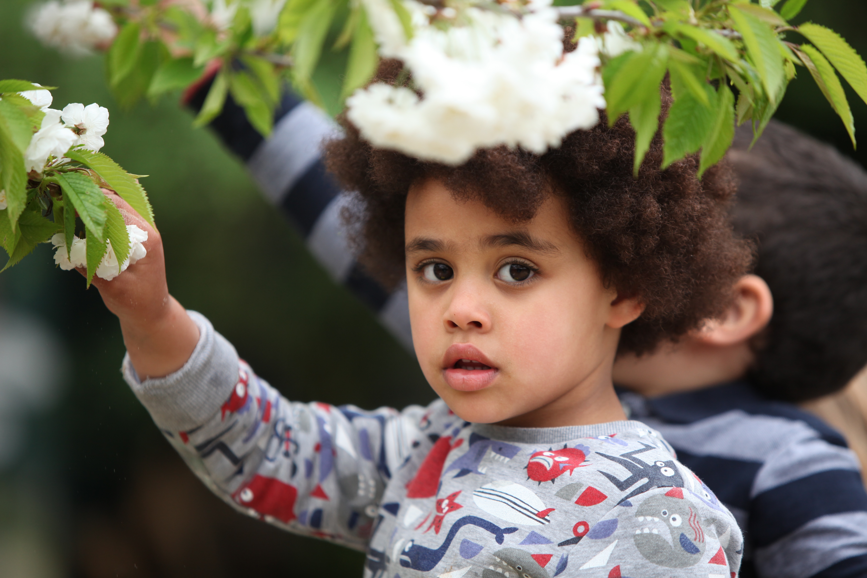

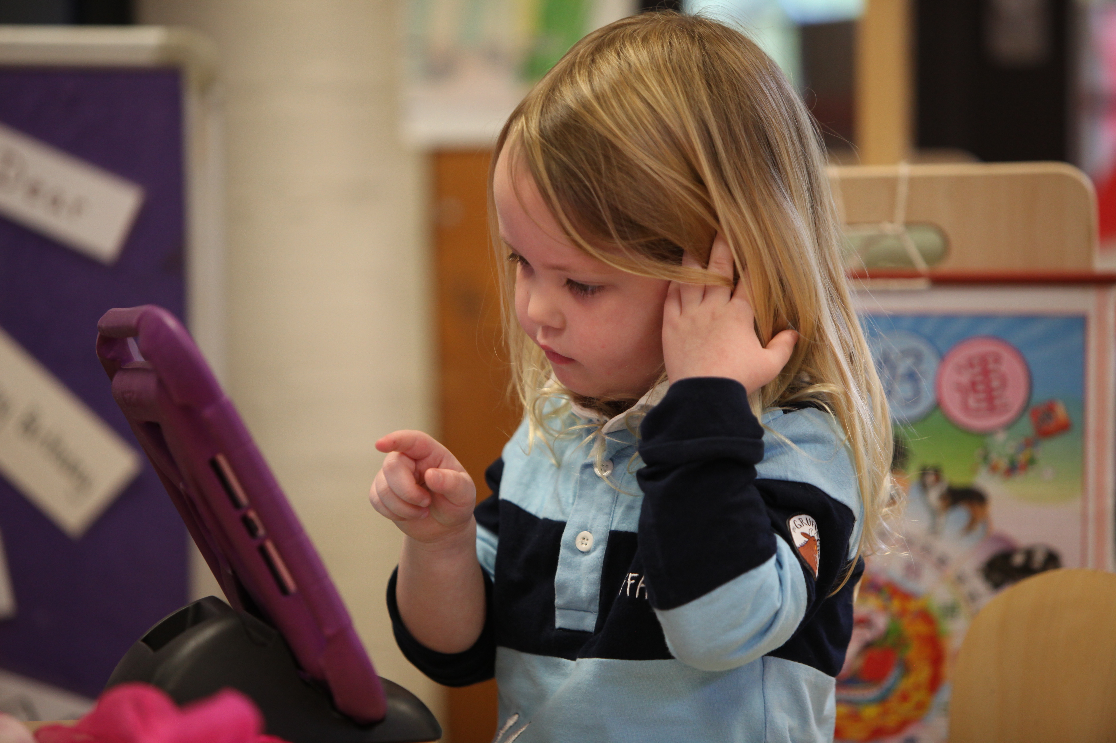

EQUALITY & DIVERSITY

What we do at Homerton reflects the variety of backgrounds, customs and languages of all our children. It is the intention of staff that no child suffers in any way by virtue of his/her gender, race, disability or class. We do not allow any behaviour that hurts or offends others. Personal and social education in this Early Years Centre will enable every child to develop high self-esteem, self-respect and to respect others. Under the Race Relations (Amendment) Act 2000 and Home Office Code of Practice on reporting and recording racist incidents (2000), we are required to record and investigate all racist incidents and to report them to the Local Authority, on a regular basis. Parents will always be contacted if their child is involved in any way in an alleged racist incident. In line with all schools we have equality objectives in place.

These are:

We will celebrate further the variety of languages spoken by children coming to Homerton by having a ‘Language of the half term’.

We have a named member of staff as ENCO and EAL co-ordinator.

We will address the imbalance of female staff within the Centre and to proactively include fathers in their children’s nursery experiences.

We will promote acceptance and challenge stereotypes around disability through staff CPD (Continuing Professional Development)

ADDITIONAL NEEDS
Our Centre is an inclusive place. We make all our children and adults welcome and feel happy to look forward to their day. Every child is different and we view differences as an opportunity for adults and children alike to learn more about ourselves.

If your child has a disability he or she will be treated no less favourably than other children. We make reasonable adjustments to ensure that children with disabilities are not placed at a substantial disadvantage.

We aim to prevent disabled children and adults in our Centre being placed at a substantial disadvantage. We take all reasonable steps to ensure that people with a disability are not treated differently without lawful justification. We make reasonable adjustments for disabled children and adults and we will know we have succeeded when disabled children and adults are participating fully in Centre life.

The Centre has a policy for supporting children with additional needs which is revised every year. This policy is available on the website and in the library. Our aim is for all children to have access to all aspects of Centre life, as far as is reasonable and practicable.

Children with additional needs have an individual educational plan (IEP) ensuring that learning is broken down into small steps. This is planned by the class teacher or room leader in consultation with parents and is regularly reviewed.

Our staff have experience and skills in teaching children with additional needs and receive targeted In Service training. Experienced teaching assistants are employed to work with children who need extra support. Our SENCO oversees and advises Centre staff in addition to working closely with other professionals within the Local Authority, child health services, social services and organisations working on behalf of children with special educational needs.

In order for effective partnership working between home and Centre to take place, we anticipate that parents will want to:

- inform the Centre at the earliest opportunity if their child has a disability or additional need and the exact nature of it;
- provide the information the Centre needs to plan effectively for the child;
- acknowledge that when deciding whether an adjustment is reasonable, one of the factors the Head of Centre must consider is the effect of the proposed change on all members of the Centre community;
- recognise the importance of Centre and home working in partnership.

HIGH ACHIEVERS
As our work is very child-centred, every child’s individual needs are closely observed and planned for. If children are achieving beyond expected levels in one or more areas, we ensure that they are suitably challenged.

POLICIES AND PROCEDURES
Our policies are available on our website or in the parents’ library.

ADMISSIONS
For details of admissions and all matters related to this and our catchment area please see the Admissions policy, available from the office, or on the website.

CHILD PROTECTION
Homerton Early Years Centre is committed to Safeguarding and promoting the well being of its children and all adults who work at or visit our Centre. If at any point you have concerns about a child’s happiness, safety or well being please report it immediately to a designated person for child protection. The designated Child Protection Staff members are the: - Head of Centre Alex Pearson, Owlets Manager Melody Wright, Nest Room Leader Harriet Riches, SENCO Bernie Cafferkey and Teaching Assistant Julie Beattie.

Parents/carers should know that the law requires all Centre staff to pass on information which gives rise to a concern about a child’s welfare, including risk from neglect, physical, emotional or sexual abuse. The Centre should make parents/carers aware that records of welfare concerns may be kept about their child. They should be informed that Centre staff will seek, in general, to discuss any concerns with them including referrals to other agencies. However, in situations where the child is suspected to be a risk of harm, the law says that Centres may take advice from other agencies without informing parents/carers. (Refer to Safeguarding Policy)

SAFE HANDLING
We have a legal obligation to maintain a safe environment and we will use physical intervention as a very last resort with children. Staff will receive individual training for Safe Handling if the need arises and parents will be informed.

Complaints Procedure
In the event that you have a complaint or concern about the Centre, we believe that it is generally better to speak directly to your classroom staff. If the matter cannot be resolved by an informal chat, please make an appointment to see the Head of Centre. If matters are still not resolved, please write a letter outlining your concerns and address this to the Chair of Governors who will reply within five working days. If you have a complaint or concern you may phone Ofsted on 0300 123 1231

CONFIDENTIALITY POLICY
Information about children and families is treated in the strictest confidence and this is made clear to all new members of staff on induction.

DATA PROTECTION
We use various web based systems to collect family/child information this enables us to record your child’s development, to contact you regarding information about this Centre. These are secure systems used by many Schools and Nurseries. Your data will be held in accordance with the General Data Protection Regulations and the Data Protection Act 2018 and treated as confidential. Please see our Privacy Notice for further details.

SEX EDUCATION
Children’s questions are always answered simply and honestly as they occur. If you have concerns please make an appointment with the Head of Centre.

A message from Parent Governors

We have parent governor elections when you can nominate yourself or a friend. Details are sent out nearer the time.

Parent governors will write to you at various times asking for help. If you have any skills or talents to offer do let us know. We will also let you know about any social events when you can come and meet other parents for a chat and a drink.

Homerton Early Years Centre is a place where a community works together, supporting each other in everyday tasks.

Parent governors work closely within the Homerton community or “extended family” and contribute to policies and general running of the Centre through half termly governors’ meetings. One of their most important functions is to help to bring together a variety of fun events that everyone can participate in. These events are greatly supported by the parents, children and teachers alike and help to raise funds for children centre resources. The contribution made by so many of the parents to ensure that these events run smoothly has been enormous.

Everyone has the chance to take part whether it is supporting by baking cakes, helping out at social events.

We hope that you will have the time to join in with one or more of the parent governor events. It is our objective that you, your children and your family have as much fun as possible during your child’s time at the Centre.

We look forward to welcoming you.



