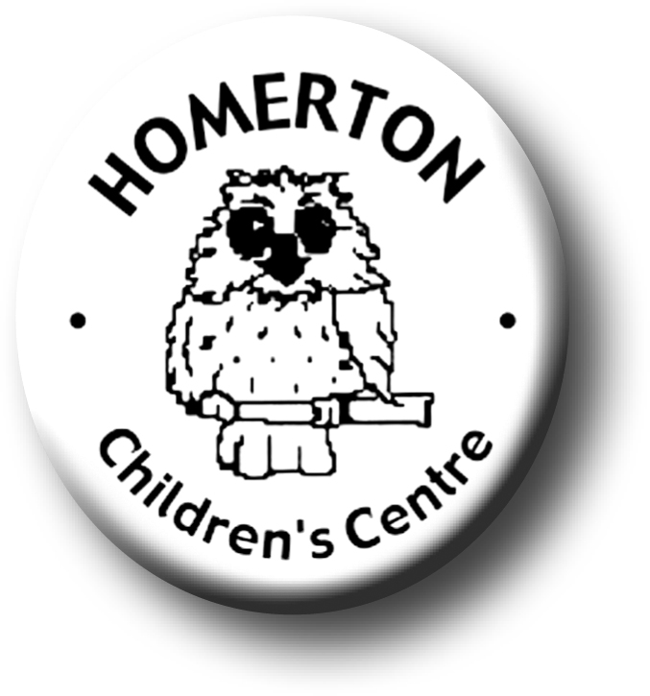Medium Term Plans Summer 2

*We follow the national Early Years Foundation Stage curriculum,*

[*www.foundationyears.org.uk*](http://www.foundationyears.org.uk)

Positive relationships

A unique child

* Transition visits to Homerton Nursery.
* Celebrating key festivals e.g. Father’s Day.
* Parent events – New parent and child Drop-ins.
* Parent and carers volunteering.
* End of year summary and Special Books go home.
* Summer celebration.
* Transitions – Exploring and extending boundaries safely, growing in confidence.
* Developing independence e.g. drinking, sunhats, rest and shade.
* Developing self-control, making choices and behaving appropriately.

Learning and development

Enabling environments

* Mini-beasts and Life cycles; caterpillars to butterflies, bug hunting.
* Growing and harvesting.
* Continuous provision – use opportunities to extend mark making opportunities outdoors, den making, planting and growing.
* Exploring with bare feet e.g. sandpit, water from hose pipe.
* Every child a talker – Sharing news with friends at Circle time and snack table.
* Learning though our core book.
* Remembering/retelling stories or parts of stories together.
* Music –
* Continue to develop fine motor control e.g. mark making in a range of media, weaving, using small equipment.
* Developing balance and control and body awareness – Coordination through ball skills.
* Every child a talker – Talking about past and future experiences.

ECAT