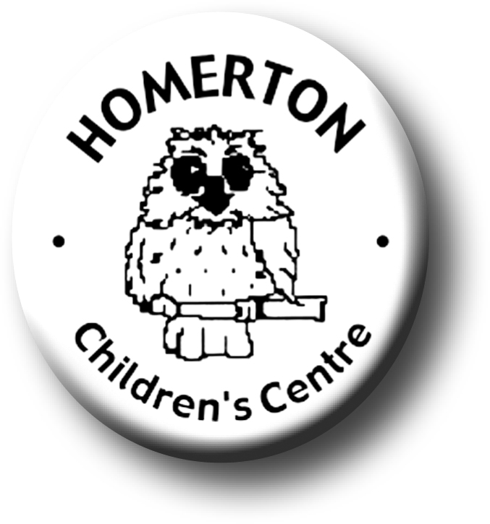Medium Term Plans Summer 2

*We follow the national Early Years Foundation Stage curriculum,*

[*www.foundationyears.org.uk*](http://www.foundationyears.org.uk)

Positive relationships

A unique child

* Transition visits to Morley and reception teachers to Homerton.
* “Maths on the Back” for home loans.
* Celebrating key festivals e.g. Father’s Day.
* Parent events – New parent and child Drop-ins.
* Parent and carers volunteering.
* End of year summary and Special Books go home.
* Summer Celebration at Homerton.
* Transitions – Exploring and extending boundaries safely, growing in confidence.
* Developing independence e.g. drinking, sunhats, rest and shade.
* Developing self-control, making choices and behaving appropriately.
* Using the language of thinking; think, know, remember, find out, forget, idea, makes sense, learn, figure out, trying to do.
* Supporting children’s interests over time, reminding them of previous approaches and encouraging them to make connections.
* Following the Staying Safe programme

Learning and development

Enabling environments

* Mini-beasts and Life cycles; caterpillars to butterflies, bug hunting.
* Growing and harvesting.
* Road and cycle safety.
* Extend technical skills and problem solving e.g. use of cameras and iPads *(extending uses),* building, constructing, den making.
* Continuous provision – use opportunities to extend literacy skills and knowledge; mark making opportunities outdoors, den making, planting and growing.
* Exploring with bare feet e.g. sandpit, water from hose pipe.
* Every child a talker – Sharing news with friends at Circle time and snack table
* Visits out e.g. allotment, park, library, Anglesey.
* Learning though our core book, “The Hungry Caterpillar” by Eric Carle.
* Understanding elements of story, sequencing and predicting outcomes.
* Music –Experience basic music concepts through mark making and beginning own compositions.
* Cooking – harvesting potatoes.
* Continue to develop fine motor control e.g. mark making in a range of media indoors and out, sewing, weaving, using small equipment.
* Developing balance and control and body awareness – Coordination through ball skills.
* Every child a talker – Talking about past and future experiences.

ECAT

ECAT