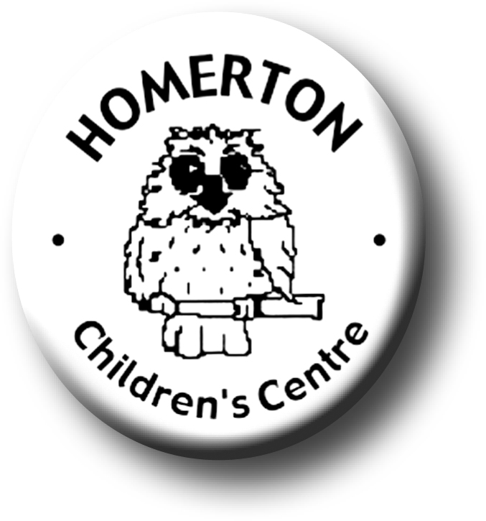
Planning for and assessing children’s learning

We follow the national Early Years Foundation Stage curriculum,
Observing
www.foundationyears.org.uk
We observe children to;
- Inform our understanding of each child’s development.
- Identify a child’s current interests so we plan appropriate play and learning experiences.
- Encourage new skills that your child has shown and opportunities for further development.
- Enable children, parents and staff to share observations in their Special Books and return to special moments.
- Involve parents in joining in with your child’s acquisition of new skills.
- Provide information which can be shared with parents and (with parental permission) other agencies e.g. next school or setting.
We record our observations and welcome parent responses in your child’s Special Book or through email to the office.

Planning

- We plan for children’s learning across seven areas; three prime areas of Personal, Social & Emotional Development, Communication & Language and Physical Development which are fundamental to children’s experiences. These support learning in the four specific areas of Literacy, Mathematics, Understanding of the World and Expressive Arts & Design.
- Our Medium term plans (half-termly) include the areas of learning above along with any festivals and parent events for each half term. These can be seen on our website and on each classroom door. Our plans include ‘core stories’; getting to know one favourite story really well to help develop language and literacy.
- Our short term plans (weekly) are based on individual children. We continue to use the seven areas of learning as above, building on each child’s next steps in development. Children’s ‘Next steps’ can be seen in their Special Books and we encourage parents to join us in sharing achievements and children’s next steps together.
- We base our planning on what children are interested in so that they are motivated and curious to learn. Please do share your children’s interests with us and we will incorporate them into our planning.
- Our short term plans include enrichment activities e.g. visits to the allotment with planting, growing, cooking and tasting, music sessions led by a specialist, visits to our neighbouring park, special visitors etc. These are shared with parents as ‘highlights of the week’.
- Our plans include indoor and outdoors play. Some children prefer to play and learn outdoors and we make sure children have as much opportunity to develop across all seven areas of learning outdoors as they do in our classrooms.

Assessing

- While observing play we informally assess a child’s development in order to identify opportunities for further learning.
- We ask parents how your child is getting on and what their current interests are, this helps us in conversations and planning with your child. You can do this by adding to your child’s Special Book or through email response to a comment sheet that we send out termly.
- We carry out a progress check when your child is two years old if they are at Homerton. We ask parent’s for information and share the progress check with you at the time.
- We share your child’s progress with you informally throughout the year. In the Spring term there is a parent evening and at the end of the year there is a “My year at Homerton” summary which goes home in your child’s Special Book. If you wish to know more about your child’s progress at Homerton at any time please do arrange an appointment with the class teacher.

Areas of learning and the learning goals towards which we are aiming:
Characteristics of learning - How we learn
Playing and exploring - How we learn  We like to find out by exploring  We are curious and use our senses  We like to follow what we are interested in, use our imaginations and play pretend games  We can take on a challenge when we feel safe |  | Active learning - How we learn  We can focus our attention, concentrate and persevere  We can show high levels of energy and fascination  We can persist through challenges with support  We enjoy meeting challenges for their own sake  We show great satisfaction in meeting our own goals |  | Creating and thinking critically-How we learn  We have our own ideas and like to test them out  We like finding new ways to solve problems  We make links and notice patterns in our experience  We can develop ideas of cause and effect  We like to plan, make decisions, solve problems and review
Personal Social & Emotional |  | Communication& Language |  | Physical development
- Self-confidence and self-awareness  - Managing feelings and behaviour  - Making relationships  We develop and learn:  - to play in a group, extending and elaborating play ideas  - to respect and take care of each other  - to do things for ourselves  - how to behave in a range of situations  - to express our thoughts, ideas and feelings and ask appropriate questions of others  - to share and take turns |  | - Listening and attention  - Understanding  - Speaking  We develop and learn:  - to express ourselves effectively  - a wider vocabulary and more descriptive language  - to listen to others and take turns to speak  - to listen attentively to stories, accurately anticipating key events and responding to what we hear  - to follow instructions and answer questions  - to communicate our own ideas and stories |  | - Moving and handling  - Health and self-care  We develop and learn:  - to use equipment like hoops and balls  - climbing, dancing, skipping, hopping, running, throwing, catching, sliding, rolling  - fine motor skills; tear, cut, weave, make marks,  - to handle tools and equipment effectively  - the importance of physical exercise and a healthy diet and to talk about ways to keep healthy and safe  - to manage our own basic hygiene and personal needs independently
Literacy | Mathematics |  | Understanding the World |  | Expressive Arts and Design
- Reading  - Writing  We learn:  - to listen and join in with stories, songs, rhymes and poems with increasing attention  - recall key phrases, events and characters from favourite stories  - to recognise familiar words  - that information can be conveyed through print  - to give meaning to marks as we draw write and paint  - link sounds to letters | - Numbers  - Shape, space and measure  We learn:  - to use some number names accurately  - recognise numerals  - count objects  - count in order  - recognise, describe and create patterns  - show an interest in number problems  - begin to use mathematical names for shapes  - order by height, length, weight, capacity  - use every day language of time, money |  | - People and communities  - The world  - Technology  We learn:  - about similarities and differences between ourselves and each other and among families, communities and traditions  - to talk about features of our immediate environment  - observe animals, plants, weather, changes and ask ‘why’ questions  - to use technology for a range of purposes |  | - Media and materials  - Being imaginative  We learn:  - to sing songs, make music and dance and experiment with making changes to them  - to use materials, tools and try a variety of techniques in experimenting with colour, design, texture, form and function  - to represent our own ideas, thoughts and feelings through design and technology, art, music, dance, role-play and stories

