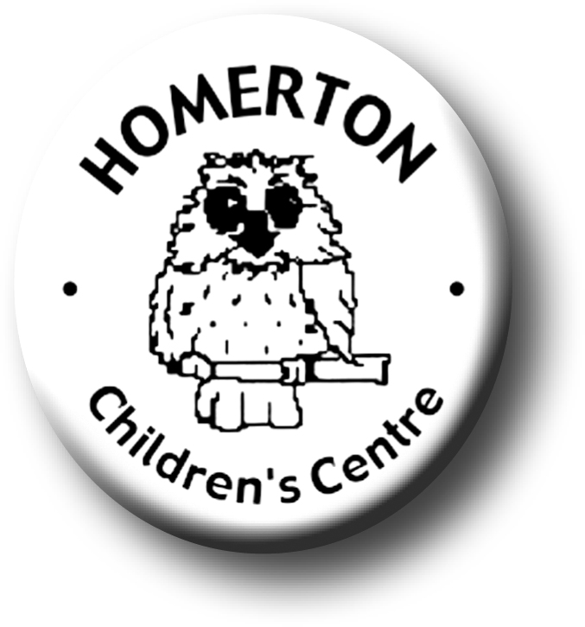
Medium Term Plans Summer 1

We follow the national Early Years Foundation Stage curriculum,
www.foundationyears.org.uk
Positive relationships
A unique child

- Develop understanding that others have needs.
- Boundaries and behaviour; working together and taking turns, sharing fairly.
- Celebrating key festivals e.g. National Children’s Day,
- Parent events – “We’re going on a bear hunt”.
- Parent and carers volunteering.
- School photographer taking individual, class and informal photos.

- Developing awareness of own needs and feelings.
- Develop child’s own voice e.g. discussing likes and dislikes.
- Develop children’s confidence through specific praise

Learning and development
Enabling environments

- Learning though our core book.
- Telling and creating stories through use of puppets and props.
- Learning about growth e.g. plants, animals & insects.
- Music –Identify well known rhymes through melody only.
- Develop fine motor control e.g. mark making in a range of media indoors and out, weaving, using small equipment, cooking.
- Every child a talker – help children expand on what they say using more complex sentences.

ECAT
- Planting – observing and experimenting.
- Continuous provision –den making, planting and growing.
- Extend knowledge of the world though wild areas; insects, dry earth/mud etc
- Animal Experience.
- Every child a talker – children sharing Special Books, reviewing past experiences.

