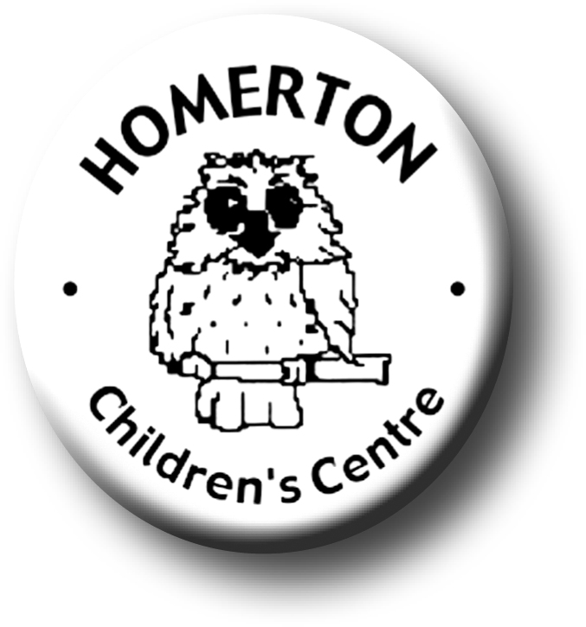
Medium Term Plans Spring 1
We follow the national Early Years Foundation Stage curriculum www.foundationyears.org.uk
We plan for each and every unique child, develop positive relationships with them and their families, engage them in stimulating environments which all contribute to every child’s learning and development.
A unique child
Positive relationships

- Develop sensitivity and listening to others, negotiating and collaborating.
- Name and talk about feelings making it clear that all feelings are acceptable but not all behaviours are. Ask children for their own ideas of what might help others when they are sad or cross.
- Celebrating key festivals e.g. Chinese new year, Valentines day.
- Soft toy owls visit homes to encourage children to talk about what they did at the weekend.
- Parents evening and parents survey.
- Parent and carers volunteering.

- New children settling in (See Autumn 1).
- Extending how children learn e.g. finding out and exploring, being involved and concentrating and choosing ways to do things.
- Planning for individual children’s next steps in development.
- Increasing independence in self-care and awareness of healthy eating and exercise.
- Children recording and reviewing their own learning through use of Special books, photographs, display etc.
- Following the Staying Safe programme “Friends”.

Learning and development
Enabling environments

- Circle time, developing listening and attention
- Responding to the weather through exploring and questioning e.g. ice melting, freezing.
- Continuous provision – enhance through additional resources in response to children’s interests e.g. plan and develop a new role play area such as ‘vets’ with the children or make collections of natural resources for creative play.
- Continuous provision – develop skills in using small and large equipment e.g. scissors, tape, staplers, spades, barrows.
- Every child a talker – use talking table mats and photographs at snack table.

- Learning though our core book, “Goldilocks” and other traditional tales.
- Use core story and everyday activities e.g. snack to calculate, compare sizes, measure and order.
- Cooking based on stories.
- Learning about healthy bodies; diet, exercise, sleep.
- Music - Use instruments to keep pulse, different rhythms through dance, experience basic musical concepts through mark making
- Developing balance and control and body awareness – movement through drama and using our imaginations.
- Every child a talker – using narratives in play.

