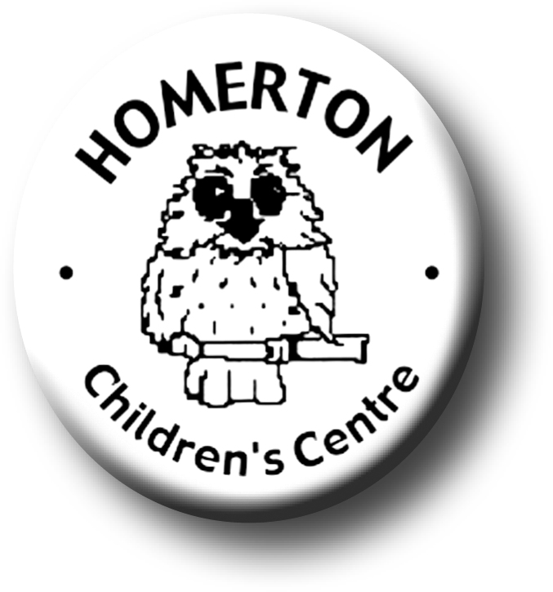
Medium Term Plans Autumn 2

We follow the national Early Years Foundation Stage curriculum, www.foundationyears.org.uk
We plan for each and every unique child, develop positive relationships with them and their families, engage them in stimulating environments which all contribute to every child’s learning and development.
Positive relationships
A unique child
- Building friendships.
- Learning to share.
- Celebrating key festivals e.g. Light festivals, Christmas.
- Parent event - Christmas Story Trail for families and Christmas raffle.
- Open evening for parents with a talk about learning and play.
- Library book loans for lunch times.
- Parent and carers volunteering.

- Developing confidence
- Continuing to get to know what children can do and enjoy through playing with children, observations and talking with parents.
- Planning for individual children’s next steps in development.
- Developing play and learning through children’s interests.
- Encouraging children to use all their senses.
- Supporting children in assessing their own risk.

Learning and development
Enabling environments

- Learning though our core book.
- Joining in with adult led sessions e.g. conker rolling, planting bulbs.
- Self –registering with name card including at snack time.
- Music – develop clapping a ‘beat’ using different parts of the body and resources.
- Every child a talker – modelling ways to talk to our friends.

ECAT
- Learning daily and weekly routines.
- Continuous provision – expand to include range of equipment and materials accessible as skills are taught e.g. talking postcards, paint other creative media, parachute and ring games, action songs and rhymes.
- Planting bulbs and playing outdoors in all weathers.
- Building confidence in managing the environment.
- Every child a talker – ‘Talking hot spots’ outdoors (vocabulary dev.)

