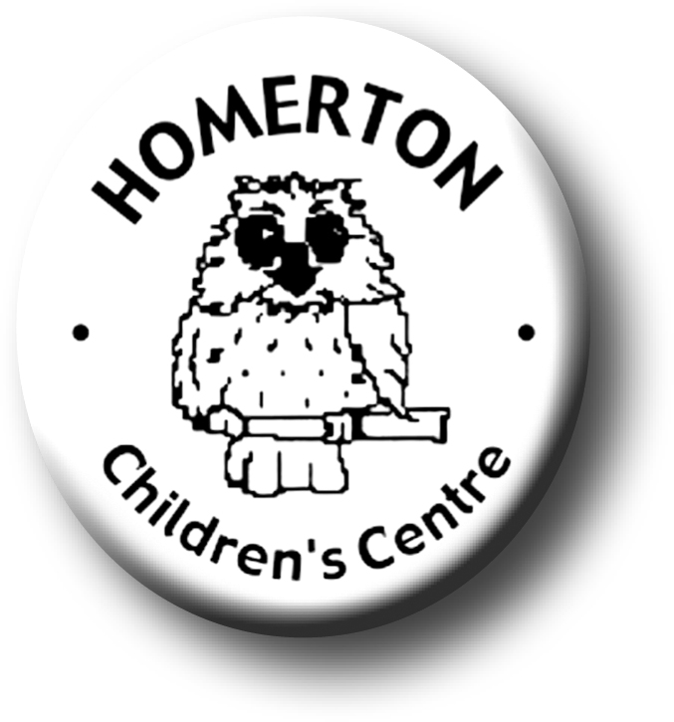Medium Term Plans Autumn 1

*We follow the national Early Years Foundation Stage curriculum,*

[*www.foundationyears.org.uk*](http://www.foundationyears.org.uk)

Positive relationships

A unique child

* Getting to know each other through home visits and supporting children as they make the transition to Homerton Nursery.
* Sharing “All about me” books with our classes to get to know about our families.
* Getting to know staff at Homerton, particularly key people.
* Playing cooperatively.
* Learning to behave in a range of situations.
* Learning about the responsibilities of being “Homerton Owl”.
* Celebrating key festivals e.g. Harvest festival, Diwali.
* Settling in and separating from carers.
* Getting to know what children can do and what they enjoy through playing with children, observations and talking with parents.
* Developing independence e.g. toileting, washing hands, accessing resources, lunch routines, choosing where to play and who to play with.
* Every child a talker – Talking about ourselves by sharing our “All about me” books.
* Developing understanding and talking about feelings.

Learning and development

Enabling environments

* Becoming familiar with the environment.
* Continuous provision – open ended resources easily accessible; sand, water, construction, creating and making, books, music, role play, malleable materials, mark making, small world.
* Learning where things are indoors and out.
* Caring for the environment e.g. looking after resources, tidying up.
* Learning daily routines.
* Understanding and ‘Stop’ and ‘Go’ signs.
* Getting to know snack and meal routines.
* Introducing Special Books.
* Learning though our core book, “Owl Babies” by Martin Waddell.
* Learning routines and expectations for Circle Time.
* Accessing the wider curriculum e.g. Rainbow room, music groups, meal times, Owlets.
* Music - reinforce pulse, move rhythmically, develop melodic sense, join in with dancing and ring games through call and response.
* Developing balance and control and body awareness – moving safely indoors and out negotiating new spaces.
* Every child a talker – Sharing “All about me” book.