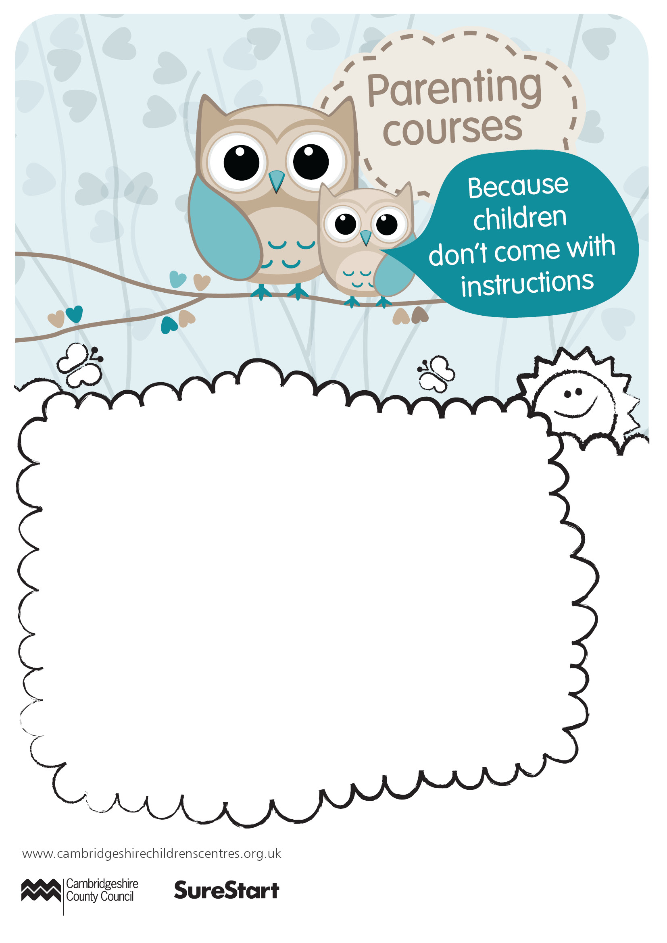

Understanding Challenging Behaviour

Wednesday 18th November 2020

10.00am to 11.00am

Is your child’s behaviour a challenge? Would you like support with how
to manage your child’s more challenging behaviour?
Come along to our free workshop where we will discuss Positive Parenting Strategies, suitable for parents of children 2-5 years
Delivered via Skype
Joining instructions and an invite will be sent via email.
Booking essential, please call 01223 728118 or email childandfamilycentre.city@cambridgeshire.gov.uk to book a space.
Booking deadline is the Friday before the session is due to take place

