Homerton home and school planning: Exploring Colour
Remember: These are just ideas to hopefully give some inspiration.
For all links please check settings are child friendly and safe viewing first.

Monday 13 July | Tuesday 14 July | Wednesday 15 July | Thursday 16 July | Friday 17 July
On a walk collect some leaves and try some leaf rubbings. Put your leaves on a flat surface then put a piece of white paper on top. Choose some colourful crayons and rub the crayons over the leaves to see their shape come through. | If you have an Elmer story at home, try counting how many different colours Elmer is. You could watch the story: Elmer’s Colours: https://www.youtube.com/watch?v=zK9TfF0qfqE  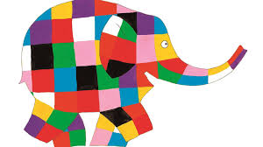 | Collect a few stones to colour or paint. You could paint a pattern or maybe a flower shape.  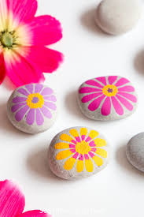 | Choose some different dried pasta shapes and colour them with paint or with a pen. Then thread them onto string to make a pasta necklace or bracelet.  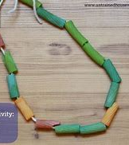 | Look at the letters in your name and what order they are in.  Can you mark make them in your favourite colours. You could use chalk, pen or paint.  E m m a
Help chop up some colourful vegetables for a snack or for dinner?  Maybe try vegetables of 3 different colours, for example, cucumber, pepper or carrot. | Make your own magical potion in a bowl or a bucket.  To water you could add a mixture of ingredients, such as dried pasta, mud, leaves, twigs. What colour is your mixture? | Go on a colour hunt in your garden or whilst out on a walk, for example:  Can you find:  - a red post box?  - a green front door?  - a yellow car  - a pink flower | Try a cosmic yoga adventure, such as ‘Coco the butterfly’. https://www.youtube.com/watch?v=pT-s1-phgxs | You could try this rainbow walking water science experiment:  https://www.messylittlemonster.com/2018/06/rainbow-walking-water-science-experiment.html
Mix cornflour and water to make ‘gloop’. Add some food colouring and watch what happens. Talk about how it changes.  https://www.learning4kids.net/2012/05/24/playing-with-gloop/#:~:text=Gloop%20is%20an%20interesting%20mixture,a%20solid%20and%20liquid%20is.  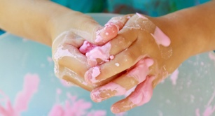 | Play the traffic light game with your family. You will need 3 objects or pieces of paper that are green, orange and red. If you call green and show the green paper, your family can run about, for orange – walk, and for red – stand very still.  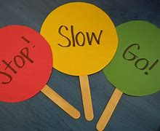 | Make your own colour book.  Fold several pieces of paper in half to make a booklet, staple at the side if you wish. Choose a different colour for each page and draw something of that colour, for example a black cat, a yellow banana, a red ladybird. | Investigate colour mixing – start with red, yellow and blue. How many different colours can you make?  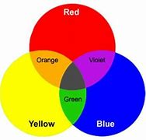 | Create a blow print monster:  https://supersimple.com/article/blow-paint-monsters/
 |  |  | Zoom Circle Time: 10am  Nursery | Zoom Circle Time: 10am  Nest

