February - April 2019
Dear Parents and Carers
Welcome back to the second half of the spring term - hope you have all had a very happy Half Term break.
Parents’ Questionnaires
Thank you so much for taking the time to complete these and for all your positive comments. They are so touching and we truly believe it is a privilege for us to be able to share this stage in your children’s lives. We are always keen to improve our practice and the parent survey is a good way for us to look at how we can do this….the survey is shared with the Governors at our meeting later in March.
If anyone would like to book a time to see me to follow up individual comments/thoughts please do so.
IMPORTANT DATES FOR YOUR DIARY!
Cake Sale Wednesday 6th March
This will be a whole school cake sale. Please bring in cakes or savoury on the day for us to sell and for you to buy!
Pancake Day 5th March
Children across the Centre usually enjoy this day. A good story to go along with the event, which follows on nicely from all our ‘Once upon a Time’ stories, is ‘Mr Wolf’s Pancakes’ should you be looking for a book to enjoy with your child over the next few weeks.
World Book Day/Week - Starting week beginning 4th March
Please do send your child to Nursery or Nest with a favourite book to share to celebrate World Book Day (please make sure your child’s name is in the book!) You are very welcome to come and read with your child and others in class, please just let your class teacher know if you are able to do this.
Each child will receive a book token to take home during the week which can be exchanged for a book at local bookshops.
Hatching Chicks from the 12th March
We will have some incubating eggs in the library, which we hope will hatch into chicks over the following two weeks. Do creep quietly into the library to have a look during this time
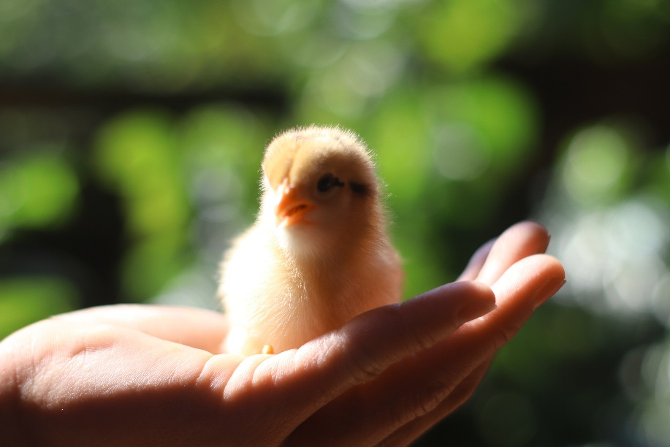
Enrichment Students week beginning 18 March
We have 2 teacher trainees from Cambridge University Faculty of Education coming to work at Homerton for the week as part of their post graduate teacher training course.
Easter Fun Day - Wednesday 27 March – A parent event for Nest and Nursery parents!
Come and have fun with your child. An “Easter Eggstravaganza” will be held in the nursery school garden. Come at drop off time morning or afternoon and be prepared to stay for 20 – 30 minutes. Invitations for this event will follow soon.
Owlets
Easter Holiday Club will run from Monday 8th - Friday 12th April. Please ask at the office for request forms. Holiday club is open for current children and their siblings up to the age of 8.
International Lunch and Summer Fair - Saturday 18th May
We thought you might appreciate advance warning of this date which is coming up next term. More information will follow in our next newsletter.
Visiting classes and helping at Homerton
We welcome parents’ visits and help in the Nursery and in The Nest. There are lots of different ways in which parents can be involved, reading, sharing a skill and now Spring is coming we'd love help with regular visits to our allotment and Old Orchard. If you be able to help please have a chat with the class staff.
Writing Sacks
These are now available in the library for your child to borrow and enjoy using at home. Please sign them out in the folder.

Easter Closure
The Centre will close for Easter at the end of the day Friday 5th April and reopens Tuesday 23rd April.

