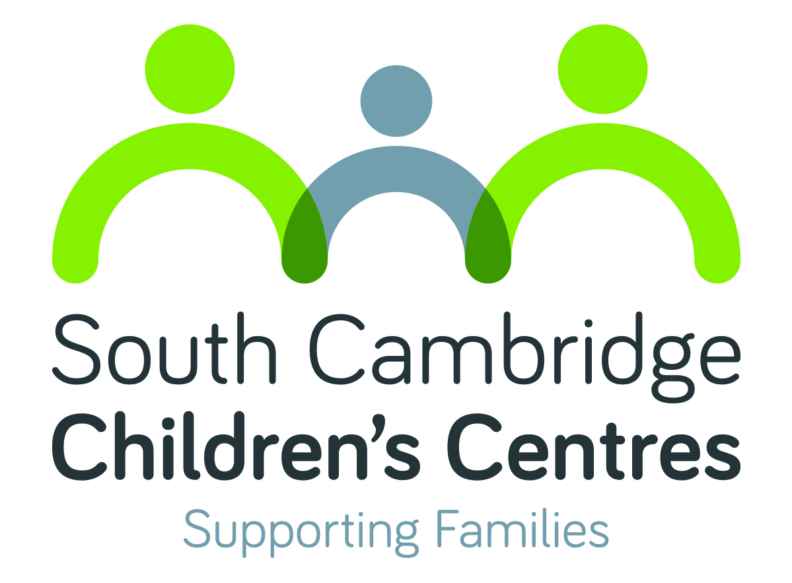

WHAT’S ON

September- December 2017
South Cambridge Children’s Centres
(Fawcett & Homerton)
Pages 2-3 Activity listings
Page 4 Activity details
Please visit our website to search for activities
across all Cambridgeshire Children’s Centres
along with online information and useful links

Monday
Development Checks
9.00am – 1.00pm
Weekly
Children aged 2
[R]
Fawcett CC
Story & Rhyme Time
10.00 – 11.30am
Weekly Term Time only
Children aged 0-5
[£]
Fawcett CC
Well Baby Clinic
1.00 – 2.30pm
Please arrive by 2:15pm
Weekly
Children aged 0-5
Fawcett CC

Tuesday
Messy Play
10.00 - 11.30am
Children aged 0-5
Weekly Term Time only
[£]
Fawcett CC

Development Checks
12.00pm – 4.00pm
Weekly
Children aged 2
[R]
Fawcett CC
Baby Time
1.30 – 3.00pm
Children aged up to 1
Weekly Term Time only
[£]
Fawcett CC

Wednesday
Family Support Group
Hearing Impairment Clinic
9.30am – 12.00pm
13th September
11th October
15th November
13th December
[R]
Fawcett CC
Baby Massage
1.30 – 3.00pm
Weekly
Ask staff for details
[B] [£]
Fawcett CC

Circle of Security
Parenting Programme
1.00 – 3.00pm
Weekly
Ask staff for details
[B]
Fawcett CC

Thursday
Antenatal Clinic
9.30am – 4.15pm
Weekly
[B]
Fawcett CC

Friday
Sling Meet
9.30 – 11.30am
8th September
6th October
3rd November
1st December
Run by Charlie Ashley-Roberts
Fawcett CC
La Leche League
10.00am – 12.00pm
22nd September
20th October
24th November
15th December
Run by Rachel O’Leary
Fawcett CC

Monday
Sparklers
10.00 – 11.45am
Weekly Term Time only
Children aged 0-5
Run by St Pauls Church
The Centre St Pauls
Antenatal Clinic
9.20am – 3.00pm
Weekly
[B]
Homerton CC

Tuesday
Messy Play
9.15 - 11.00am
Weekly Term Time only
Children aged 1-5
[£]
Homerton CC

Wednesday
‘ESOL
Writing to Communicate
English Qualification
9.30 – 11.30am
Weekly
[B]
Homerton CC
Baby Massage
1.30 – 3.00pm
Weekly
[B] [£]
Homerton CC

Thursday

Friday
Friday Friends
9.15 – 11.00am
Weekly Term Time only
Children aged 0-5
[£]
Homerton CC

NEW!
Swim For All
Free swimming for
under 5s

Abbey Swimming Pool
Whitehill Road CB5 8NT
01223 213352

TUESDAY 1.00-3.00pm
FRIDAY 11.45am-12.15pm
Half hour sessions

Collect a form from your local Children’s Centre

Parents and children
Story & Rhyme Time; Sparklers; Stay & Play; Friday Friends
A variety of play based activities, and themes that change weekly. They are a great way for you to learn about your child’s development, enjoy time with your child and meet other parents. The activities are based on the Early Years Foundation Stage (EYFS).
Messy Play
Tactile and messy, come in old clothes. A great way for you to learn about your child’s development, enjoy time together and meet other parents. The activities are based on the Early Years Foundation Stage (EYFS).

Parents and babies
Baby Massage
5 week course for babies up to crawling age. Booking essential. Call your centre for more information.
Baby Time
Drop in session for carers with babies up to 12 months. Come along and meet other families in a fun and friendly group
La Leche League
Drop-in session for breastfeeding and expectant mothers wanting information and advice on the subject. Children aged 0-5 welcome.
Sling Meet
Drop-in session for sharing experiences of carrying babies. Information and advice on sling use, fitting and comfort.

Antenatal Services
Antenatal Clinic
Visit the midwife at the Children’s Centre. Appointment only.

Support and Community
Hearing Impairment Clinic
Drop-in session to see the Hearing Support Service team and meet with other families. Referral only.
Development Checks
Routine checks carried out by a Health Visitor. Appointment required.
Well Baby Clinic
Drop-in session to see a Health Visitor for all health related queries in your Under 5. Clinic will close promptly at 2.30pm so please ensure you arrive in good time to see the Health Visitor
ESOL
Develop skills in reading, writing, listening and speaking. For learners whose first language is not English. Booking essential.

Family Worker Support
Our centre have a team of dedicated Family Workers who work all year round to support children and families with a range needs. Whether it is financial difficulties, parenting, domestic abuse, mental health or a drug/alcohol addiction, please contact us to see what support we can offer or signpost you to.

