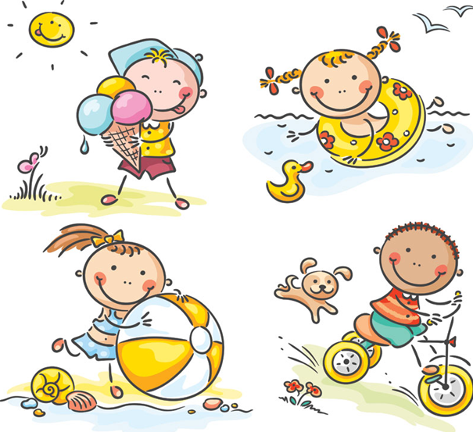
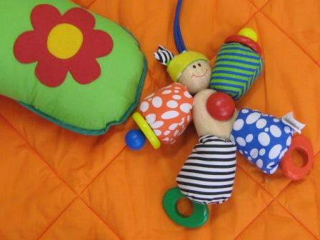

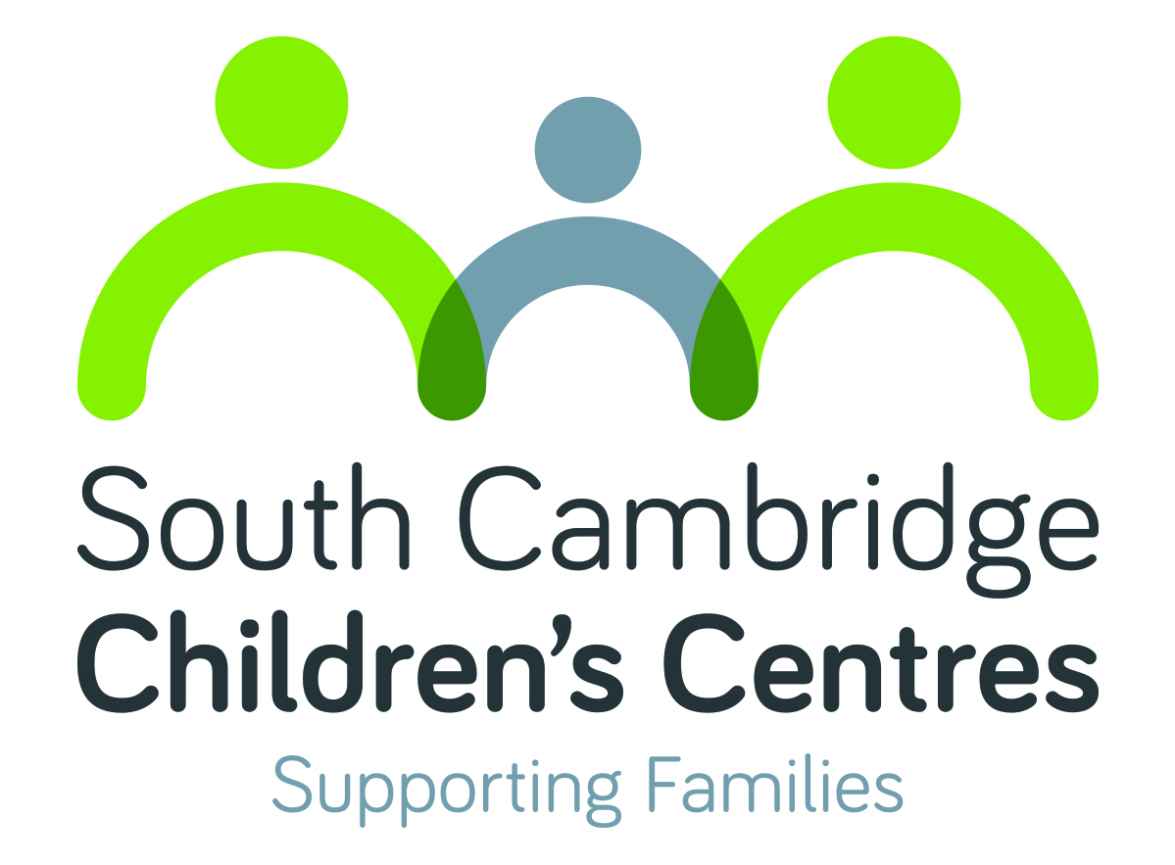

WHAT’S ON

Summer 2017
South Cambridge Children’s Centres
(Fawcett & Homerton)
Pages 2-3 Activity listings
Page 4 Activity details
Like our Facebook page to stay up to date with events
https://m.facebook.com/SouthCambCC/

Please visit our website to search for activities
across all Cambridgeshire Children’s Centres
along with online information and useful links

Monday
Development Checks
9.00am – 4.00pm
Weekly
Children aged 2
[R]
Fawcett CC

Antenatal Clinic
9.30am – 4.15pm
Weekly
[B]
Homerton CC

Well Baby Clinic
1.00 – 2.30pm
Please arrive by 2:15pm
Weekly
Children aged 0-5
Fawcett CC

Story & Rhyme Time *
10.00 – 11.30am
July 24th
July 31st
Children aged 0-5
[£]
Fawcett CC

Family Craft Day *
August 7th
August 14th
Booking essential
Free entry
The Centre St Pauls

Arts & Crafts *
11.00am – 1.00pm
July 24th
August 7th
August 21st
All ages welcome
Free entry
Trumpington Community Orchard

Tuesday
Development Checks
9.00am – 4.00pm
Weekly
Children aged 2
[R]
Fawcett CC

Messy Play *
9.45am – 11.15am
August 1st
Children aged 0-5
[£]
Homerton CC

Clothing, book & toy swap *
11.30 am – 1.00pm
August 15th
Healthy snacks included
Free entry
Fawcett CC

Botanic Gardens Trip
August 15th
By invitation only

Wednesday
Development Checks
9.00am – 4.00pm
Weekly
Children aged 2
[R]
Fawcett CC

Family Support Group
Hearing impairment clinic
9.30am – 12.00pm
August 16th
[R]
Fawcett CC

Outdoor Fun *
11.00am – 1.00pm
July 26th
August 2nd
August 9th
All ages welcome
Free entry
Clay Farm Drive (on the Aura Site)

Thursday
Antenatal Clinic
9.30am – 4.15pm
Weekly
[B]
Fawcett CC

Fun Twos *
9.45am – 11.15am
July 27th
Children aged 2
[R]
Fawcett CC

Messy Play *
9.45am – 11.15am
July 27th
Children aged 0-5
[£]
Homerton CC

Botanic Gardens Trip
July 27th
By invitation only

Friday
Friday Friends *
Picnic in the Park
10.00am onwards
July 21st
Free entry
Light snacks included
Homerton CC

Saturday
Trumpington Youth Fest *
2.00 – 6.00pm
August 19th
Arts & crafts for under 5s
Free entry
King George V Playing Fields Paget Road

*There will be an opportunity to discuss the future of our children’s centres with members of staff at these events.

Parents and children
*Story & Rhyme Time; Fun Twos, Messy Play, Arts & Crafts, Family Craft Day
A variety of play based activities, and themes that change weekly. They are a great way for you to learn about your child’s development, enjoy time with your child and meet other parents. The activities are based on the Early Years Foundation Stage (EYFS).
*There will be an opportunity to discuss the future of our children’s centres with members of staff at these events.

Parents and babies
Drop-in session to see a Health Visitor for all health related queries in your Under 5. Clinic will close promptly at 2.30pm so please ensure you arrive in good time to see the Health Visitor

Antenatal Services
Antenatal Clinic
Visit the midwife at the Children’s Centre. Appointment only.

Support and Community
Family Support Group
Drop-in session to see the Hearing Support Service team and meet with other families. Referral only.
Development Checks
Routine checks carried out by a Health Visitor. Appointment required

Family Worker Support
Our centre have a team of dedicated Family Workers who work all year round to support children and families with a range needs. Whether it is financial difficulties, parenting, domestic abuse, mental health or a drug/alcohol addiction, please contact us to see what support we can offer or signpost you to.

