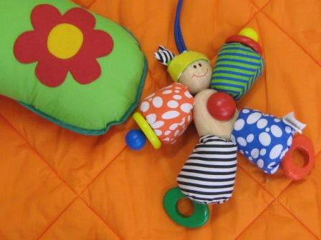

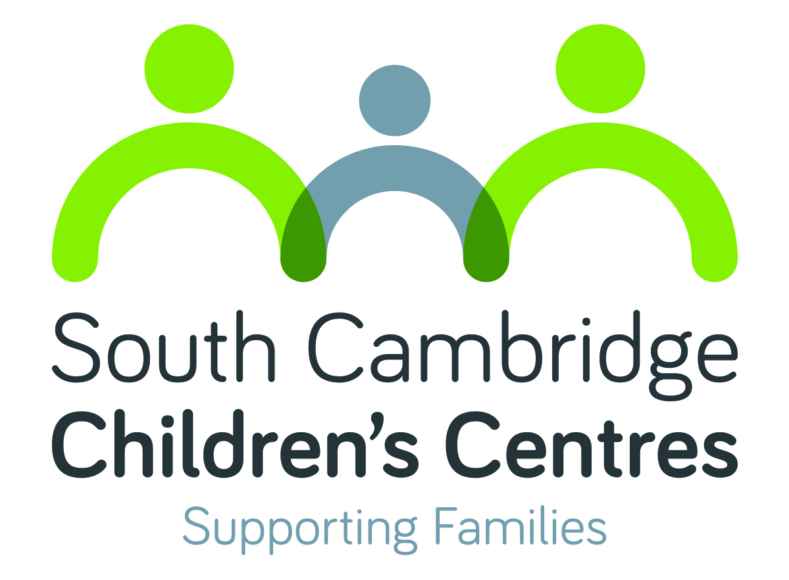

WHAT’S ON

January - March 2017
South Cambridge Children’s Centres
(Fawcett & Homerton)
Pages 2-3 Activity listings
Page 4 Activity details
Please visit our website to search for activities
across all Cambridgeshire Children’s Centres
along with online information and useful links

Monday
Development Checks
9.00am – 4.00pm
Weekly
Children aged 2
[R]
Fawcett CC
Story & Rhyme Time
10.00 – 11.30am
Weekly Term Time only
Children aged 0-5
[£]
Fawcett CC
Well Baby Clinic
1.00 – 2.30pm
Please arrive by 2:15pm
Weekly
Children aged 0-5
Fawcett CC

Tuesday
Messy Play
10.00 - 11.30am
Children aged 0-5
Weekly Term Time only
[£]
Fawcett CC

Baby Time
1.30 – 3.00pm
Children aged up to 1
Weekly Term Time only
[£]
Fawcett CC

Wednesday
Development Checks
9.00am – 4.00pm
Weekly
Children aged 2
[R]
Fawcett CC

Hearing Impairment Clinic
9.30am – 12.00pm
11th January
1st February
8th March
[R]
Fawcett CC

Baby Massage
1.30 – 3.00pm
Weekly from 18th January
Ask staff for details
[B] [£]
Fawcett CC

Thursday
Antenatal Clinic
9.30am – 4.15pm
Weekly
[B]
Fawcett CC

Friday
Sling Meet
9.30 – 11.30am
6th January
3rd February
3rd March
Run by Sophie Messager
Fawcett CC

La Leche League
10.00am – 12.00pm
27th January
24th February
24th March
Run by Rachel O’Leary
Fawcett CC

Monday
Sparklers
10.00 – 11.45am
Weekly Term Time only
Children aged 0-5
Run by St Pauls Church
The Centre St Pauls

Antenatal Clinic
9.20am – 3.00pm
Weekly
[B]
Homerton CC

Tuesday
Messy Play
9.15 - 11.00am
Weekly Term Time only
Children aged 1-5
[£]
Homerton CC

Wednesday
ESOL
9.30 – 11.00am
Weekly from 18th January
[B]
Homerton CC

Thursday

Friday
Friday Friends
9.15 – 11.00am
Weekly Term Time only
Children aged 0-5
[£]
Homerton CC

Parents and children
Story & Rhyme Time; Sparklers; Stay & Play; Friday Friends
A variety of play based activities, and themes that change weekly. They are a great way for you to learn about your child’s development, enjoy time with your child and meet other parents. The activities are based on the Early Years Foundation Stage (EYFS).
Messy Play
Tactile and messy, come in old clothes. A great way for you to learn about your child’s development, enjoy time together and meet other parents. The activities are based on the Early Years Foundation Stage (EYFS).

Parents and babies
Baby Massage
5 week course for babies up to crawling age. Booking essential. Call your centre for more information.
Baby Time
Drop in session for carers with babies up to 12 months. Come along and meet other families in a fun and friendly group
La Leche League
Drop-in session for breastfeeding and expectant mothers wanting information and advice on the subject. Children aged 0-5 welcome.
Sling Meet
Drop-in session for sharing experiences of carrying babies. Information and advice on sling use, fitting and comfort.
Well Baby Clinic
Drop-in session to see a Health Visitor for all health related queries in your Under 5. Clinic will close promptly at 2.30pm so please ensure you arrive in good time to see the Health Visitor

Antenatal Services
Antenatal Clinic
Visit the midwife at the Children’s Centre. Appointment only.

Support and Community
ESOL
Develop skills in reading, writing, listening and speaking. For learners whose first language is not English. Booking essential.
Hearing Impairment Clinic
Drop-in session to see the Hearing Support Service team and meet with other families. Referral only.
Development Checks
Routine checks carried out by a Health Visitor. Appointment required.

