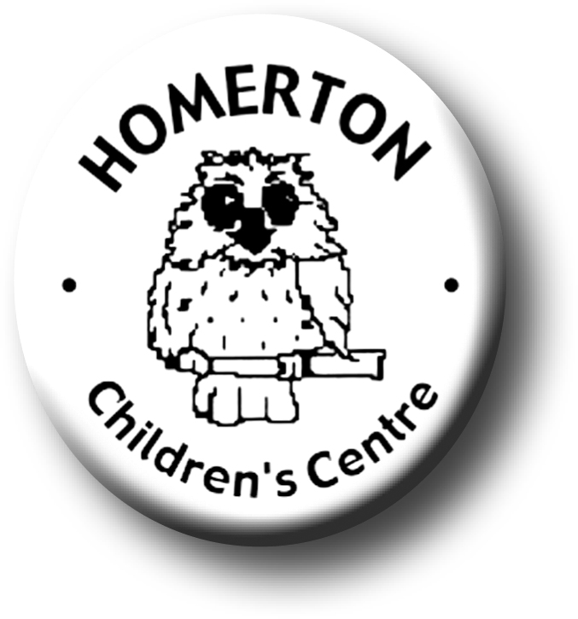
Play
Adults
The Early Years Foundation Stage (2012) States that
- Play at Homerton has a focus on well-being, being together, being able to trust and rely on others, having a voice and developing a deep sense of belonging both to the group and to the natural world.
- At the heart of our practice is the belief that children’s own need and drive to learn can most often be trusted.
- We aid and encourage independent learning and supporting children in making choices and decisions about their own learning.
- We seek to provide a multi-sensory and movement-rich environment
- We want children to find excitement and a sense of adventure through providing environments that encourage imagination where they can discover new things about themselves and their world.
- We provide freedom, flexibility and rich experiences within a framework of safety.
- We provide for individual and group play enabling children through our continuous provision to plan, repeat and return to things that have interest for them.
- We aim to feed children’s curiosity, fascination, wonder, awe and to provide satisfaction of their deep drive to learn and make meaning.
- Adults encourage children to develop a mindset that enables them to have a go, go for it and try again and know that ‘I can do it’.
- Adults will model and participate in play, when appropriate, developing both children’s characteristics of learning and the EYFS areas of learning.
- Adults observe play and learning and plan for children’s next steps in development which are encouraged through focused provision and sensitive adult interaction.
- Parents are introduced to the meaning of play from the first parents evening at Homerton; this is followed up through events, leaflets and records throughout the year.
- Good quality resources are shared with parents to encourage further play and learning at home.
- Children who are with us for extended hours will be able to ‘Play for play’s sake’.
- Adults will make the play environment accessible for all by adapting for individual needs.

‘Play underpins all learning and development in the foundation stage’
Children

- Children learn best by actively pursuing their interests and ideas through play.
- Play allows children to explore ideas and feelings, to develop social skills and make relationships. They can take risks, make mistakes and try things out without fear of failure.
- Young children must have real, direct, hands-on opportunities that are experiential, meaningful and worthwhile to them.
- Research shows 5 types of play that are important for development; physical, play with objects, symbolic play, socio-dramatic or pretend play and games with rules (Dr David Whitebread, 2012).
- Both genders benefit from all types of play and the absence of regular types of play could lead to children missing out on vital aspects of their development (Dr David Whitebread, 2012).
- Children, especially those under three, have a great need for sensory stimulation and movement, highlighting the importance of the natural outdoor environment.
- Outdoor play particularly provides children with challenge and risk as well as enabling children’s natural ways of growing, learning and thriving.
- Young children need time to think, to repeat, to return to things time and again and to come back later to something that has interest for them.

Organisation

- Provision for play is equally as rich outdoors as it is indoors; outdoors provision can be larger, noisier and messier.
- Provision represents a wide range of cultural diversity and provide for interest for all children.
- The majority of resources provide for open-ended play and are freely accessible for independent learning within a ‘managed’ environment.
- Provision focuses on the processes of learning, not end products.
- Our curriculum model based on play includes planning for continuous, enhanced and focused provision.
- We are an all weather setting where children access the outdoors every day.
- Rules and responsibilities are part of making the play environment safe for all users.

