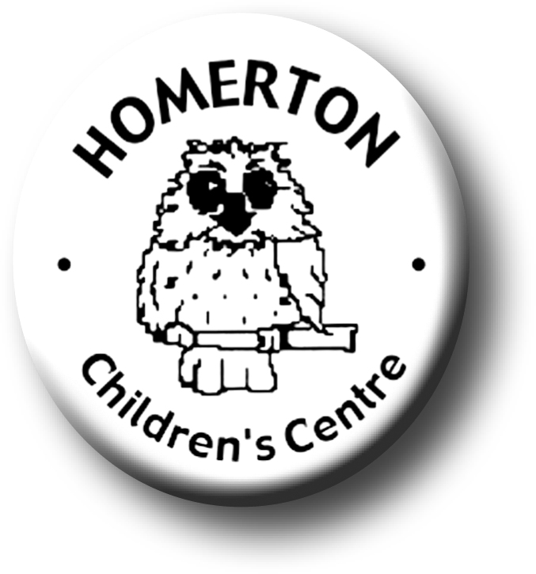
Medium Term Plans Spring 1

We follow the national Early Years Foundation Stage curriculum, www.foundationyears.org.uk
We plan for each and every unique child, develop positive relationships with them and their families, engage them in stimulating environments which all contribute to every child’s learning and development.
Positive relationships
A unique child

- Continue to develop learning to share.
- Name and talk about feelings helping children to recognise when they and others are sad or cross.
- Celebrating key festivals e.g. Chinese new year, Valentines day.
- Soft toy owl visit homes to encourage children to talk about their lives.
- Parents evening and parents survey.
- Extending how children learn e.g. finding out and exploring, being involved and concentrating and choosing ways to do things.
- Planning for individual children’s next steps in development.
- Developing independence through separating confidently, finding name card, accessing favourite resources, washing hands, toileting, etc.
- Children sharing Special books to celebrate what they know and can do.

Learning and development
Enabling environments

- Circle time, developing listening and attention
- Responding to the weather through exploring and questioning e.g. ice melting, freezing.
- Continuous provision – enhance through additional resources in response to children’s interests.
- Continuous provision – develop skills in using small and large equipment e.g. balancing and building with blocks, digging with spades, using glue for sticking etc.
- Every child a talker – use talking table mats and photographs at snack table.

- Learning though our core book
- Introduce cooking activities including helping to prepare snacks.
- Learn some nursery rhymes or favourite phrases/songs by heart.
- Develop cooperative and pretend play in the role play area
- Every child a talker – use the role play area to talk about familiar events e.g. shopping, having tea etc.

