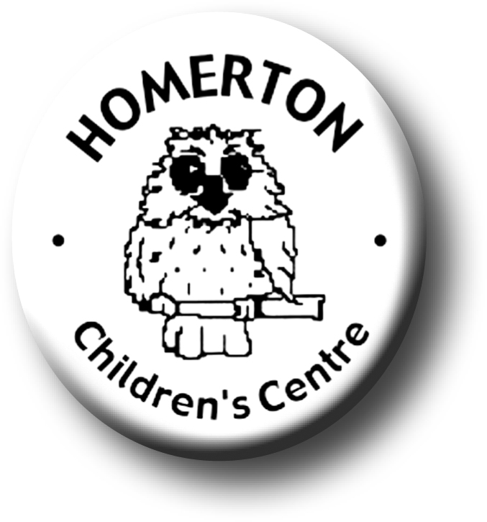Medium Term Plans Autumn 2

We follow the national Early Years Foundation Stage curriculum,
www.foundationyears.org.uk
Positive relationships
A unique child

- Continuing to build relationships with staff across Homerton.
- Building friendships.
- Learning to respect and take care of each other.
- Being polite to each other.
- Celebrating key festivals e.g. Light festivals, Christmas, Mill Road Winter Fair, Children’s Centre Activities, Christmas play for children.
- Parent event - Christmas Story Trail for families and Christmas raffle.
- Open evening for parents with a talk about learning and play.
- Library book loans begin.
- Parent and carers volunteering.

- Developing confidence
- Continuing to get to know what children can do and enjoy through playing with children, observations and talking with parents.
- Planning for individual children’s next steps in development.
- Self –registering with name card, one way into reading and writing.
- Developing play and learning through children’s interests.
- Encouraging children to use all their senses.
- Building on independence skills e.g. completing a self chosen task.
- Following the Staying Safe programme “All about me”.
- Supporting children in assessing their own risk.

Learning and development
Enabling environments

- Learning daily and weekly routines.
- Continuous provision – expand to include range of equipment and materials accessible as skills are taught e.g. ICT, woodwork, paint other creative media, maths toolkit, parachute and ring games, action songs and rhymes.
- Beginning to manage winter clothing independently.
- Planting bulbs and playing outdoors in all weathers.
- Using Stop Go signs to encourage independence in the environment.
- Building confidence in managing the environment.
- Visits out e.g. allotment, harvesting pumpkins, park
- Every child a talker – ‘Talking hot spots’ outdoors (vocabulary dev.)

- Learning though our core book, “Whatever Next” by Gill Murphy.
- Core story sack loans for home
- Joining in with adult led sessions e.g. conker rolling, planting bulbs, drawing myself.
- Cooking together, preparing snack, spreading skills.
- Music - Copy similar short rhythmic patterns, recognise short and long sounds, listen to a wide range of music
- Developing balance and control and body awareness – moving cooperatively in a group and developing awareness of space.
- Every child a talker – modelling ways to talk to our friends.

ECAT

ECAT

